SENIOR SIX TERM 2
TOPIC 1/2: Inheritance and Evolution
Competency: The learner appreciates the transmission of traits from one generation to the next, and the mechanisms that drive change in a gene pool, by analysing the concepts of inheritance and evolution, so as to make informed decisions regarding inheritable conditions, for genetic engineering, conservation biology, and health.
Contents
Nature of the Gene 4
Evidences that DNA is the hereditary material 4
Nucleic acids 5
Similarities between DNA and RNA 5
DNA structure according to Watson and Crick 9
Adaptations of DNA 10
DNA replication 10
Theories of DNA replication 11
General structure of RNA 12
The central dogma of molecular biology 13
Protein synthesis 13
Genetic code 16
Properties of genetic code 16
Mutation 17
Examples of diseases that resulted from mutation 18
Benefits of mutation in crop husbandry 18
Reasons why recessive alleles persist in a population 18
Cell division 19
Mitotic cell division 19
Meiosis 20
Differences between mitosis and meiosis 23
Cancer 24
Cancer risk factors 25
Management of cancer 26
Gene technology 26
Gene technology techniques 27
Gene Cloning 27
Application of gene cloning 27
Polymerase Chain Reaction (PCR) 28
The ethical, social, and environmental implications of gene technology, particularly GMOs 28
Genetics 30
Terminologies in genetics 30
Mendel’s laws of inheritance 32
Back cross 34
Monohybrid inheritance human 34
Heterozygous advantage 35
Possible reasons why an individual with sickle cell trait show resistance to malaria 35
The difference between individuals who have sickle cell anemia and those that have sickle cell trait 36
Co-dominance 36
Incomplete dominance 37
Difference between co-dorminance and incomplete dominance 38
Sex determination 38
Multiple alleles 38
Dihybrid inheritance 39
Gene linkage & chromosomes 42
Sex linkage 44
Reasons why there are more color-blind individuals than hemophilic among the population in spite
of similar way of transmission 45
Reasons why colorblindness is more common than hemophilia in the population 45
Sex limited characters 45
Crossing over 45
Lethal alleles 46
Evolution—History of life 47
Theories for origin of the earth 47
Theories for origin of life on earth 47
Theories of evolution 47
Natural Selection 48
Variation 48
The importance of variation in a population 49
Role of environment in the process of natural selection 49
Importance of natural selection 49
Ways by which Humans influence evolution 52
Causes of bacterial resistance to chemicals 53
Solution to bacterial resistance 54
Possible causes of malaria resistance 54
Polymorphism 54
Causes of variation 54
Examples of Conditions caused by non-disjunction in man 56
Gene pool 58
Allele frequency 58
Genotype frequency 58
Genetic drift 59
Genetic load 59
Gene flow 60
Heterozygotes as a reservoir of genetic variation (the Hardy-Weinberg principle) 60
Speciation 62
Isolation mechanisms 62
Contributions of isolation mechanisms to evolution 63
Inbreeding 64
Hybrid 64
The green revolution 64
Evidences of evolution 65
Extinction 66
Causes of extinction 66
Revision Questions on the gene and protein synthesis 68
Revision questions on cell division 78
Revision questions on genetics 83
Revision questions for evolution 102
Discontinuous distribution 106

Nature of the Gene
A gene is the basic physical and functional unit of heredity, made up of a segment of DNA that contains instructions for building a specific molecule, most often a protein. Located on chromosomes within the nucleus of cells, genes are responsible for determining physical traits like eye color, hair color, and height, and for directing other bodily functions, such as muscle flexing or hair growth. That is;
- Unit of heredity: Genes carry the instructions that are passed from parents to children, determining many inherited characteristics.
- Segment of DNA: Each gene is a specific sequence of DNA, the molecule that contains the genetic code written in four "letters": A, C, T, and G.
- Instructions for molecules: Genes provide instructions for making proteins and other molecules that are essential for the body to function.
- Location: Genes are located on chromosomes, which are thread-like structures found in the nucleus of nearly every cell.
- Function: Genes direct specific processes, like building muscle tissue, or help regulate other genes.
- Alleles: Different versions of the same gene are called alleles.

Evidences that DNA is the hereditary material
- Experimental evidence
  - Avery-MacLeod-McCarty experiment (1944): showed that DNA could transform bacteria. In this experiment Scientists isolated different components from virulent bacteria, including DNA and proteins. They showed that only the DNA, when added to a
non-virulent strain of bacteria, could transform it into a virulent strain. This demonstrated that DNA carried the "transforming principle" that determined the bacteria's traits.
  - Hershey-Chase experiment (1952): proved that viruses inject their DNA into bacteria to replicate, not their protein. In this experiment used bacteriophages (viruses that infect bacteria) to determine which part of the virus—the protein coat or the DNA core—
carried the genetic information. This found that by using radioisotope labeling technique that the virus injected its DNA into the bacteria, and the protein coat remained outside, proving that DNA is the genetic material.
  - Mutation or changes in the composition of DNA alter the organisms’ characteristics.
- Structural and functional evidence
  - Replication mechanism: The double-helix structure of DNA, with its complementary base pairing (A with T, and G with C), provides a clear mechanism for how genetic information can be copied accurately and passed to new cells.
  - Stability: DNA is a stable molecule, both chemically and structurally, which is a necessary characteristic for a molecule that must reliably store genetic information over time.
  - Capacity for variation: The vast number of possible sequences of the four bases in DNA allows for the genetic variation seen in living organisms.
  - Expression: DNA's sequence of bases codes for proteins, which carry out the functions of life, demonstrating that it can be "expressed" through the traits and characteristics of an organism.

Nucleic acids
This is a form of genetic material in all living organisms including the simplest viruses. Nucleic acids are polymers made of subunits called nucleotides.

Types
- Deoxyribonucleic acid (DNA) is found in the nucleus
- Ribonucleic acid (RNA) is found in both nucleus and cytoplasm.

Similarities between DNA and RNA
Both:
- are polymers of nucleotides
- carry genetic information
- have same purine bases adenine and guanine plus pyrimidine bases cytosine
- originate from the nucleus
- both have some base pairing (such as in tRNA)

Differences between Deoxyribonucleic acid (DNA) and Ribonucleic acid (RNA)
Deoxyribonucleic Acid (DNA) | Ribonucleic Acid (RNA)
Made Deoxyribose sugar | Made of Ribose sugar
Has Double-stranded helix | Has Single-stranded
Consists of bases: Adenine, Thymine, Cytosine, Guanine (A, T, C, G) | Consists of bases: Adenine, Uracil, Cytosine, Guanine (A, U, C, G)
Used to Stores genetic information for development and function | Used to Transports genetic information to create proteins, regulates genes, and more
Fond primarily in the nucleus | Found throughout the cell, including the nucleus and cytoplasm
More stable due to deoxyribose sugar and double helix structure | Less stable and more reactive, making it suitable for short-term functions
DNA is self-replicating. | RNA is synthesized from DNA when needed.
Only two types: intra nuclear and extra nuclear DNA | Three different types: mRNA, tRNA and rRNA

Nucleotide
A nucleotide is the basic building block of the nucleic acids DNA and RNA. Each nucleotide consists of three parts
- A five-carbon sugar molecule – either Deoxyribose (in DNA) or Ribose (in RNA).
- A phosphate group.
- A nitrogenous base – any purine (Adenine, Guanine) or pyrimidine (Cytosine and either Thymine in DNA or Uracil in RNA)
.
- Phosphoric acid

OH
OOH
P
OH

- Sugar: the pentose sugar in RNA is ribose while that of DNA is deoxyribose sugar. Deoxyribose sugar lacks an oxygen atom on the second carbon atom

5CH₂OH 5CH₂OH
HOH HOH
C
C
O
C
C
H
H
H
1
2
3
4
C
C
O
C
C
H
H
H
1
2
3
4
OH OH OH H
Ribose sugar Deoxyribose sugar

- Organic Bases: DNA contains four different organic bases; adenine (A), guanine (G) cytosine (C) and thymine (T). RNA also contains adenine (A), guanine (G), cytosine (C) and Uracil (U). all these bases are ring compounds, made of carbon and nitrogen.
  - Pyrimidines (cytosine, uracil and thymine; CUT) have a six-membered ring.

H
N
C
C
C
C
N

NH₂ O
H
H
H
N
C
C
C
C
N
H
O
C
H
3
H
O
O
N
C
C
C
C
N
N
C
C
C
C
N
H
H
O
O
H
H H
Cytosine Thymine Uracil

  - Purine (Guanine and Adenine (GA) have a two membered ring)
NH₂ O
N
C
C
C
C
N
N
N
C
H
H
N
C
C
C
C
N
N
N
C
H
H
N
H
2
H H
Adenine Guanine

Nucleoside
A nucleoside is a molecular building block composed of a nitrogenous base and a five-carbon sugar. The key difference between a nucleoside and a nucleotide is that a nucleoside lacks the phosphate group(s).

Nucleoside forms when a pentose sugar joins an organic base by condensation reaction (a water molecule is lost).

Nucleotide forms when a nucleoside (pentose sugar + organic base) joins a phosphate by loss of second water molecule.

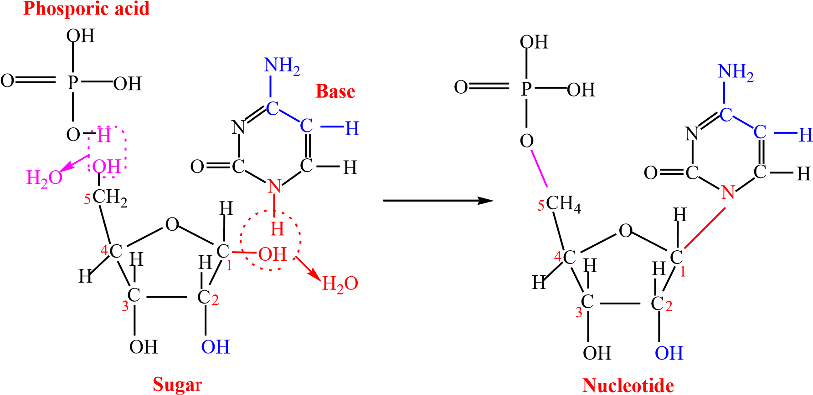

The sugar-phosphate-sugar backbone is formed when the 3’ carbon on one sugar joins to the 5’ carbon on the next sugar by phosphodiester bonds repeatedly to form a polynucleotide (long chain of nucleotides) with organic bases protruding sideways from sugars.
Nitrogen base

DNA structure according to Watson and Crick
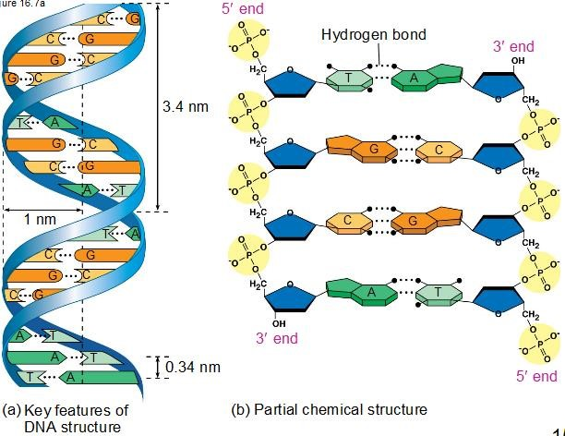
According to the Watson and Crick model, DNA is a double helix, a "twisted ladder" structure where two antiparallel strands are held together by hydrogen bonds between complementary base pairs. The sugar-phosphate backbones form the sides of the ladder, while the nitrogenous bases (Adenine, Thymine, Guanine, and Cytosine) form the rungs, with A always pairing with T and C always pairing with G.
Key features of the model:
- Double Helix: DNA is composed of two strands that coil around each other to form a right-handed double helix.
- Antiparallel Strands: The two strands run in opposite directions. One strand runs from the 5’ to 3’ end while another runs from 3’ to 5’end.
- Sugar-Phosphate Backbone: The sides of the "ladder" are formed by alternating deoxyribose sugar and phosphate groups.
- Base Pairing: The rungs of the ladder are made of pairs of nitrogenous bases, which are held together by hydrogen bonds.
  - Adenine (A) always pairs with Thymine (T) via two hydrogen bonds.
  - Guanine (G) always pairs with Cytosine (C) via three hydrogen bonds.
- Complementarity: The sequence of one strand dictates the sequence of the other. For example, a strand with the sequence AGTC would have a complementary strand with the sequence TCAG.
- Genetic Information: The sequence of the bases along the strand is the genetic code that carries instructions for building proteins.

- Replication Mechanism: The model suggested that the two strands could separate, and each could serve as a template for creating a new, complementary strand, which explains how DNA is accurately copied.

Adaptations of DNA
- Structural adaptations for information storage
  - Double helix structure: The helical shape provides a compact and strong structure.
  - Phospho-diester linkages: These strong bonds in the backbone protect the DNA from physical and chemical damage.
  - Long/large molecule for storage of much information
  - Hydrogen bonds: Weak hydrogen bonds between the base pairs allow the two strands to be easily "zipped" open for processes like replication and transcription.
  - Grooves: The major and minor grooves created by the helix provide binding sites for proteins that regulate gene expression.
- Functional adaptations for information management and evolution
  - Universal code: The four nucleotide bases form a code that is the same in almost all organisms, making it universally readable.
  - Semi-conservative replication: The DNA molecule is copied so that each new DNA molecule contains one original strand and one new strand, allowing for accurate information transfer with minimal corruption.
  - Replication proofreading: DNA polymerase has proofreading capabilities to minimize errors during replication, ensuring the integrity of the genetic code.
  - Mutation: Changes in the DNA sequence (mutations) can create new traits. If a mutation is beneficial, it can lead to an adaptation, where the trait is passed on through generations.
- Epigenetic adaptations
  - Epigenetics: This involves changes in gene expression that are not caused by alterations to the DNA sequence itself, such as DNA methylation or modifications to histone proteins.
  - Reversible: Unlike mutations, epigenetic changes are often reversible, allowing for more rapid "fine-tuning" of gene expression in response to environmental factors.

DNA replication
DNA replication is the process of creating two identical copies of a DNA molecule, which is essential for cell division, growth, and repair.

Theories of DNA replication
DNA replication is the process by which the parent DNA molecule makes another copy of itself. The three main theories of DNA replication were the conservative, dispersive, and semiconservative models.
- Conservative model: The two original DNA strands remain together and act as a template for a new, complementary strand, resulting in one molecule being entirely original and the other being entirely new.
- Dispersive model: The original DNA double helix is fragmented, and new segments are synthesized along the original fragments. This results in each new DNA molecule being a patchwork of old and new segments on both of its strands.
- Semi-conservative model: The two strands of the original DNA molecule separate and each separated strand serves as a template for the synthesis of a new, complementary strand. The outcome is two new DNA molecules, each consisting of one original (parental) strand and one newly synthesized strand.
Scientific consensus: Experiments, most notably the Meselson-Stahl experiment, provided evidence that supported the semi-conservative model, which is now known to be the correct mechanism for DNA replication.
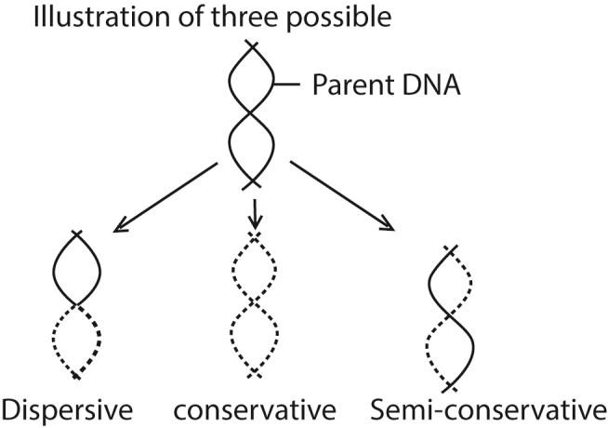

Requirements for DNA replication
- Free nucleotides to bond with complementary bases on the separated DNA strands.
- Energy source in form of ATP
- Complementary DNA strand
- Enzymes such as DNA polymerase, DNA helicase and DNA lingaze.

Stages of DNA replication
- Initiation: DNA helicase unwinds the double helix at a specific origin, creating a replication "bubble" with two replication forks where the two strands are separated.
- Elongation: DNA polymerase synthesizes new DNA strands using the parental strands as templates. Because DNA polymerase can only add nucleotides in the 5′→3′ direction, the two new strands are synthesized differently.
  - The leading strand is synthesized continuously toward the replication fork.
  - The lagging strand is synthesized discontinuously in short segments called Okazaki fragments away from the fork, and requires RNA primers to start. RNA primase synthesizes short RNA primers to provide a starting point for DNA polymerase while DNA ligase joins Okazaki fragments on the lagging strand into a continuous molecule.

- Termination: The process concludes when the replication forks meet, and the newly synthesized DNA strands are joined together to form two complete, identical DNA molecules.
- DNA repair: The DNA Replication is not completed before a mechanism of repair fixes possible errors caused during the replication. Enzymes like nucleases remove the wrong nucleotides and the DNA Polymerase fills the gaps.

General structure of RNA
- RNA molecules are small/short, single stranded (rRNA and mRNA) but may be coiled around such that bases of the same strand pair with each other.
- RNA nucleotide is made up of three molecules:
  - Phosphate group
  - Ribose sugar
  - Nitrogen base - either adenine (A), guanine (G), cytosine (C) or uracil (U) (c) The sugar-phosphate-sugar backbone is held by covalent phosphodiester bonds.
(d) RNA occurs in three types whose sizes, shapes, amounts/abundance and roles vary:

Types of RNA
- Ribosomal RNA (rRNA) is a type of non-coding RNA that serves as a primary component of ribosomes, the cellular machines that synthesize proteins. It provides the structural framework and catalytic function for the ribosome, which translates the genetic information from messenger RNA (mRNA) into a chain of amino acids, or protein.
Functions of rRNA
rRNA performs several critical tasks within the ribosome to ensure accurate protein synthesis:
  - Provides a scaffold for the ribosome: rRNA molecules fold into complex threedimensional structures that form the foundation for the ribosome, ensuring its stability and proper assembly.
  - Catalyzes protein synthesis: rRNA acts as a ribozyme, meaning it has catalytic activity.
It catalyzes the formation of peptide bonds between amino acids.
  - Facilitates translation: rRNA helps correctly align the mRNA and transfer RNA (tRNA) molecules within the ribosome. This ensures that the genetic code is read accurately and translated into the correct amino acid sequence.
- Messenger RNA (mRNA)is a type of RNA that carries coded information from DNA to ribosomes in the cytoplasm

- Transfer RNA (tRNA) is a small type of RNA molecule that acts as an adaptor between the messenger RNA (mRNA) and the amino acids during translation/protein synthesis. Each tRNA molecule has two critical sites that allow it to read the genetic code and deliver the correct amino acid during translation

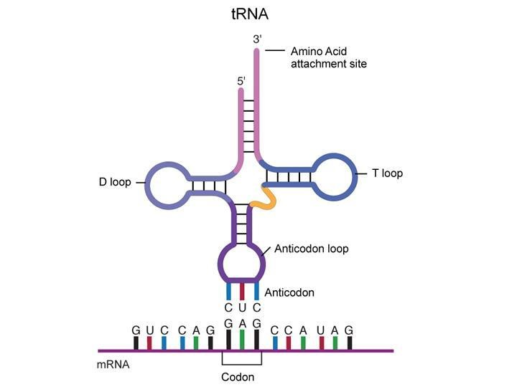

The central dogma of molecular biology

It states that DNA makes RNA makes proteins

Protein synthesis
Protein synthesis is the fundamental biological process by which cells create proteins. This process is guided by the genetic information encoded in DNA and occurs in two main stages: transcription and translation.

1. Transcription
The first stage takes place in the cell's nucleus and involves converting a gene's DNA sequence into a messenger RNA (mRNA) molecule.
- Initiation: The enzyme RNA polymerase binds to a specific region of the DNA called the promoter, located at the start of a gene. It separates the two DNA strands, creating an opening for transcription.
- Elongation: RNA polymerase moves along one of the DNA strands (the template strand) and synthesizes a new mRNA molecule. It reads the DNA and adds complementary RNA nucleotides: C with G, and U with A (replacing DNA's T).
- Termination: Transcription ends when RNA polymerase reaches a specific stop signal on the DNA. The mRNA molecule detaches from the DNA template, and the DNA double helix reforms.
- Processing (in eukaryotes): In eukaryotic cells, the newly synthesized pre-mRNA undergoes processing before leaving the nucleus. This involves splicing out non-coding segments called introns and adding a protective cap and tail.

2. Translation
The second stage occurs in the cell's cytoplasm, where ribosomes use the mRNA template to assemble a protein.
- Initiation: The processed mRNA leaves the nucleus and binds to a ribosome. The ribosome recognizes the start codon (typically AUG) on the mRNA. A transfer RNA (tRNA) molecule carrying the amino acid methionine and an anticodon complementary to the start codon then binds to the ribosome.
- Elongation: The ribosome moves along the mRNA, reading the codons (three-nucleotide sequences). For each codon, a matching tRNA molecule delivers the correct amino acid. The ribosome catalyzes the formation of a peptide bond between the growing amino acid chain and the new amino acid. The empty tRNA is released to pick up another amino acid.
- Termination: The ribosome continues to move and build the polypeptide chain until it encounters a stop codon (UAA, UAG, or UGA) on the mRNA. A protein called a release factor binds to the stop codon, causing the ribosome, mRNA, and newly formed polypeptide chain to separate.

3. Post-translational modification
After translation, the newly synthesized polypeptide chain is not yet a functional protein. It must undergo further processing, which can include:
- Folding: The polypeptide chain folds into its unique three-dimensional shape, which is essential for its function.
- Cleavage: Some polypeptides are cut into smaller, active protein molecules.
- Chemical modification: Functional groups like carbohydrates, lipids, or phosphates may be added to the protein, further altering its structure and function

Genetic code
The genetic code is the set of rules by which information encoded in genetic material (DNA or RNA sequences) is translated into proteins (amino acid sequences) by living cells. THE GENETIC CODE CHART / TABLE
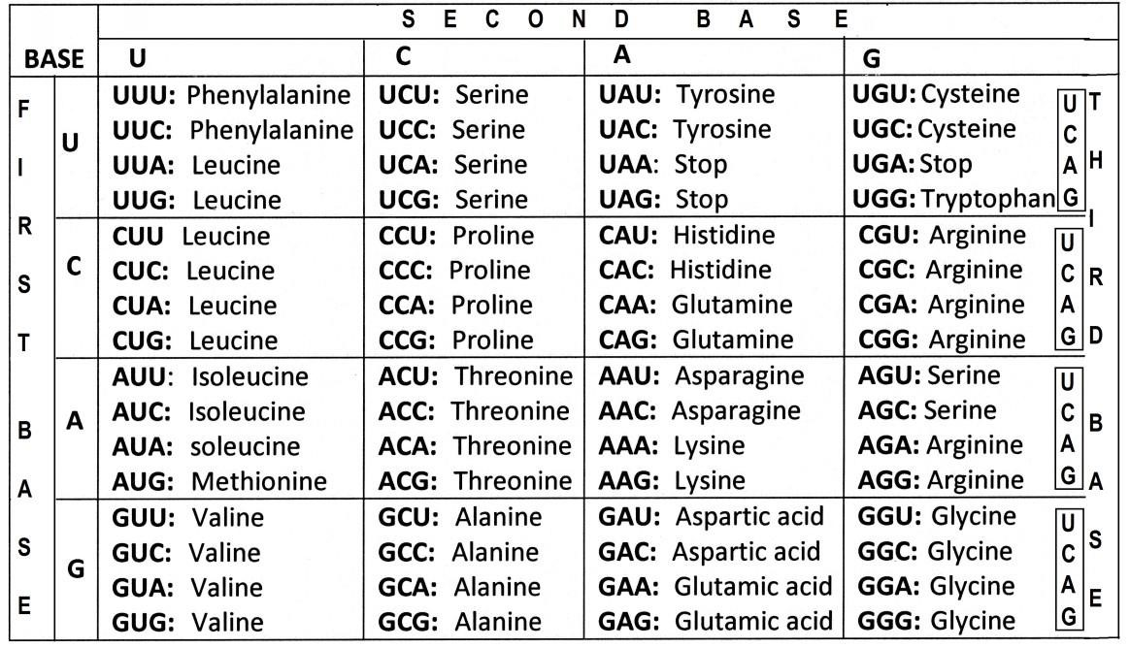

Properties of genetic code
- The code is a triplet codon: The nucleotides of mRNA are arranged as a linear sequence of codons, each codon consisting of three successive nitrogenous bases, i.e., the code is a triplet codon.
- The code is non-overlapping: In translating mRNA molecules, the codons do not overlap but are “read” sequentially.
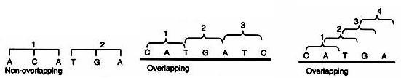
- The code is comma less: This means that no codon is reserved for punctuations. After one amino acid is coded, the second amino acid will be automatically, coded by the next three letters and that no letters are wasted as the punctuation marks.
- The code is non-ambiguous: A particular codon will always code for the same amino acid. The same codon shall never code for two different amino acids.
- The code has polarity: The code is always read in a fixed direction, i.e., in the 5’→3′ direction.
- The code is degenerate: More than one codon may specify the same amino acid; For example, except for tryptophan and methionine, which have a single codon each, all other 18 amino acids have more than one codon.

Biological advantages of degeneracy
- It permits essentially the same complement of enzymes and other proteins to be specified by microorganisms varying widely in their DNA base composition.
- It provides a mechanism of minimizing mutational lethality. E.g. Substitution of the third base-U in GUU (for valine) with C/A/G does not change the amino acid coded for.
- Some codes are start codons: In most organisms, AUG codon is the start or initiation codon, i.e., the polypeptide chain starts either with methionine (eukaryotes) or Nformylmethionine (prokaryotes).
- Some codes are stop codons: Three codons UAG, UAA and UGA are the chain stop or termination codons. They do not code for any of the amino acids. These codons are also called nonsense codons, since they do not specify any amino acid.
- The code is universal: Same genetic code is found valid for all organisms ranging from bacteria to man.

Mutation
A mutation is any alteration in the nucleotide sequence of a cell's DNA or a virus's genome. Mutations can be small, like a point mutation (the addition, deletion, or substitution of a single nucleotide), or large, involving the duplication or deletion of entire segments of DNA. Changes in somatic cells (body cells) can affect the organism itself, while mutations in germ cells (sperm or egg cells) can be passed down to offspring.

Causes of mutations
- Errors during cell division: Mistakes can happen when cells replicate their DNA.
- External factors: Exposure to things like UV radiation, X-rays, and certain chemicals can damage DNA and cause mutations.

Effects of mutations
- Neutral: Many mutations have no noticeable effect because they occur in a non-coding area of the DNA or the change still results in the same amino acid being coded for.
- Harmful: Some mutations can be detrimental, leading to genetic disorders like cystic fibrosis or increasing the risk of cancer.
- Beneficial: Occasionally, a mutation can be advantageous, helping an organism adapt better to its environment. For example, some mutations allow people to digest milk into adulthood (lactase persistence).
- Genetic variation: Mutations are the source of all genetic variation within a population.

Examples of diseases that resulted from mutation
- Cystic fibrosis: A recessively inherited genetic disorder caused by a deletion in the CFTR gene, which leads to damage in the lungs and digestive tract.
- Sickle cell anemia: A condition resulting from a missense mutation in the gene that codes for hemoglobin, causing red blood cells to become sickle-shaped.
- Hemophilia: A bleeding disorder caused by mutations in genes that are responsible for blood clotting factors, leading to prolonged bleeding after injury.
- Color blindness: A hereditary condition that affects the ability to distinguish between certain colors, often due to mutations in genes on the X chromosome.

Benefits of mutation in crop husbandry
- Enhanced yield and quality: Mutations can lead to traits that increase crop yield or improve nutritional value, such as larger seeds or higher protein content.
- Stress tolerance: Mutation breeding is crucial for creating varieties that can withstand environmental stresses like drought, high temperatures, salinity, and pests, which is essential for climate change adaptation.
- Increased genetic diversity: It expands the genetic pool of a crop, which can be beneficial when traditional breeding methods are not effective, particularly for crops with low genetic variety.
- Development of seedless crops: Mutation is a simple and effective method for developing seedless varieties, such as certain fruits and vegetables.
- Addressing specific agricultural issues: It can improve specific characteristics in existing cultivars without sacrificing their overall desirable traits.

Reasons why recessive alleles persist in a population
- Recessive alleles are hidden in heterozygous condition where they cannot be eliminated by natural selection.
- In some cases heterozygous condition may have selective advantage promoting persistence of recessive alleles in a population.
- Immigration may reintroduce the recessive allele
- Heterozygous carriers reproduce and pass the recessive allele to their offspring.
- New mutations can continually introduce or reintroduce recessive alleles into the gene pool, even if selection is working to remove them.

Cell division
Growth, reproduction and replacement of old cells involve the multiplication cells. In order to multiply cells under cell division: there are two types of cell division.

Mitotic cell division
This type of cell division; leads to the formation of two daughter cells each with exactly the same number of chromosomes as the parent cells.
Mitosis takes place in five stages, Interphase, prophase, metaphase, anaphase and telophase.
At each of these stages certain crucial events take place, particularly in regards to chromosome. It is a continuous process that takes about an hour.
1. Interphase: It is sometimes described as a resting stage. During this stage, there is protein synthesis, formation of organelles and replication of DNA. It also builds up a sufficiently large store of energy to carry the cell through the remaining stage of mitosis. During interphase the chromosomes are not visible or distinct bodies either under light microscope or electron microscope. Just before mitosis begin the centrioles are among the most prominent organelles in the cell.

2. Prophase
- Early prophase: Chromosomes become visible as they contract, and nucleus shrinks, centrioles move to the opposite sides of nucleus. Spindle fiber start to form

- Late prophase: Chromosomes become shorter and fatter-each seen to consist of a pair of chromatid joined at the centromere. Nucleolus disappears. Prophase ends with the breakdown of the nuclear envelop.


Chromatid

Centromere

- Metaphase: Chromosomes arrange themselves on the equator of a spindle

- Anaphase: Chromatid separate and migrate to opposite pol of the cell. The centromere leading

- Telophase: Chromosomes unwound. Nuclear envelope and nucleoli form.

The two silent features of mitosis that ensure that chromosome constitution of the cell is preserved are
- DNA replicates before mitosis
- The chromosomes arrange themselves at the equator before migration to opposite side.

Importance of mitosis
Mitosis provides new cells for growth and development, repairs and replaces damaged tissues, and enables asexual reproduction

Meiosis
This is a type of cell division where each parent cell divides into four haploid cells. It leads to formation of gametes. By having the number of chromosomes prior to fertilization, meiosis ensure that the zygote has normal diploid condition
Meiosis occurs into two successive divisions, the parent cell splints into two (first meiotic division) and the product then divides again (second meiotic division) giving a total of four daughter cells.

Meiotic division 1
- Interphase: Cells in normal non-dividing conditions with chromosomes long and threadlike.
- Prophase 1: This is the longest phase and is subdivided into 5 stages

  - Leptotene: The chromosomes are single, long and scattered
  - Zygotene: The single chromosomes begin to pair up with homologous chromosome the process called synapsis and each pair is called a bivalent

  - Pachytene: Chromosomes become intimately coiled around each other. The chromosomes replicate into chromatids that move slightly apart. The chromatids of homologous chromosomes remain in contact at certain points called the chiasmata. The chiasmata are the sites of genetic exchange called crossing over.


Chiasmata

  - Diplotene: Chromosomes in the bivalents begin to separate but remain joined at the chiasmata in each bivalent. The number of chiasmata in each bivalent varies but they tend to be more on long chromatids.

  - Diakinesis: Internal coiling continues and the bivalents are most contractive stage.

- Metaphase 1: The homologous chromosomes (bivalents) arrange themselves opposite each other on the equator of the spindle

- Anaphase 1: The homologous chromosomes each made up a pair of chromatid joined at the centromere move towards opposite pole of the spindle. The sister chromatids also separate from each other’s along their length except at the centromere.

- Telophase 1: When the chromosomes reach their respective pole, the cell start to divided across the middle, and as in mitosis, nuclear envelop form around the two new nuclei

Meiotic division II
Separation of homologous chromosomes that make up a bivalent is achieved by the first meiotic division. The purpose of the second division is to separate the chromatids from one another
(i) Prophase II: The two daughter cells prepare for the second meiotic division: centrioles have replicated and a new spindle is formed.

(ii) Metaphase II
The chromosomes move to the equator of the spindle, the chromatids orienting towards opposite pole.

- Anaphase II: Chromatid separate and move apart from each other

- Telophase II: When the chromosomes reach the end of the spindle the cell divides, the spindle apparatus disappear and chromosome begin to regain their threadlike form. New nuclear envelops and nucleoli form.

Significance of meiosis
Meiosis reduces the chromosome number by half to create gametes for sexual reproduction and generates genetic diversity through processes like crossing over and independent assortment.

How meiosis lead to variation
Meiosis produces gametes of varying genetic composition through two processes
- Crossing Over: During Prophase I, homologous chromosomes exchange segments of DNA, creating new combinations of alleles (versions of genes) on each chromosome.
- Independent Assortment: In Metaphase I, homologous chromosome pairs align randomly at the cell's center, leading to a unique mix of maternal and paternal chromosomes in each resulting gamete.
- Random Segregation: The chromosomes further separate randomly into daughter cells (gametes), ensuring each gamete has a unique genetic blueprint.
- Produces haploid gametes for sexual reproduction, enabling additional variations in offspring through random fusion alleles during fertilization

Differences between mitosis and meiosis
 | Mitosis | meiosis
1. | Homologous chromosomes remain separate | Homologous chromosomes pair up
2 | There no crossing over | Crossing over occurs
3. | No formation of chiasmata | Formation of chiasmata
4. | Single division | Two series of division
5. | Results into two diploid daughter cells | Results in four haploid daughter cells
6. | Occurs in somatic cells | Occurs in gonads

Cancer
Cancer is a group of diseases where some of the body's cells grow uncontrollably, ignore signals to stop, and can invade nearby tissues or spread to other parts of the body. This happens when cells accumulate damaged DNA, causing them to divide and multiply without regulation to form masses called tumors. It is not a single disease but includes over 100 different types.

How cancer develops
- Normal cell cycle: Your body makes new cells to replace old ones as they die. This is a highly regulated process.
- Cancer cells: In cancer, this process goes wrong. Cells grow and multiply even when new cells aren't needed, and old cells don't die when they should.
- Tumor formation: These extra cells can form a mass called a tumor.
- Malignant vs. benign: Tumors can be benign (non-cancerous) or malignant (cancerous). Malignant tumors can invade nearby tissues.
- Metastasis: Cancerous cells can break away from the original tumor and spread to other parts of the body through the bloodstream or lymphatic system. This spread is called metastasis.

Key characteristics of cancer
- Uncontrolled growth: Cancer cells divide without stopping.
- Invasion: Malignant cells can move into surrounding tissues.
- Spread: They can spread to other parts of the body (metastasis).
- Ability to avoid normal signals: Cancer cells ignore the signals that normally tell cells to stop dividing or to die (apoptosis).
- Angiogenesis: They can tell new blood vessels to grow toward the tumor, supplying it with oxygen and nutrients.

Relationship between cell division and cancer
Cancer is a disease of uncontrolled cell division, where a cell's DNA has accumulated mutations that disable the normal "stop" signals, leading to rapid and reckless multiplication. This breakdown of cell cycle control allows cells to bypass the normal checkpoints that would halt division or trigger self-destruction (apoptosis), resulting in a tumor.

Important to know
- Cancer is a major cause of death worldwide, but early detection and treatment can improve outcomes.
- The symptoms and treatments for cancer depend on the specific type of cancer and how advanced it is.

Cancer risk factors
They are classified into factors that are controllable and those that are not

Risk factors one can control
- Tobacco use: Smoking and other tobacco use are linked to many cancers and account for a large percentage of cancer deaths.
- Alcohol consumption: Drinking alcohol increases the risk for several types of cancer, particularly with higher consumption.
- Unhealthy diet and obesity: A diet high in processed foods and sugar, combined with excess body weight, is linked to an increased risk of many cancers.
- Physical inactivity: A lack of exercise is a risk factor for several types of cancer.
- Sun exposure: Excessive exposure to natural or artificial UV radiation from the sun or tanning beds can lead to skin cancer.
- Unsafe sexual practices: Unprotected sex can increase the risk of contracting viruses like HPV and hepatitis, which can lead to cancer.

Risk factors you cannot control
- Age: The risk of developing cancer increases as you get older, with most new cases occurring in people 66 and older.
- Family history and genetics: Inherited gene mutations, such as in the BRCA1 and BRCA2 genes, can significantly increase your risk for certain cancers.
- Environmental exposures: Exposure to carcinogens like radon, arsenic, asbestos, and certain chemicals in the environment or workplace can increase risk.
- Infections: Certain viruses and bacteria, such as HPV, hepatitis B and C, and HIV, can increase cancer risk.

What you can do
- Talk to your doctor: Discuss your personal risk factors and appropriate cancer screenings with your healthcare provider. Early screening can limit dangers of cancer.
- Avoid tobacco: Do not start using tobacco products, and if you do, quit.
- Limit alcohol: Reduce your alcohol intake.
- Protect your skin: Use sunscreen and protective clothing to limit UV exposure.
- Maintain a healthy weight: Work to achieve and maintain a healthy body weight through diet and exercise.

Management of cancer
Cancer management includes treatments like surgery, radiation therapy, and chemotherapy, as well as other options such as immunotherapy, hormone therapy, and targeted therapy. The best approach is a personalized plan developed by a healthcare team, considering factors like the cancer's type, stage, and location, along with the patient's overall health and preferences. Goals of management can include curing the cancer, slowing its growth, or managing symptoms through palliative care.

Gene technology
Gene technology is the manipulation of an organism's genes through techniques like modifying, removing, or transferring them to alter its traits. It's a branch of biotechnology used to create organisms with new or improved characteristics, such as genetically modified (GM) crops or medicines like insulin.

What gene technology involves
- Genetic modification: Introducing new or altered genes into an organism.
- Gene transfer: Moving genes from one species to another, such as inserting a gene from bacteria into a plant to make it pest-resistant.
- Gene editing: A more precise method for inserting, deleting, or replacing specific genes within an organism's DNA.

Examples of gene technology applications
- Agriculture: Creating crops that are resistant to pests, diseases, or herbicides, which can increase yield and improve food quality.
- Medicine: Producing medicines like human insulin in bacteria and creating vaccines for humans and animals.
- Research: Studying how specific genes function by modifying them to see the effect on the organism.
- Diagnostics: Using techniques to quickly and accurately identify pathogens, such as in food safety.

Gene technology techniques
Gene technology includes a variety of techniques that manipulate genetic material to alter, repair, or enhance an organism's traits/systems.

Key gene technology techniques
- Recombinant DNA technology: Uses enzymes to cut and paste DNA fragments from different sources to create a new DNA molecule. This is a foundational technique for genetic engineering.
- Genetic engineering: The broad process of altering an organism's genetic makeup to achieve a desired trait. This can involve inserting, deleting, or modifying specific genes.
- Precision gene editing: More advanced methods like CRISPR-Cas9 allow for highly specific changes, such as editing a single base pair or deleting a specific segment of DNA.
- Transgenic: Involves implanting a gene from one organism into another to create a genetically modified organism (GMO). For example, a jellyfish gene can be transferred to bacteria to make them glow.
- Synthetic biology: Engineers new organisms or biological functions by designing and constructing novel life forms or systems.
- RNA interference (RNAi): A technique to "silence" or switch off specific genes, reducing their activity without altering the DNA sequence itself.
- Marker-assisted breeding: Uses genetic markers to identify and select organisms with desirable traits, speeding up conventional breeding processes.
- Gene drives: A natural or engineered genetic system that biases inheritance to rapidly spread a specific gene or trait through a population.

Gene Cloning
Gene cloning is the process of making many identical copies of a specific gene or DNA segment. It involves isolating a gene of interest, inserting it into a vector (like a bacterial plasmid), and then using a host organism (like a bacterium) to replicate the vector and produce many copies of the gene. This is achieved using tools such as restriction enzymes and DNA ligase, and the resulting recombinant DNA can be used for research, medicine, and agriculture

Application of gene cloning
Gene cloning has numerous applications, including:
- Producing proteins: It can be used to mass-produce proteins for medical use, such as human insulin for treating diabetes.
- Studying gene function: Scientists can isolate and study genes in detail to understand their roles.
- Developing new technologies: Gene cloning is a fundamental technique in genetic engineering, with applications in areas like developing modified crops or creating mRNA vaccines.

Polymerase Chain Reaction (PCR)
Polymerase chain reaction (PCR) is a laboratory technique that makes millions of copies of a specific DNA segment, a process known as amplification.
How PCR works
- Denaturation: The double-stranded DNA is heated to about 94⁰, breaking the hydrogen bonds and separating it into two single strands.
- Annealing: The temperature is lowered to allow short DNA sequences called primers to bind to their complementary sequences on the single strands. This step typically occurs around 54−60⁰C for 20-40 seconds.
- Extension: The temperature is raised to about 72⁰, the optimal temperature for the DNA polymerase enzyme (like Taq polymerase), which synthesizes new DNA strands by adding nucleotides to the primers.
- Repetition: These three steps are repeated 20-25 times, resulting in an exponential increase in the number of target DNA molecules.

Applications of PCR
- Forensic science: Used to amplify tiny amounts of DNA found at a crime scene for analysis and comparison.
- Medical diagnostics: Detects genetic diseases, identifies pathogens (like viruses and bacteria), and monitors gene therapy. A common example is using PCR tests to diagnose infections like COVID-19.
- Paternity testing: Can be used to establish a biological relationship by comparing DNA samples.
- Research: A foundational technique for a wide range of molecular biology applications, including gene cloning.

The ethical, social, and environmental implications of gene technology, particularly GMOs
Gene technology, especially GMOs, presents significant ethical, social, and environmental implications, including potential ecological damage like harm to biodiversity and the development of herbicide-resistant weeds, socioeconomic issues such as corporate control over the food supply and impacts on small farmers, and ethical concerns regarding the manipulation of life, potential health risks, and animal welfare. Balancing the potential benefits of innovation with these risks requires careful consideration, public engagement, and adaptive governance to ensure responsible use.

Environmental implications
- Biodiversity loss: Potential for genetically modified crops to cross-breed with wild relatives, creating invasive species or harming non-target organisms, such as insects that consume pollen from GM crops.
- Ecosystem disruption: Concerns that GMOs could deplete essential soil microorganisms or alter the natural balance of ecosystems.
- Resistance: Widespread use of herbicide-resistant GM crops may lead to the development of herbicide-resistant weeds.

Social implications
- Corporate control: A risk that a few large companies could gain control over the food supply through patents on genetically modified seeds, potentially increasing socioeconomic inequality.
- Impact on small farmers: Potential for small farmers, especially in developing countries, to be negatively impacted by the cost and accessibility of GM seeds and the associated farming practices.
- Public perception and knowledge: Misinformation and a lack of public knowledge can lead to negative societal attitudes towards GMOs, influencing acceptance and policy decisions.
- Access and equity: Potential for genetic technologies to create or exacerbate existing health disparities if the benefits and risks are not equitably distributed among different populations.

Ethical implications
- Manipulation of life: A fundamental ethical question about whether it is morally right to alter the genetic makeup of organisms.
- Human health risks: Worries about potential new toxins or allergens being introduced into food, and the unknown long-term effects of consuming GMOs.
- Animal welfare: Genetic engineering in animals raises concerns about potential animal suffering and whether these applications go against the "telos" or intrinsic purpose of an animal.
- Patenting life: Allowing patents on certain life forms and genetic material can lead to ethical and legal issues regarding ownership and the unauthorized exploitation of natural resources.
- The precautionary principle: The need to consider potential risks alongside scientific evidence, especially for irreversible environmental or social changes.

Genetics
This is a branch of biology that tries to explain the cause of similarities and difference between parents and their off springs. The first quantitative experiments on heredity of any significance were carried out in the middle of the nineteenth century by Gregor Mendel on the garden peas

Terminologies in genetics

1. Agene
This is the basic unit of hereditary and occupies a discrete position on the chromosomes. The gene controls the production of enzyme which in turn determines the process that goes on in a cell and eventually in the organ and the entire organism. In sexually reproducing organism, genes occur in pairs, where each member of a pair is contributed by the female and male parents.

2. Alleles (Allelomorphs)
This is one of the pair of a gene that occupies the same locus (position). Alleles are genes that are responsible for the production of contrasting characteristics such as tallness and shortness in plants and animals.

3. Genotype
This is the genetic constitution of an organism i.e. the particular set alleles, leading to observable characteristics
4. Phenotype
This is the physical characteristic of an organism determined by the genotype and the environment.

Monohybrid inheritance
This is an inheritance that deals with a single pair of contrasting characteristics such Tallness and shortness when concerned with height of peas.
In his investigation of a single pair of contrasting characteristics, Mendel observed that, in the first filial (F1) generation one of the characteristic never appeared only to appear in the second filial (F2) generation in small proportion compared to the one that appeared in the first filial (F1) generation.
For example; he crossed peas with long internode, with peas of short internode. He observed that in the F1 generation, all plants had tall internodes. When F1 is selfted to produce F2, the peas with short internodes, then appeared in small proportions.
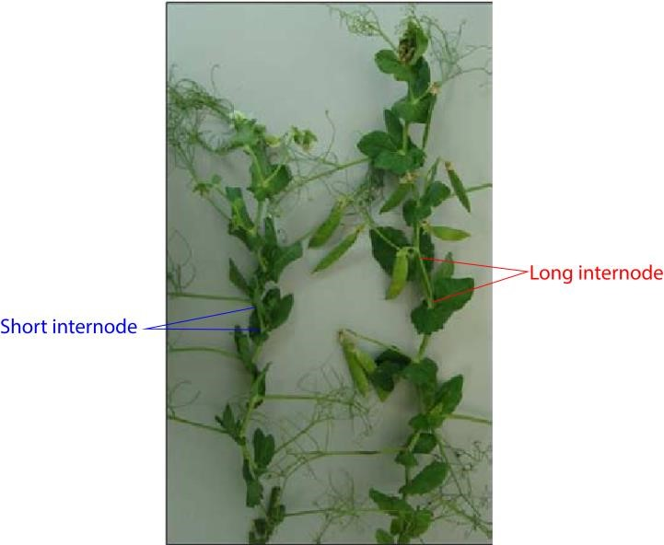
The result of these crosses can be illustrated as follows,

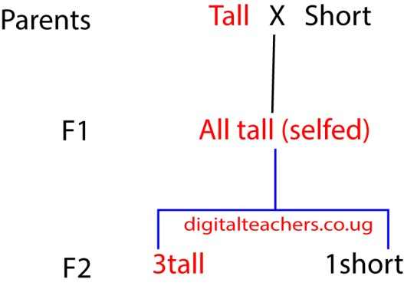

It was concluded from the results that inheritance is a process in which discrete structure or particle (genes) which may or may not show themselves in the outward appearance of the organism are transmitted from parent to off spring.
The evidence of existence of inheritable particles is got from the observation that they can be combined in one generation but separate in the next, as in witness by the recovery of the short form in F2 generation despite its absence in the F1 generation,
The characteristic that show in F1 generation (tallness in this case) is described as being dominant and while that which masked F1 generation (shortness) is said to be recessive.

Genes and their transmission
Genes normally occur in pair each of which is obtained from each parent. The cross of a tall plant and short plant is shown diagrammatically by the two methods below.
The allele for tallness (dominant) character is represented by a capital letter T while the allele for shortness (recessive character) is represented by small letter t. It is assumed that each parent plant contains a pair of identical alleles; TT in case of tall plant and tt in case of short plant.
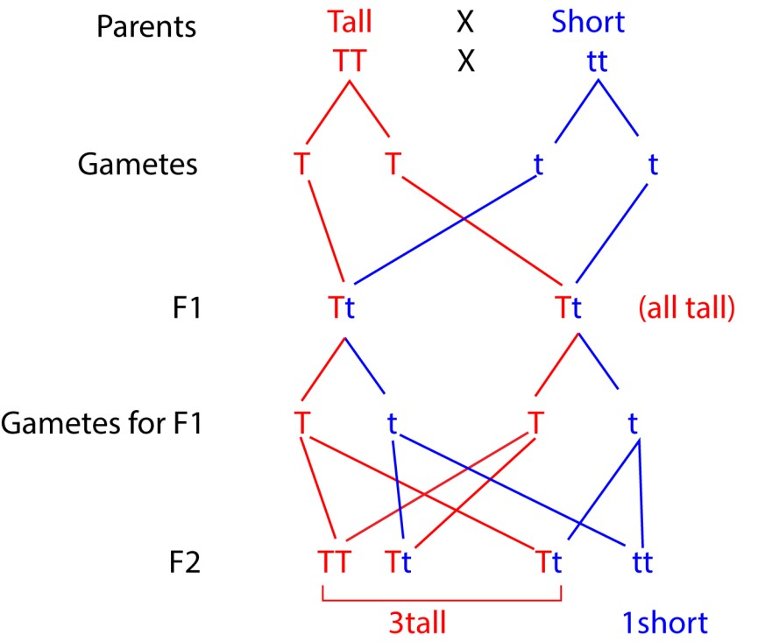

Pannet square to show fusion of F1 gametes

 | ½ T | ½ t
½ T | ¼ TT | ¼ Tt
½ t | ¼ Tt | ¼ tt
In terms of probability, there are 3 chances out of four for a tall plant to appear in F2 generation; and one chance of four for a short plant to appear.

Mendel’s laws of inheritance
Mendel’s first law of segregation states that an organism’s characteristics are controlled by two genes (alleles) and only one can be carried by in a gamete.
Mendel’s second law of Independent Assortment:
During the formation of gametes, alleles in a pair may combine with another allele from another pair randomly.

Stages of meiosis that demonstrate Mendel’s laws of inheritance
Anaphase I of meiosis illustrates Mendel's first law, the law of segregation, because it is the stage where homologous chromosomes, which carry the different alleles for a gene, separate and move to opposite poles of the cell. This physical separation ensures that each resulting gamete receives only one of the two alleles.
Mendel's second law of independent assortment is best illustrated by Metaphase I, Metaphase II, Anaphase I and Anaphase II of meiosis, where the random alignment and separation of homologous chromosome pairs leads to different combinations of alleles. During Metaphase I, homologous chromosomes line up at the metaphase plate in a random orientation, and in
Anaphase I, they are pulled apart to opposite poles. Likewise, during Metaphase II, chromatids (which may have different gene through crossing over) at the metaphase plate orient in a randomly, and in Anaphase I, they are pulled apart to opposite poles. This random orientation and separation is what causes genes on different chromosomes/chromatids to be assorted independently into the resulting gametes.

Breeding True
Phenotypically TT and Tt are the same i.e. Tall. When an organism contains identical alleles like TT and tt is said to be homozygous and with dissimilar allele is heterozygous.
Since the homozygous (TT) and heterozygous (Tt) peas are both tall there is no way we can distinguish between the two genotypes from their external appearance.
One way of establishing whether a given tall plant is homozygous or heterozygous is to selfpollinate it. If the resultant off springs are all tall, we can conclude that the parent has the genotype TT. If, however, we get a mixture of Tall and short plants; the parent plant must have the genotype Tt.
The point is that when an organism which is homozygous at a particular locus is self- fertilized it produce off spring all of which are identical with parent. Exactly the same results occur if organism is crossed with another organism that is homozygous is said to breed true; the organism is said to belong to a pure line for the characteristics in question.

Test crosses
This is the crossing of an individual having homozygous recessive genotype with an individual showing a dormant trait to determine whether that individual is homozygous or heterozygous for the trait.
The homozygous individual produces all offspring having dominant trait while a heterozygous individual produces a mixture of offspring with dominant and recessive traits.

Back cross
This is a cross between hybrids in F1 generation with one of the parents or an organism genetically equivalent to the parents. Back crossing is mainly aimed at increasing the genetic contribution of one particular parent to the off spring.

Monohybrid inheritance human
A number of human conditions are known to be associated with a single pair of alleles which are inherited in Mendelian fashion.

1. Albinism
This is a condition in human beings where the individual fail to produce skin pigments called melanin.
Albinos have;
- Light skin
- White hair
- Pink eyes
- They are sensitive to bright light
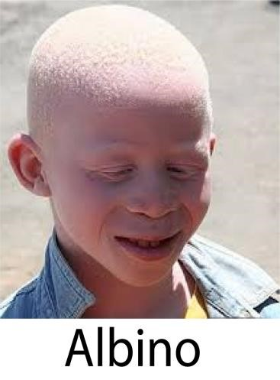
The allele for albinisms is caused by recessive [a] and so only exert its effect in the homozygous state [aa]. The allele for melanin production [A] is dominant.
Suppose a couple each with normal pigmentation have an albino child. For this to happen the child must have [aa]. Therefore, unless for rare mutation, the parents must both heterozygous [Aa] so each produces A and a gametes in about equal number. Therefore, randomly to produce three type of genotype AA, Aa, aa.

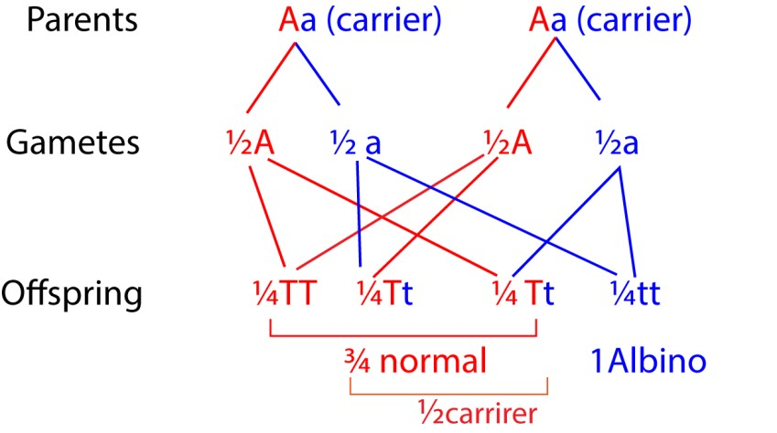

- Congenital disease such as cystic fibrosis in which the connective tissue develops in glands of the body.
- Chondrodystrophic dwarfs are characterized by shortened and deformed legs and arms. It is cause by a dominant gene and hence affect in homozygous and heterozygous state

Heterozygous advantage
Heterozygous advantage is a genetic phenomenon where a heterozygous genotype has a higher relative fitness than either homozygous genotype. This occurs when a combination of two different alleles provides a benefit, such as resistance to a disease, which can maintain genetic variation within a population. A classic example is sickle cell trait, where heterozygous individuals are more resistant to malaria than either homozygous genotype.

Possible reasons why an individual with sickle cell trait show resistance to malaria
- some of their red blood cells have reduced capacity of oxygen that they may not be able to support intracellular parasite
- the sickle shaped have reduced life span to complete the life span of parasite - hemoglobin s may not be digestible

The difference between individuals who have sickle cell anemia and those that have sickle cell trait
Feature | Sickle Cell Anemia | Sickle Cell Trait
Gene Copies | Two copies of the sickle cell gene | One copy of the sickle cell gene
Symptoms | Serious symptoms, chronic anemia, and complications such as strokes and infections | Usually no symptoms
Health Outlook | Can be life-limiting and may lead to organ damage and early mortality | Generally healthy with a normal life expectancy
Risk Factors | Inherited the sickle cell gene from both parents (or one sickle gene and another abnormal gene) | Inherited one normal gene and one sickle cell gene
Complications | Chronic anemia, organ damage, and other serious health problems | Rare complications possible under extreme conditions, such as intense exercise in high temperatures (e.g., heat stroke, muscle breakdown)

Co-dominance
Here, a heterozygous offspring expresses both parental phenotypes at the same time and not a blended mix. Both alleles are fully and equally expressed, and neither is dominant or recessive.
In genetic crosses, the alleles for each trait are represented with different capital letters.
Example: Roan cattle, the "roan" coat color in cattle is a result of codominance, where a cross between a red-coated and a white-coated animal produces offspring with a mix of both red and white hairs, not a blended color.
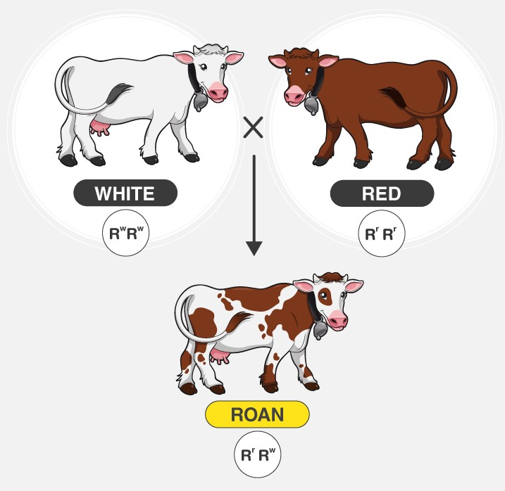

Other examples of co-dominance
- ABO blood group system is codominant; an individual with genotype I^{A}I^{B} will have both A and B antigens on their red blood cells.
- Speckled chickens: When a black chicken is crossed with a white chicken, the offspring are speckled, with both black and white feathers visible on the same bird.
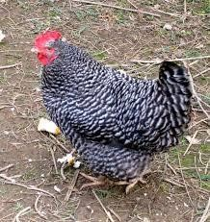
- Rhododendron flowers: When a red-flowered rhododendron is crossed with a whiteflowered one, the offspring can have flowers with distinct patches of both red and white petals, rather than a single blended color.

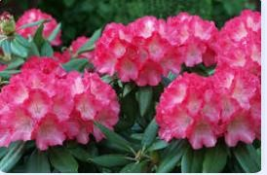
- Sickle-cell anemia: This is a classic example where individuals with one normal allele and one sickle-cell allele produce both normal hemoglobin and sickle-shaped hemoglobin.

Incomplete dominance
A heterozygous offspring has an intermediate phenotype that is a blend of the two homozygous parents. A new, third phenotype is created through blending
Example: A cross between a red-flowered plant (C^{R}C^{R}) and a white-flowered plant (C^{W}C^{W}) produces pink flowers (C^{R}C^{W}).
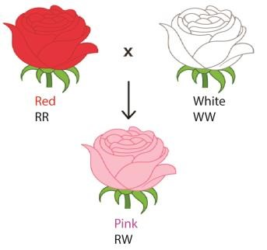

Difference between co-dorminance and incomplete dominance
The main difference is how the heterozygous offspring expresses the alleles from both parents: incomplete dominance results in a blended, intermediate phenotype, while co-dominance results in both parental phenotypes being expressed simultaneously.

Sex determination
The medium size chromosome in drosophila melanogaster determines the individual’s sex for which reason they are called the sex chromosome. In the female the two sex-chromosomes are both rod shaped in appearance and identical; they are known as X-chromosomes. In the male, however the two sex-chromosomes differ from each other one is rod- shaped X-chromosome, the other is hook- shaped and is called Y-chromosome.
The sex chromosomes are exception to the rule that homologous chromosomes are identical in appearance. Being different they are described as heterosomes; while the other chromosomes, which are identical in appearance, are called autosomes.
Despite this difference, the sex chromosomes are transmitted in a normal Mendelian manner as shown below.
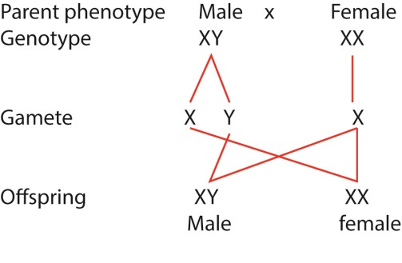
Generally, a female produces only one kind of gamete as the chromosomes are concerned; all her eggs contain an X - chromosome. For this reason, in human and many other species, the female is said to be homogametic (same gametes). A male on the other produces two kinds of gametes as far as sex chromosome are concerned: half of the sperms contain X - chromosome, the other half Y -chromosome. The male is therefore heterogametic (different gametes) on fusing randomly; approximately half the zygotes receive two X chromosome and develop into female, the rest receive Y chromosomes and give rise to males. In some insects, females are XX and male XO

Multiple alleles
Multiple alleles are two or more alternative forms of a gene controlling a particular characteristic, of which any two may occupy the same gene loci on homologous chromosomes. An example of such multiple allele is provided by the alleles controlling the ABO blood group system in humans. The ABO system is controlled by three alleles generally referred to as I^{A}, I^{B}, and I^{O}.
The I^{A} allele is responsible for production of type A antigens in the person’s red blood cells, and the I^{B} allele for type B antigen. The I⁰ produces neither antigen.
But only two of the three alleles can be present at any one time, an individual may thus, possess any of the following six genotype; I^{A}I^{A}, I^{A}I⁰, I^{B}I^{B}, I^{B}I^{O}, I^{A}I^{B}, and I^{O}I^{O}.
I^{A} and I^{B} show equal dominance with respect to one another [i.e. they are codominant] but each is dominant to I^{O} thus;
- A person belongs to blood group A has genotype I^{A}I^{A} or I^{A}I⁰
- A person belongs to blood group B has genotype I^{B}I^{B} or I^{B}I^{O}
- A person belong to blood group AB has genotype I^{A}I^{B}
- A person belongs to blood group O has genotype I^{O}I^{O}
The fact that there more than two alleles responsible for determining the blood group makes no difference to their transmission, which take place in a normal Mendelian fashion.
Thus, a child whose parents are both blood group O must be group O. However, a parent with blood A or B, the child may have any of the blood group has shown below.

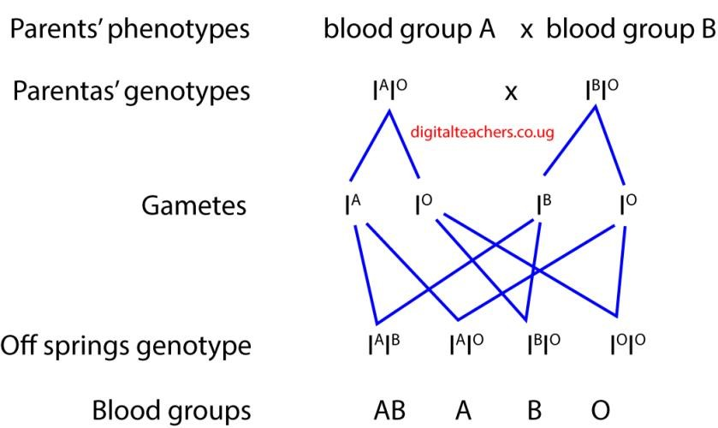

Dihybrid inheritance
This is the inheritance of 2 pairs of characteristics. It’s characterized by a phenomenon called independent assortment i.e. each of the alleles of one gene may combine independently with each of the alleles of another gene.
For instance, when a pure breed tall pea plant possessing purple flowers was crossed with a short plant possessing white flowers and the F1 generation plants were tall and had purple flowers.
These were self-pollinated, in F2 generation there were four different phenotypes observed; tall plants with purple flowers, tall plants with white flowers, short plants with purple flowers and short plant with white flowers.
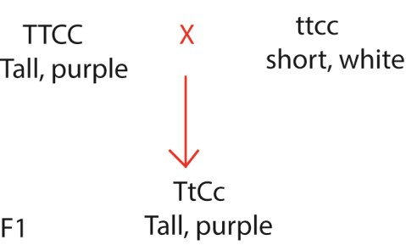

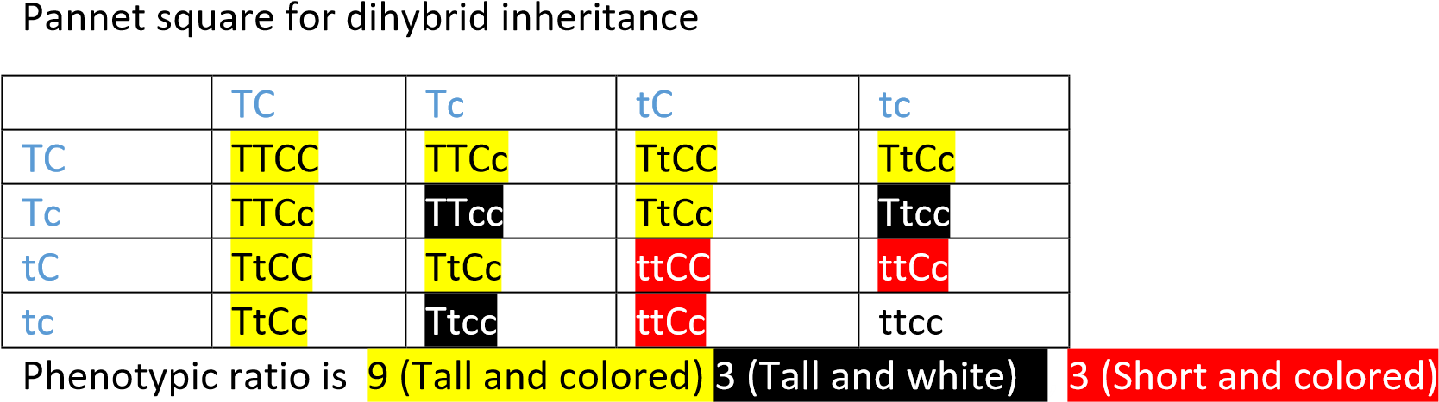

Modification of the ratio 9: 3: 3: 1. in F2 generation in hybrid inheritance or exceptions to Mendelian inheritance
The following do not conform to the process of inheritance as illustrated by Mendel.
- Incomplete dominance.
- Co-dominance 3. Multiple alleles
- Epistasis.
- Linkage

Epistasis
This s a condition where one gene on a different chromosome interacts or modifies or masks the action of another gene.
Example;
- Gene T on chromosome 9 of gives a pigment that is brown and gene C on chromosome 7 gives the same pigment but when gene T and C are both present they give another pigment purple.
Assuming that Brown dominant to purple what would be the phenotypic ratio of the off spring.
A – B purple 9
A – bb brown 3 Phenotypic ratio: 9: 6: 1 aa-B brown 3
aabb colorless 1
- Gene T on chromosome 2 given an eyeless drosophila whereas gene C on chromosome 4 gives a brown eyed drosophila. What would be the phenotypic. A-B eyeless 9 A-bb eyeless 3 aa-B Brown 3 aa-bb colorless or white- 1
Phenotypic ratio:
Eyeless brown another color
12 :3 :1
- Dominant complementary genes
This is where gene T and C are necessary for the color to be expressed.
A-B 9 colored A-bb 3 colorless aa-B 3 colorless aabb- 1coluorless

Ratio colored 9: colorless; 7
- Recessive complementary gene; is where the recessive alleles must be together before a pigment is formed Ratio 15: 1
- Gene G in a mouse give a grey coat while gene B in mice give a black coat. But when both gene occur G is epistatic to B find the phenotypic ratio.
G-B 9 grey
G-bb 3grey
gg-B black
ggbb | 1 any other time
Ratio | Grey 12
black 3 colorless 1
- In maize a gene C is necessary for coloration of the grain while gene P gives purple color to the grain and its recessive gives a red color. Find the phenotypic ratio

C-P 9 purple Phenotypic ratio
C-pp 3 red purple : red :colorless Cc-P 3colourless 9 : 4 : 3
ccpp 1 red .

Gene linkage & chromosomes
Gene linkage is the existence of many genes as a unit and not as separate individuals. Linked genes occur on the same chromosome and will always segregate together during meiosis and gamete formation.

Dihybrid inheritance and linked genes
In Drosophila melanogaster [fruit fly] Broad body B is dominant to narrow body [b] and normal sized wing A is dominant to vestigial wing.
When homozygous dominant drosophila for the 2 characters was crossed with a homozygous recessive for the two characters above mentioned, all the F1 generate drosophila were grey bodied with normal wings.
When two of F1 generation flies were mate the F2 generation failed to yield 9: 3: 3: 1 ratio we expected. Instead about ¾ of the off spring had long wings and broad body and nearly the remaining flies about ¼ of the total had vestigial with and narrow body.
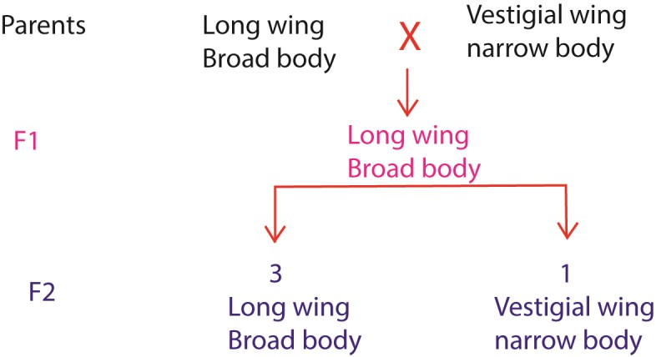
The explanation is that the gene determining the length of the wings and the width of the abdomen are located on the same chromosome. This results in their being transmitted together. Such genes are said to be linked and the general phenomenon is known as gene linkage
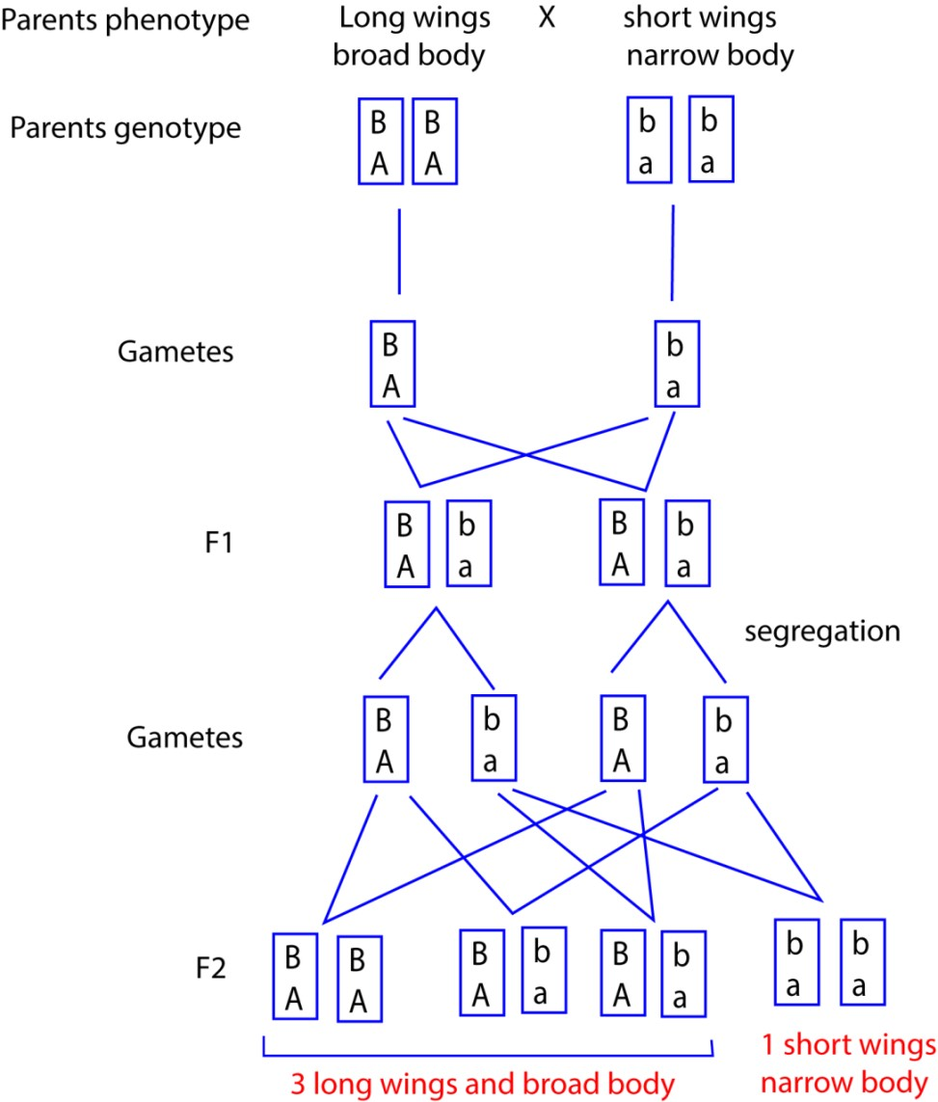

Sex linkage
Sex linked characters are those whose genes that are carried on sex chromosomes usually Xchromosomes and is inherited along with sex for examples:
- Red-green color blindness the decreased ability to see color or differences in color. Simple tasks such as selecting ripe fruit, choosing clothing, and reading traffic lights can be more challenging. People with total color blindness (achromatopsia) may also have decreased visual acuity and be uncomfortable in bright environments
- Hemophilia
Symptoms of hemophilia are
  - Unexplained and excessive bleeding from cuts or injuries, or after surgery or dental work
  - Many large or deep bruises
  - Unusual bleeding after vaccinations
  - Pain, swelling or tightness in your joints
  - Blood in your urine or stool

- eye color in drosophila

Transmission
Hemophilia can be represented as follow
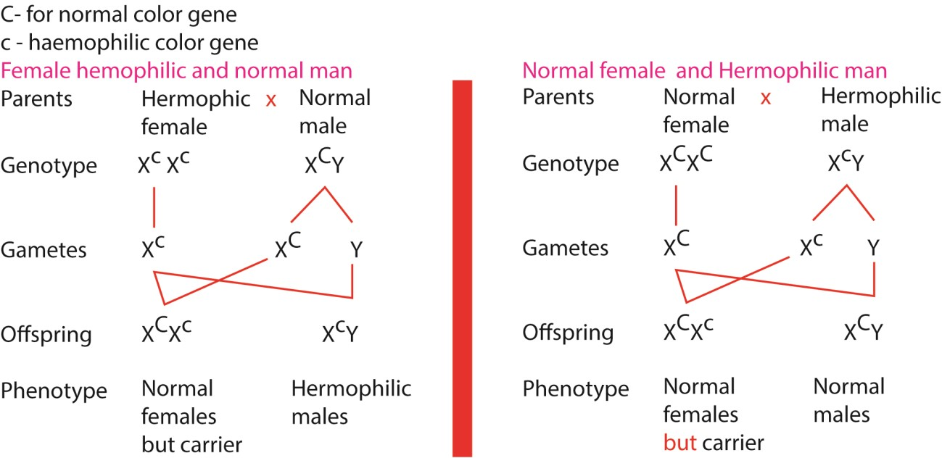

Reasons why there are more color-blind individuals than hemophilic among the population in

spite of similar way of transmission
- Mutations leading to color blindness are more frequent than those leading hemophilia
- Hemophilic victims are less likely to survive compared to colorblind victims because excessive bleeding is fetal.
The Y-chromosome.
- If a sex-linked trait is associated exclusively with Y-chromosome, it is expected to show up exclusively in males. In general, most Y-chromosomes are empty. However, the ‘porcupine’ man is said to have transmitted hard and spine skin exclusively to his male children.
- The hairy pinna or ear is a characteristic common in India and it is transmitted to male off spring only.
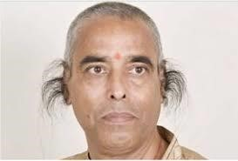

Reasons why colorblindness is more common than hemophilia in the population
- Mutations leading to color blindness are more frequent than those leading hemophilia
- Hemophilic victims are less likely to survive compared to colorblind victims because excessive bleeding is fetal (historically) while colorblindness has minimal effect on life expectance.

Sex limited characters
These are characters that that show up exclusively in one sex only e.g. ovary in female

Note: A sex – limited character is one which is controlled by a gene located on any chromosome but expresses itself in only one of the two sexes.

Crossing over
In maize smooth kennels are dominant to shrunken ones and colored kennels are dominant to colorless. The gene for texture and color are linked. When a maize plant homozygous for kennel which are Smooth and colored is crossed with that with shrunken and colorless kennels; F1 generation yields all colored smooth kennel. However, F2 generation contains small proportions of maize with smooth and colorless or colored and shrunken kennels as opposed to what is expected,
These small proportions are explained by cross over; During prophase 1in meiosis, homologous chromosomes become intertwined and at chiasmata chromatids break and rejoin. The result is that portions of the chromatids belonging to the two homologous chromosomes change places taking their alleles with them, So the chiasmata result in crossing over.

Crossing over value

Lethal alleles
Lethal alleles are alleles or a combination of alleles that cause the death of the organism that carries them. They are usually a result of mutations in genes that are essential for growth or development. Lethal alleles may be recessive, dominant, or conditional depending on the gene or genes involved.
Example of lethal alleles are YY genotype in the color inheritance in mice.
Yellow furs are dominant to grey. If a pair or yellow mice are mate, the results are always the same i.e.2:1 instead of 3: 1 because homozygous individual for yellow die off before birth. i.e. genotype YY present a lethal combination of genes.
This has to been confirmed
- the present or dead embryo in the uterus
- the yellow mice do not breed true i.e., crossing yellow mice with yellow mice does not produce exclusively yellow mice.

Evolution—History of life
Evolution is the process by which new species are formed from pre-existing one over a long period of time. It is believed that life exists only on earth of all planets.

Theories for origin of the earth
- Stead – state. Cosmologist maintain that the earth and universe never had origin, has always been able to support life, has change remarkably little if at all, and that the has 5,000 x10⁶ years based on radioactive decay rates.
- Other hypothesis suggest that the universe may have begun as a ball of neutrons exploded in a ‘big bang’ emerged from one of several black holes
- It was a design of a creator.

Theories for origin of life on earth
- Special creation; life was created by a supernatural being at a particular time. Genesis 1; 1- 26
- Spontaneous generation; life arose from non- living matter on numerous occasions.
- Steady- state. Life has no origin
- Cosmozoan; life arrived on this planet from elsewhere.
- Biochemical evolution; life arose according to chemical and physical laws.

Modern view
Modern geologists believe the earth is over billion years old. They speculate that the mountains deserts and oceans of today formed from slow, gradual but continuous process of erosion and uplifting. The about 3.5 billion year ago, life began From simple unicellular organism, new life forms arose and changed in response to environmental pressures producing the past and present biodiversity [evolution]

Theories of evolution
Evolution is an overall gradual development which is both ordered and sequential. In terms living organism it may be defined as; the development of differentiated organism from preexisting less differentiated organism over the course of life.

Lamarckian theory
The French biologist Lamarckian proposed, in 1805 a hypothesis to account for the mechanism of evolution based on two conditions; the use and disuse of parts and inheritance of acquired characteristics. Changes in environment may lead to changed pattern of behavior which necessitate new increase use or disuse of certain organism /or structure. Extensive use would lead to increased size and or efficiency whilst disuse would lead to degeneracy and a trophy. These traits acquire during the lifetime of individual were believed to be heritable and thus transmitted to off spring.
According to Lamarckism, as the theory came be to known, the long neck and legs of the modern giraffe were the results of generation of short necked and legged giraffe ancestor feeding on leaves at progressively higher levels trees. The slightly longer necks and legs produced in each generation were passed on the subsequent generation until the size of the present-day giraffe was reached.

Darwin, Wallace and the origin of species by natural selection
Darwin and Wallace proposed that natural selection is the mechanism by which new species arise from pre-existing species. This hypothesis / theory is based on three observations and two deductions which may be summarized as follows:
Observation 1: Individuals within a population have a great reproduction potential, e.g., American oyster produces 10⁶ eggs per season.
Observation 2: The number of individual in a population remain approximately constant.
Deduction 1: Many individuals fail to survive or reproduce. There is a ‘struggle for existence’ with the population
Observation 3: Variations exists within all populations.
Deduction 2: In the ‘struggle for existence’ those individuals showing variation best adapted to their environment have a ‘reproductive advantage’ and produce more off spring than less adapted organism.

Natural Selection
This is a natural mechanism by which those organisms which appear physically, physiologically and behaviorally better adapted to the environment survive and reproduce. Those organisms not so well adapted fail to reproduce or die. The former organisms pass on their successful characteristics to the next generation.

Variation
Variation refers to any differences in traits/characteristics among individuals of the same species, stemming from genetic (genotypic) or environmental factors.

Types of variation
1. Continuous variation.
Variation is said to be continuous when there is a gradual change of character from one individual to another of the same population e.g. skin color, length of leaves, and height of individuals. I.e., it is quantitative.

2. Discontinuous variation
In discontinuous variation, there is a clear – cut difference between the characteristics of individuals of the same population e.g. blood groups, tongue- rolling, sex (male or female) etc.

The importance of variation in a population
Variation is the raw material for evolution, providing the diverse traits within a population that natural selection acts upon, allowing species to adapt to changing environments, resist diseases and pollution, and ultimately survive, evolve and increase their chances to survive in different habitats/environment, Without variation, there would be no differences for advantageous traits to be selected for, and populations would struggle or fail to adapt to new challenges, increasing their risk of extinction.

Role of environment in the process of natural selection
The environment is the primary driver of natural selection by creating selective pressures (like predation, resource scarcity, or climate) that favor certain inheritable traits (adaptations) over others. These environmental factors determine which existing genetic variations within a population are beneficial, harmful, or neutral, ultimately influencing which organisms are more likely to survive and reproduce, thereby shaping the genetic makeup of future generations.

Importance of natural selection
- May lead to emergence of new species.
- leads constant improvement of the population to better species
- population size in given environment is regulated to supportable limit.
- Eliminate undesirable genes from population - Reduces competition for natural resources.

Types of selection
Three types of natural selection
- Directional selection
- Stabilizing selection
- Disruptive selection

1. Directional selection occurs when an extreme phenotype is favored. Such a shift occurs when a population is adapting to changing environment.

Examples of directional selection
- Industrial melanism; the gradual increase in darkened peppered moth with increasing pollution that accompanied the industrial revolution in UK. The darkened walls and tree trunks due to shoot, favored the darker moths that could camouflage from predators and their population increased.
- Antibiotic Resistance: The widespread use of antibiotics has created a strong selective pressure against bacteria with less resistance. Over time, this has favored the survival and reproduction of bacteria with stronger resistance, shifting the population's genetic makeup.
- Darwin's Finches: On the Galapagos Islands, a drought that led to a shortage of smaller seeds favored finches with larger, stronger beaks that could crack the larger, harder seeds that remained.
- Giraffe Necks: Giraffes with longer necks can reach higher leaves, giving them a food advantage over shorter-necked individuals. This has led to a long-term directional selection for longer necks in the species, as seen in the fossil record.
- Long-tailed Widowbirds: In this species, females prefer to mate with males that have unusually long tails. This has led to directional selection for longer tails in males, increasing the average tail length in the population over time.
- The gradual increase in size of a modern horse with change in environment from forest-like [which required penetration of thicket] condition to grass land [which required escape from the predator] conditions.

2. Stabilizing selection occurs when an intermediate phenotype is favored. It can improve adaptation of a population for those aspects of the environment that remains constant. With stabilizing selection extreme phenotypes are selected against and individuals near the average are favored.

Examples of stabilizing selection
Human birth weight: Babies with extremely low or high birth weights have lower survival rates. Low weight can lead to health complications, while high weight can cause difficult deliveries for the mother. A moderate weight is therefore selected for.
- Bird clutch size: A small number of eggs may lead to insufficient offspring to survive, while a large number can lead to starvation due to the parents' inability to feed all the chicks. This results in a population stabilizing on an intermediate clutch size.
- Animal coat coloration: For many species like mice or squirrels, a coat color that is an intermediate shade between too dark and too light provides the best camouflage against predators in their environment.
- Plant height: Medium-sized plants are favored over very tall or very short ones. Tall plants may be more susceptible to wind damage, while very short plants may not get enough sunlight.
- Cactus spine density: Cacti with too few spines are more vulnerable to herbivores, while those with too many can obstruct their own sunlight, reducing photosynthesis. A moderate density is therefore favored.

3. Disruptive selection; Here two or more extreme phenotypes are favored over any intermediate phenotype. Fluctuating condition in an environment, say associated with season and climate may favor the presence of more than one phenotype within a population. Selection pressure acting from with in the population as a result of increased competition may push the phenotype away from the population mean towards the extremes of the population.
- Peppered Moths: In industrial areas, dark moths are favored because they can camouflage against soot-covered trees, while in rural, non-polluted areas, lightcolored moths have the advantage. Moths with intermediate colors are more visible to predators in both environments, leading to their decline.
- Darwin's Finches: On the Galápagos Islands, different finch populations have evolved with beaks adapted to different food sources. For instance, some have large beaks for cracking hard seeds, while others have small beaks for eating insects. Finches with intermediate beak sizes are less efficient at both tasks and are less likely to survive.
- Mexican Spadefoot Toad Tadpoles: Tadpoles that can develop into either largebodied, carnivorous forms or small-bodied, omnivorous forms thrive. Tadpoles with intermediate diets and body sizes face more competition for resources and have lower survival rates.
- Lazuli Buntings: In certain habitats, both the dullest and the brightest yearling male buntings have an advantage in attracting mates. Adult males may tolerate or avoid the dullest males, while they tend to leave the brightest males alone. Yearlings with intermediate plumage are more likely to be attacked and fail to establish territories.
- Oysters: Oysters with light coloration can blend in with sandy shallows, while darkcolored ones can camouflage in deeper, shadowy water. Oysters with medium coloration are more visible against both backgrounds and are therefore more vulnerable to predators.
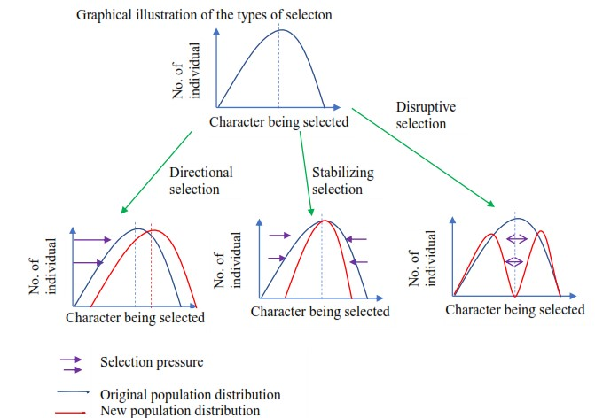

Effects of disruptive selection
(i) It split the population into two subpopulations, each which may give rise to a new species (ii) It can lead to appearance of different phenotypes within the population, i.e. polymorphism.

Ways by which Humans influence evolution
A. Habitat alteration
- Urbanization: New environments like cities can favor species that can adapt to them, such as rats and pigeons.
- Agriculture: The use of pesticides and herbicides creates intense selection pressure for resistance in weeds and insects.
- Deforestation: Removing forests causes habitat loss, which can drive some species to extinction and favor others that can survive in a more fragmented environment.

B. Direct selection
- Hunting and fishing: These activities select for individuals that are harder to catch, such as smaller fish that are more difficult to hook or animals that are less aggressive.
- Medical interventions: The widespread use of antibiotics has led to the evolution of antibiotic-resistant bacteria, a significant public health concern.
- Genetic modification: Humans are directly changing the genetic makeup of species through selective breeding and genetic engineering, which is a form of artificial selection.
- Artificial selection: Human beings are able to select and allow breeding of animals or plants with characteristics at the expense of others. This may lead to emergence of bred animals or plants with the desired characteristics and extinction of the others.

C. Indirect selection
- Climate change: The warming climate is causing changes in ecosystems, such as earlier spring thaws, which can lead to a mismatch between the timing of breeding and food availability, placing pressure on populations.
- Invasive species: Humans have introduced many species to new environments, which compete with native species for resources and can alter the evolutionary trajectory of native populations.
- Pollution: Chemical and other pollutants can impose strong selective pressures on organisms, favoring those that can tolerate or metabolize the pollutants.

Causes of bacterial resistance to chemicals
- Mutations: Random changes in a bacterium's DNA can make it less vulnerable to a chemical. This often happens during reproduction, especially when the bacteria survive initial exposure.
- Gene transfer: Bacteria can share resistance genes with one another through a process called horizontal gene transfer.
- Plasmids: These are small, circular pieces of DNA that can be transferred between bacteria.
- Transposons: These "jumping genes" can move resistance genes from one piece of DNA to another.
- Target site modification: Bacteria can alter the specific site where a chemical normally binds, such as a protein or ribosome, making the chemical ineffective.
- Efflux pumps: Bacteria can develop pumps that actively transport a chemical out of the cell before it can cause harm.
- Enzymatic inactivation: Some bacteria produce enzymes that can break down or alter the chemical, rendering it inactive.

Solution to bacterial resistance
- developing new drugs/chemicals,
- using chemicals in combination
- reducing unnecessary use of antibiotic, pesticides and chemicals
- using alternative treatments like bacteriophages and antimicrobial peptides,
- combining existing drugs with enzyme inhibitors,
- and preventing the spread of resistance through better hygiene, vaccination, and responsible antibiotic use.

Possible causes of malaria resistance
- Failure of the parasite to absorb the drug
- Formation of inaccessible forms during its development life cycle in man (tissue hypnozoites)
- Parasite may use alternative biosynthetic pathway not affected by the drug.
- The parasite tissue may become tolerant to drug molecules (v) Parasite may produce an enzyme that destroys the drugs

Polymorphism
This is the existence of many forms of the same population and can be applied to biochemical morphological and behavioral characteristics e.g., land snail cepaea nemoralis, the shell species may be yellow, brown or various shades

Types of polymorphism
- Transient polymorphism: This arises when different forms or morphs, exist in a population undergoing a strong selection pressure. The frequency of the phenotypic appearance of each form is determined by the intensity of selection pressure, e.g., melanic and non-melanic form of peppered moth. Transient polymorphism usually applies in situation where one form is gradually replaced by another
- Balanced polymorphism. This occurs when different forms co-exist in the same population in a stable environment. E.g.
(i) Existence of the two sexes in animals and plants (ii) Existence of A, B, AB and O blood group in human.

Causes of variation
Variations are caused by both genetic and environment differences. From the evolution point of view genetic variations are more important because they can be transmitted from parents to off springs.

The causes of genetic variations

1. Gene reshuffling
a. Independent assortment of genes at meiosis I allow gene reshuffling in in two ways
- Orientation on the equator in metaphase I: During metaphase I of the first meiotic division homologous chromosomes came together in pairs and subsequently segregate into a daughter cells independently of each other. The result of this independent assortment is the production of the wide variety of different gametes depending on which particular chromosome end up with one another in each cell.
- Crossing over: In prophase of the first meiotic division, homologous chromosomes came together and make intimate contact with each other. Chromatid of homologous chromosome may break and rejoin at any place called chiasmata. b. Fertilization
Union of gametes at fertilization results in alleles present in one gamete being united with alleles in another. If a population consists of large number of out breeding individual, the amount of variation that may result from this is again virtually infinite.
Despite the tremendous amount of variation these three processes may generate, they play only a limited role in evolution. The reason is that although they may establish a new combination of alleles in one generation, they do not generate long lasting variation of a novel kind.

2. Mutation
This is a change in the amount or structure of DNA of an organism. This produces a change in the genotype which may be inherited by cells derived by mitosis or meiosis. Individuals showing the new characteristics are referred to as mutants. Mutants arise spontaneously and in no sense ‘directed’ by the environment, although the environment greatly influence the mutation rate.

Types of mutation

1. Chromosomal mutation
This may be the result of changes in the number or structure of chromosomes

a. Change in number of chromosomes.
This is usually due to errors occurring during meiosis and mitosis. The changes may involve the loss or gain of single chromosome a condition called Aneuploidy or the increase in entire haploid set of chromosomes a condition called euploidy[polyploidy]

Aneuploidy
In this condition where half of the daughter cell produced have an extra chromosome [n + 1], [2n + 1] and so on, while the other half have a chromosome missing [n- 1], [2n- 1] and so on.
An aneuploidy can arise from the failure of a pair or pairs of homologous chromosome to separate during anaphase 1 of meiosis. If this occurs both sets of chromosomes pass to the same pole of the cell and separation of homologous chromosomes during anaphase II may lead to information of gametes containing either one or more chromosome too many or too few. This is known as non-disjunction.

Examples of Conditions caused by non-disjunction in man
Autosomal conditions (affecting non-sex chromosomes)
- Down syndrome: Trisomy of chromosome 21, resulting in an extra copy of chromosome 21 (47 chromosomes). Down syndrome is characterized by mental retardation, reduced resistance to disease, congenital heart abnormalities a short stocky body and thick neck and the characteristic fold of skin over the inner corner of the eyes.
- Edwards syndrome: Trisomy of chromosome 18, meaning an extra copy of chromosome 18 (47 chromosomes). Have physical characteristics like a clenched fist with overlapping fingers, a small head with a prominent back, low-set ears, and a cleft lip or palate. Other common signs are heart defects, developmental delays, low birth weight, and problems with the heart, kidneys, and digestive or respiratory systems.
- Patau syndrome: Trisomy of chromosome 13, resulting in an extra copy of chromosome 13 (47 chromosomes). Characterised by physical abnormalities like a small head, cleft lip and/or palate, small or absent eyes, and extra fingers or toes

Sex chromosome conditions
- Klinefelter syndrome: Occurs in males who have an extra X chromosome, leading to an XXY karyotype (47 chromosomes).
- Turner syndrome: Affects females who have only one X chromosome instead of the usual two, resulting in a monosomy X karyotype (45 chromosomes).
- Trisomy X syndrome: Occurs in females who have an extra X chromosome, resulting in an XXX karyotype (47 chromosomes).
- XYY syndrome: Occurs in males who have an extra Y chromosome, leading to a 47, XYY karyotype.

b. Polyploidy
This occur when there is an increase in the entire haploid sets of chromosomes; i.e., 3n triploid], 4n [tetraploid]
Polyploidy is rare in animals but common in plants. Polyploidy is often associated with advantageous characteristics such as increased sized and greater, hardness of seeds, though such advantages are sometimes offset by reduced fertility.

Artificial method of inducing polyploidy
Polyploidy is sometimes induced by colchicine an alkaloid substance extracted from the crocus colchicum.

c. Structural change in chromosomes
These include loss, multiplication or changes in the sequence of bases on a chromosome
- Deletion; This involved loss of a piece of chromosome together with its genes.
- Inversion; Here a chromosome breaks in two places and the middle piece then turns around and joins up again so that the normal sequence of gene is reversed.
- Translocation; a section of one chromosome break off and becomes attached to another chromosome.
- Duplication; a section of a chromosome replicates so that a set of gene is repeated.

d. Gene mutation
Gene mutation arises as a result of a chemical change in an individual gene and it ‘s thought to be very important in generating evolutionary change. An alternation in a sequence of nucleotide in a gene may change the order of amino acids making proteins. This may affect the fitness of the organism. It includes.
(i) substitution; here one base is substituted with another e.g., sickle cell anemia (ii) insertion; here an extra base nucleotide is inserted into the genetical code.
- deletion; here a base is lost from the genetic stand
- There may be a change in the sequence of nucleotides in the gene

e. Somatic mutation.
Here mutation in non-reproductive cells of an organism. The resulting genetic change will present in all descended cells from the original mutant cell and may have profound effect of individuals.
However, as the genetic change is only in non-reproductive cell, it cannot be transmitted to feature generation.

Gene pool
A gene pool is the stock of different genes in an interbreeding population
Species with small gene pools may be easier to wipe out due to a natural event that favors one trait over the other. A large gene pool means variety of genes which prevents this.
The composition of gene pool may be constantly changing from generation to generation as a result of natural selection or may be static in a stable environment.

Allele frequency
This is the fraction of organisms in a population carrying a particular allele.

Genotype frequency
This is the fraction of organisms in a population carrying a particular genotype. The frequency of dominants and recessive allele in a population will remain constant from generation to generation provided the following conditions exist.
i. The population is large ii. Mating is random iii. No mutation occurs
- All genotype is equally fertile so that, no selection occurs
- There is no emigration or immigration from and into the population, that is, there is no gene flow between population.

Any change in allele or genotype frequencies must therefore result from the alteration of one or more of the condition above. These are factors that significant in producing evolutionary a
Factors producing change of genotype are allele in population.

1. non- random breeding
Nonrandom mating occurs when the probability that two individuals in a population will mate is not the same for all possible pairs of individuals. This can happen when individuals prefer mates with particular traits (sexual selection), have limited options due to physical accessibility, or mate with relatives (inbreeding) or distant relatives
(outbreeding). Non-random mating changes genotype frequencies, disrupts HardyWeinberg equilibrium, and can influence evolution by reinforcing advantageous traits or creating reproductive isolation
Examples of nonrandom mating;
- Inbreeding - individuals are more likely to mate with close relatives (e.g. their neighbors) than with distant relatives.
- Large blister beetles tend to choose mates of large size and small blister beetles tend to choose small mates

Genetic drift
This refers to the fact that variation in gene frequencies with populations can occur by chance rather than by natural selection. E.g., chance events such as premature accidental death prior to mating of an organism in a small population which is the sole possessor of a particular allele would result in the elimination of that allele from the population.
This process can lead to the loss of some alleles and the increase of others, reducing overall genetic variation. Its effects are most significant in small populations and can be caused by random events like the bottleneck effect (a drastic population reduction) or the founder effect (the isolation of a small group from a larger population).
Genetic drift in small populations has several key consequences that alter gene frequencies:
- Loss of genetic diversity: Genetic drift is a directionless process that leads to the loss of genetic variation over time. Alleles are randomly lost or fixed (reaching 100% frequency), which reduces the population's ability to adapt to new environmental pressures.
- Fixation of alleles: An allele can become "fixed" in a population, meaning all individuals carry that allele, and all other variants are lost. This can happen rapidly in small populations. In some cases, a harmful allele may become fixed by chance, negatively impacting the population's fitness.
- Increased homozygosity: As a result of lost genetic diversity, the proportion of homozygous individuals (having two identical alleles for a trait) increases.
- Increased inbreeding: Mating among close relatives is more likely in small, isolated populations. This increases the chance that offspring will inherit two copies of the same recessive deleterious alleles, which can lead to "inbreeding depression" and reduced fitness.

Genetic load
This is the existence within a population of disadvantageous alleles in heterozygous genotype e.g. sickle cell trait in region where malaria is endemic.
Or
Genetic load is the reduction in a population's average fitness compared to the best possible genotype, caused by the presence of deleterious alleles.
Genetic load can be a result of several factors, including new mutations (mutational load), changes in the environment (substitutional load), and inbreeding (segregational load).

Gene flow
Gene flow is the transfer of genetic material from one population to another, occurring through the movement of individuals and their subsequent interbreeding. This process can introduce new alleles into a population, increasing genetic diversity and influencing evolution. Gene flow can be hindered by physical barriers, but it plays a vital role in adapting species and is a key factor in conservation efforts.

Heterozygotes as a reservoir of genetic variation (the Hardy-Weinberg principle)
For a particular character in a population, the dominant form expresses itself more often that a recessive form, for example normal skin color is more common than albino. In a large population, proportion of dominant allele and recessive alleles of a particular gene remain constant. It is not altered by interbreeding. This constancy is known as the Hardy-Weinberg principle is expressed by a mathematical law
P² +2pq+ q² =1
Where p = frequency of allele for dominant character
q = frequency of allele for recessive character
The formula can be used to calculate the frequency of any allele in the population. For example, imagine that a particular metal defect is the result of a recessive allele. If the number of babies born with the defect is 1 in 20000, the frequency of the allele can be calculated as follow:
The defect will only express itself in individual who are homozygous recessive. Therefore, the frequency of these individuals (q²) = 1/20000 = 0.00005
The frequency of the allele q = √0.00005 = 0.007
Since p + q = 1
The frequency p of the dominant allele = 1- 0.007 = 0. 997
From the Hardy-Weinberg formula, the frequency of heterozygotes is 2pq
i.e., 2 x 0.997 x 0.007 = 0.014
In other words, 14 in 1000 or 280 in 20000 are carriers (heterozygotes) of allele.
This means that in a population of 20000 individual, one individual will suffer the defect and about 280 will carry the allele. The heterozygotes are acting as a reservoir of the alleles, maintain it in the gene pool. As these heterozygotes are normal, they are not specifically selected against, and so the allele remains. Even if the defective individuals are selectively removed, the frequency of the allele will hardly be affected. In our population of 20000, there is one individual who has two recessive alleles and 280 with one recessive allele- a total of 282. The removal of the defective individual will reduce the number of alleles in the population by just 2, to 282. Even with the removal of the defective individual, it would take thousands of years just to halve the allele’s frequency.
Occasionally, as the sickle cell anemia the heterozygotes individual have a selective advantage. This is known as heterozygote superiority.
Conditions that allow Hardy-Weinberg principle to be true
- No mutation
- The population is isolated i.e. there in no immigration or emigration
- There is no natural selection or individuals are equally fertile
- The population is large and mating random

How migration affects genotype frequencies
- Introduces more copies of genes in the population increasing the proportion of certain gene the population
- Introduces new genes in the population that have risen by mutation of these new have a selective advantage, then their proportion in the population increase
- Leads to loss of genes from the population reducing their proportions and may lead to total loss of genes from a small population if the one/few individuals that possess a certain gene vacates. This reduces the proportion of the lost genes to zero.

Ways of upsetting genetic equilibrium
- Mutation: Any sudden, heritable change in the DNA sequence creates new alleles, directly altering the genetic makeup of a population and changing allele frequencies.
- Natural Selection: When certain genetic variations provide a survival or reproductive advantage, individuals with those traits pass them on more frequently, increasing the frequency of their alleles in the next generation.
- Gene Flow (Migration): The movement of individuals (and their genes) into or out of a population introduces or removes alleles, respectively, thereby changing the allele frequencies.
- Genetic Drift: Random fluctuations in allele frequencies, particularly significant in small populations, can lead to some alleles being lost and others becoming fixed by chance.
- Non-random Mating: When individuals choose mates based on specific traits (like assortative mating or inbreeding), it changes the distribution of genotypes, even if the overall allele frequencies remain the same.
- Large Population Size (Absence of Drift): While not a disruptive force itself, the lack of a sufficiently large population size allows genetic drift to have a greater impact.

Speciation
Speciation is the formation of new and distinct species in the course of evolution.

The main types of speciation are allopatric and sympatric, which are categorized by the degree of geographic isolation between populations. Allopatric speciation involves geographic barriers, while Sympatric speciation occurs when new species arise within the same geographic area, often due to factors like polyploidy or changes in habitat or food preferences.
Speciation will only occur as a result of the formation of barrier which leads to reproductive isolation between members of the population.

Isolation mechanisms
An isolating mechanism is a mean of producing and maintaining isolation within a population. This can be brought about by mechanisms acting before or after fertilization.

(a) Prezygotic mechanism [barrier to the formation of hybrids]
- Seasonal isolation; occurs when two species mate or flower at different time of the year/season that do not overlap. E.g., California Pinus radiata flowers in February whereas Pinus attenuata flowers in April
- Geographic isolation: Physical separation by barriers like mountains or oceans.
- Ecological isolation; occurs where two species inhabit the similar regions but have difference habitat preference e.g., Viola arvensis grows on calcareous soil whereas viola tricolor prefers.
- Behavioral isolation; occurs where animals exhibit courtship patterns, that attract one individual for sex but not another.
- Mechanical isolation; occur in animal where difference in genitalia prevent successful copulation and in plant where related species of flower are pollinated by different animals.

(b) Postzygotic mechanism [barrier affecting hybrids]
- Hybrid in-viability; Hybrid are produced but fail to develop to maturing. E.g. hybrid formed between northern and southern race of the leopard frog [Rana pipens] in North America.
- Hybrid sterility; hybrid fail to reproduce functional gametes; e.g., the male [2n= 63] result from the cross between the horse [Equus hernionus 2n = 66]
- Hybrid breakdown; F1 hybrid are fertile but the F2 generation and back crosses between F1 hybrid and parental stock fail to develop or and infertile i.e., hybrid formed between species [genus Gossypium].

Contributions of isolation mechanisms to evolution
- Promoting speciation: By preventing interbreeding, isolation mechanisms allow populations to accumulate unique genetic changes over time. Eventually, these differences can become so significant that the populations are considered separate species.
- Maintaining species integrity: They act as barriers to gene flow, ensuring that the genetic integrity of distinct species is maintained by preventing the mixing of their gene pools.
- Enabling adaptation: Isolation, whether geographic or behavioral, allows populations to evolve in different environments with different selective pressures, leading to different adaptations and increased biodiversity.
- Driving diversification: Through processes like allopatric speciation (where a population is physically separated), isolation mechanisms can lead to a single ancestral species splitting into multiple new species, as seen in the example of Darwin's finches, which adapted to different food sources on different islands.
- Facilitating reinforcement: In cases where hybrid offspring are less fit, natural selection can favor individuals that are more successful at avoiding interbreeding. This "reinforcement" process can lead to the evolution of stronger pre-zygotic isolation over time.

Artificial selection
This is when breeders of animals and plants select individuals with the characteristic that are wanted and allow them to interbreed, individual lacking the desire qualities are prevented from breeding. By rigorous selection over many generations special breed or varieties may be developed for particular purpose.
Animals that have been subjected to artificial selection include.
-cow for beef and milk
-Sheep for wool and meat
-horse for racing and holing
-pig for bacon and lard production
-dog for beauty
Among plants crops such as wheat, barley and potatoes, have been bred for higher yield, greater resistance to disease and drought.

Inbreeding
This is the crossing of closely related individuals especially for many generations.
Inbreeding leads to a loss of fitness known as in breeding depression. This is because an individual produced as a result of the crossing of the close relatives is more likely to have two copies of harmful or ever lethal recessive alleles.

Hybrid
A hybrid is the offspring of two unrelated parents, such as a cross between two different breeds, varieties, or species.

Hybrid vigor
Hybrid vigour, or heterosis, is the biological phenomenon where a hybrid offspring exhibits superior traits, such as increased size, fertility, and yield, compared to its genetically diverse parents.
This occurs because the hybrid offspring inherits a more diverse set of genes, leading to the masking of harmful recessive alleles and the potential for beneficial gene combinations that result in greater fitness. This effect is widely used in agriculture for breeding crops and animals with improved performance

The green revolution
This is the production of new varieties of the world major food crop such as rice, wheat, maize and barley by agriculturalist in the recent past.
In general, the new varieties display some or all the following advantage over the older one.
- There stems are shorter, resulting in dwarf varieties which are less likely to be flattened by wind and rain and can be more easily harvested.
- They give a higher yield per unit area
- They show a greater response to water & fertilizer.
- They are relatively insensitive to day length and or imperative, with the result that two or even three crops may be grown per year.
- They are more resistant to pests and disease.

The disadvantage of green revolution.
New varieties required high level of fertilizer which are expensive and not always available in developing countries introduction of these species in developing world concentrates wealth in the hands of the minorly of farms able to afford artificial fertilizer.

Evidences of evolution
- Fossil record: Fossils show that life forms have changed over millions of years, with intermediate fossils illustrating transitional forms between ancestral and modern species. For example, the fossil record of horses shows gradual changes in their bone structure over time.
- Comparative anatomy: Homologous structures, which are similar in underlying bone structure but have different functions, point to a common ancestor. An example is the similar bone structure in the forelimbs of humans, dogs, birds, and whales. Vestigial structures, like the pelvic bones in some snakes or the human appendix, are remnants of features that were functional in ancestors but are no longer used.

Descriptive terminologies of comparative anatomy
Homologous structures are physical features in different species that have a common underlying anatomical plan due to inheritance from a shared ancestor, though they may have different functions. E.g., wings of bird and arms of man, Halters of Diptera [housefly] and hind wing many flies.
Adaptive radiation is the rapid diversification of a single ancestral species into a multitude of new species, each adapted to a different ecological niche. Example Darwin's finches i.e. a single ancestral finch species on the Galapagos Islands evolved into many different species with specialized beaks, each adapted to a specific food source.
Divergent evolution is the process where two or more related species, originating from a common ancestor, become increasingly distinct over time due to different environmental pressures and lead to new species
Analogous structures are features in different species that perform a similar function but have different evolutionary origins and internal structures. e.g., wings of insects and bats and the jointed legs of insects and vertebrates
Convergent evolution is the process where unrelated species independently evolve similar traits, often as adaptations to similar environments or ecological niches. E.g.
wings of bird and insects
Vestigial structures are anatomical features or behaviors that have lost their original function through evolution.
They are remnants of a common ancestor that are no longer useful but can still provide evidence of evolutionary history. Examples include the human appendix, wisdom teeth, and the coccyx (tailbone), as well as the hipbones in whales and the wings of flightless birds like kiwis.
- Biogeography: The geographical distribution of species provides clues about their evolutionary history. For instance, the unique species on isolated continents, like the marsupials in Australia, reflect their long evolutionary isolation.
- Embryonic development: Early-stage embryos of different species, such as fish, birds, and mammals, show surprising similarities, suggesting a shared ancestry.
- Molecular biology: Comparing DNA and protein sequences between species reveals their degree of relatedness. Similarities in genetic and protein structures provide strong evidence for a shared evolutionary history and descent with modification.
- Direct observation: Evolution can be observed directly. Examples include the development of antibiotic-resistant bacteria and the ongoing changes in the flu virus, which are both products of natural selection and have happened within a human timescale.

Extinction
Extinction is the complete disappearance of a species from Earth, meaning no individuals remain alive. It occurs when a species is no longer able to reproduce or recover, often due to environmental changes like habitat loss, climate change, or disease, or evolutionary factors such as inbreeding and competition with other species. Humans are a major factor in modern extinctions through activities like habitat destruction and overhunting.

Causes of extinction
Environmental factors:
- Habitat loss: Destruction or fragmentation of natural habitats due to deforestation, urban development, or other human activities.
- Climate change: Gradual or rapid changes in temperature and other environmental conditions.
- Natural disasters: Catastrophic events like asteroid impacts or volcanic eruptions.
Biological and evolutionary factors:
- Disease: The emergence of new diseases that spread through a population.
- Competition: New species outcompeting native species for resources like food and shelter.
- Inbreeding: Small population sizes can lead to reduced genetic diversity and inbreeding, which lowers a species' ability to adapt and survive.
Human activities:
- Overexploitation: Overhunting, overfishing, or overharvesting species for commercial use.
- Pollution: Contaminating habitats and directly harming organisms.
- Introduction of invasive species: Human introduction of non-native species that can outcompete or prey on native wildlife.

Examples of extinction
- The passenger pigeon was hunted to extinction by the early 1900s for food.
- The dodo bird became extinct due to predation by introduced species like pigs and cats.
- The dinosaurs went extinct 66 million years ago, likely due to an asteroid impact.

Revision Questions on the gene and protein synthesis
- If a messenger RNA has a base sequence of CUGACGAGU, which one of the following would be the possible maximum number of amino acids coded for, if the code is overlapping?
  - 7 B.6 C.4 D.3 A
- The two strands of DNA easily separate during replication because of the
  - helical nature of the nucleotide
  - the closeness of the base pairs
  - weak hydrogen bonds between the base pairs
  - the week hydrogen bonds between phosphate and sugars. C
- Which one of the following is the mRNA strand that corresponds to the DNA strand TAGGCT?
A. AUCCGA B. UUCCGU C. CGAAUC D.UAGGCU  4. Which one of the following base triplet pair with ACG triplet base? |  | D
A. TGC B. AAT C. GTG D. ACC  5. Which one of the following is confined within the nucleus? |  | A
A. DNA molecules B. Ribosome C. Messenger RNA D. Transfer RNA  6. Which of the following are purines?  A. Adenine and cytosine C. Thymine and cytosine |  | A
B. Adenine and guanine D . Thymine and Adenine |  | B
- Which one of the following statement correctly describes the transcription of DNA?
  - It produces amino acids
  - it results in and increased DNA synthesis
  - It produces messenger RNA C
  - It occurs at the surface of the ribosome
- Which of the following is found in both DNA and messenger RNA?
  - double helix structure C. sugar-phosphate chain C
  - ribose D. Thymine

- Which base sequence below pair with AGU?
  - TGC B. TCA C. GCC D ATT B
- What is the maximum number of triplets of nucleotides that could code for 20 amino acids?
  - 3 B. 6 C. 48 D. 64 D
- Which one of the following tRNA anti-codons will correspond to the DNA base triplets CAT?
  - GUA B. CAU C. GTC D. GTA B
- The synthesis of mRNA may be described as a
A. Replication B. Transcription C. translocation D. transduction B
- Which of the following is the correct sequence of combination forming a double helix of DNA?
  - Phosphate- sugar- guanine-hydrogen bond- cytosine-sugar - phosphate
  - Thymine-sugar-phosphate-hydrogen bond-adenine-sugar-phosphate
  - Sugar- phosphate-cytosine-hydrogen bond-guanine-sugar- phosphate
  - Phosphate-sugar-guanine-hydrogen bond-thymine-sugar-phosphate A

- Hyroxylamine, a mutagen, converts cytosine to a compound which pairs with adenine. If
DNA is treated with hydroxylamine, the resulting mutation is
  - a deletion B. a substitution C. an insertion D. an inversion B
- Name the bases that may be synthesized of the t-RNA from strand (ii) of the DNA indicated in the diagram below
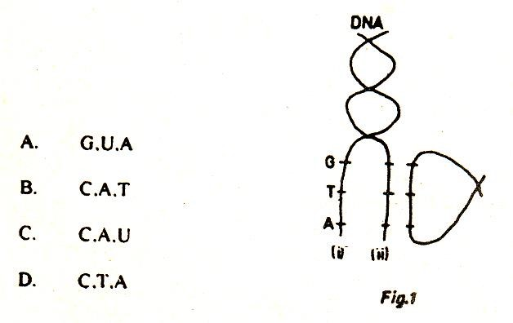 A

- If the bases on t-RNA are ACU, what would be the corresponding bases on original DNA coding strand during protein synthesis?
  - ACT B. UGA C. TGA D. ATG A
- When DNA replicate, it thought to unwind and ‘unzip” along
  - bonds between the deoxyribose and phosphate units
  - Phosphate to phosphate bonds
  - hydrogen bonds between base pairs
  - ribose to deoxyribose sugars. C
- Which of the following carries the triplet nucleotide code?
  - ribosome RNA (r-RNA)
  - Transfer RNA (t-RNA)
  - Messenger (mRNA)
  - Nuclear (n-RNA) B
- The nucleotide is attached to another in DNA strand by bridge
  - Base to Base
  - Sugar to Base
  - Phosphate to Base
  - phosphate to Sugar A
- Which one of the following show the correct coding sequence during protein synthesis?
  - DNA, mRNA, tRNA, rRNA, amino acids
  - rRNA, tRNA, mRNA, polypeptide
  - DNA, mRNA, tRNA, amino acids
  - DNA, mRNA, rRNA, tRNA, amino acids D
- Transfer RNA of function in
  - Carrying RNA from the ribosome to mRNA
  - Attaching RNA to ribosome
  - Carrying amino acids to the correct site on mRNA
  - Carrying nucleotide to mRNA on the ribosome C

- The genetic code is most directly related to the sequence of
  - Ribose unit B. Deoxyribose unit
C. Nitrogen bases D. Phosphates and pentose sugar B
- Any change in the sequence of bases of a DNA molecule by addition, deletion or substation always result in a
  - Lethal gene
  - mutation of the gene
  - visible change in offspring
  - variation in the new individual making it more capable of adaptation B
- In the Watson-Crick model of double helix, the “rugs” of the “twisted ladder” are composed of
  - Sugar C. Two purines
  - A purine and a pyrimidine D. Two pyrimidine B
- The figure below shows a stage in protein synthesis. A mutation in DNA template strand involving substitution of the original base G on the mRNA codon was transcribed with match with a complementary anticodon having the following base triplet code

A G

U

  - UUA B. TCU C. GCA D. UCA D
- Analysis of a sample of DNA showed that 33% of the bases were adenine. The percentage of guanine bases in the sample was
  - 34 B. 33
  - 17
  - 28 C
%of A = %of T = 33%and % C = %G = (100 – 66)/2 = 17
- The figure below represents the structure of
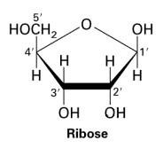
  - Amino acid
  - Glucose
  - Ribose
  - Fatty acid C
- Some bacteria when infected with microphages, may make a particular amino acid they could not make before. This is due to
  - Transformation
  - Mutation
  - Transduction
  - Conversion C
Transduction is a process where a bacteriophage (microphage) transfers bacterial DNA to another bacterium introducing new genes, such as the ability to synthesize a particular amino acid.
- In a non-dividing cell, the percentage of guanine is 40%. The percentage of adenine in the cell is.
  - 30 B. 20 C. 40 D. 10 D

- In an outline for protein synthesis,
DNA mRNA polypeptide
Stage 1 stage 2
Stage 2 represents
  - Transcription
  - Translation
  - Transduction
  - Transformation B
- If the triplet of mRNA is AAG, what is the complementary triplet of the base on tRNA molecule?
  - UUC B. TTC C. CCT D. CCU A

- Which of th following molecules is represented in figure below
  - Fattay acid
  - Deoxyribose
  - Glucose
  - Ribose D
- Which two of the following strands of nucleotide would pair with strand X in the figure?


A

C

A

G

A

C

A

G

T

G

T

C

A

C

A

C

U

G

U

C

X (i) (ii) (iii) (iv)

  - (i) and (iii)
  - (ii) and (iv) C. (i) and (ii)
D. (iii) and (iv) B
- A biochemical analysis of a DNA sample showed that 34% of the bases were guanine. The percentage of adenine bases in the sample is
  - 32 B. 16 C. 17 D. 34 B
- The process of changing the information on mRNA into formation of polypeptides is known as
  - Transcription
  - Translation
  - Transduction
  - Transformation B

- Which one of the following shows he correct coding sequence during protein synthesis?
  - DNA → mRNA → tRNA → rRNA → amino acid
  - rRNA → tRNA → mRNA → polypeptide
  - RNA → mRNA → tRNA → proteins
  - DNA → mRNA → rRNA → tRNA → amino acid D
- During protein synthesis, the anticodon base of tRNA is AUG. What is th base sequence on the template DNA strand?
A. UAU B. ATG C. AUG D. TAC B
- Analysis of a sample of DNA showed that 33% of the bases were adenine. The percentage of guanine bases in the sample was
A. 34 B. 33 C. 17 D. 28 C

- (a) Biochemical analysis of sample of DNA showed that 33% of the nitrogenous base were guanine. Calculate the percentage of the bases in the sample which would be adenine. Explain how you arrived at your answer
Percentage of G = % of C = 33 and % of A = % of T = X
33 + 33+ x + X = 100
2x = 100 – 66
2X = 34
X = 17
Hence percentage of adenine = 17%
  - What name is given to the triplet of bases which designate individual amino acid? Codon
  - If the triplet of mRNA base which designate the amino acid lysine is AAG, what is the complementary triplet of bases on the tRNA UUC
- (a) state where each of the following is found in a cell
DNA – nucleus
RNA – nucleus and cytoplasm

  - give three structural differences between DNA and RNA (3marks)
DNA | RNA
Double helix  Has thymine  Has no uracil  Has hydrogen bonds between base pairs  High molecular weight | Single  Has no thymine  Contains uracil  Had no hydrogen bond  Low molecular weight

  - What is the genetic significance of DNA replication? (2marks)

    - it allows maintenance of a constant amount of genetic information within organisms of a population
    - it allows passing over of genetic information from parents to offspring in constant amounts, generation after generation

(d) Give two ways that suggest that DNA is hereditary material (4marks) (i) ability to replicate
    - it the major component of chromosomes believed to transmit genetic material
    - it is stable
    - constant for a given species

- Describe the process of protein synthesis (20marks) Ref to page 13
- (a) Describe the biological function of amino acids (05marks)

    - Protein synthesis: Amino acids link together in specific sequences to form proteins.
    - Enzymes and hormones: Amino acids are used to create enzymes, which speed up chemical reactions, and hormones, which regulate metabolism and other functions.
    - Neurotransmission: Certain amino acids are precursors to neurotransmitters like serotonin and dopamine, which transmit signals in the nervous system.
    - Immune system: Amino acids help produce antibodies, which are vital components of the immune system that fight pathogens.
    - Energy source: During fasting or intense exercise, the body can break down proteins into amino acids to be used for energy production.
    - pH regulation: Some amino acids, such as histidine, act as buffers to help maintain the body's acid-base balance.
    - Transport: They assist in transporting molecules, like nutrients, across cell membranes.

  - Describe how amino acids form a polypetide (09marks)
Ref to page 13, i.e. protein synthesis
  - How do inhibitors change the rate of enzyme controlled reaction? (06marks)

Inhibitors decrease the rate of an enzyme-controlled reaction by binding to the enzyme and blocking its activity.
Competitive inhibitors bind to the active site, blocking the substrate, while noncompetitive inhibitors bind to a different site, causing a conformational change that prevents the substrate from binding. This leads to a reduced reaction rate, with the severity depending on the type of inhibitor and the concentration of both the inhibitor and the substrate.

- (a) Describe the structure of DNA (11marks)
Ref. pgage 8
    - Using examples, explain an effect of gene mutation in humans (6marks) Ref. pgage 17
    - What is the signifince of mutation in crop hasbandary? 06marks) Ref. pgage 17
- (a)Compare DNA and RNA (10marks) Ref. pgage 5
      - Describe the role of mRNA protein synthesis in a cell(5marks) mRNA's role in protein synthesis is to act as a messenger that carries genetic instructions from DNA in the nucleus to the ribosomes in the cytoplasm. It serves as the template for building a specific protein by providing the sequence of codons that dictate the order of amino acids, which are then assembled by the ribosomes.
      - How does molecular structure of proteins relate to their functions? (05marks)

A protein's molecular structure dictates its function by creating a specific threedimensional shape that determines how it interacts with other molecules. This structure is built from the primary sequence of amino acids, which folds through secondary and tertiary structures, to form a final conformation that allows it to perform its specific task, whether it's acting as an enzyme, a structural component, or a transporter.
Examples of structure-function relationships
Enzymes: Have a specific active site with a unique shape, formed by the tertiary structure, that is complementary to a specific substrate, allowing them to catalyze a reaction.
Transport proteins: Like channel proteins, have a specific shape and size that allows only certain molecules or ions to pass through them.
The fibrous, insoluble proteins like collagen, keratin provides support and protection to the body structures.
Globular and soluble proteins act as regulatory molecules, food storage molecules in plants and as pH buffers in body fluid.
Conjugated proteins made of a simple protein united with some non-protein substance such as mucin of saliva that helps in softening food; chromo proteins combined with a pigment such as hemoglobin, an oxygen carrying molecule; metallo-proteins which act as enzymes.

Revision questions on cell division
- Which one of the following events occurs both in mitosis and meiosis?
  - Synapsis
  - DNA synthesis
  - Crossing over
  - Halving of chromosomes number B
- The function of meiosis in gamete formation is to
  - Maintain the chromosome number and produce genetically similar gametes
  - Halve the chromosome number and produce genetically similar gametes
  - Halve the chromosome number and produce genetically variable gametes
  - Maintain the chromosome number and produce genetically variable gametes C
- At which one of the following stages of cell division does a cell have the same nucleic content as that in metaphase I?
    - Anaphase I
    - Metaphase II
    - Telophase II
    - Prophase I D
- Gametes are haploid because
  - Two replications of DNA occur during meiosis
  - Homologous chromosomes separate during meiosis
  - Crossing over during prophase I
  - Chromatids do not separate during meiosis B
- It is difficult to observe individual chromosomes during interphase because
  - The DNA is not yet replicated
  - They uncoil to form long thin strands
  - They are dispersed
  - Homologous chromosomes do not pair up until division starts B
- Which of the following statements is true?
  - Meiosis produces gametes for sexual reproduction or spores for asexual reproduction
  - Only diploid cells can divide by meiosis but both haploid and diploid cells can divide by mitosis
  - If mitosis produces a multicellular organism after fertilization, but before meiosis, that organism is haploid
  - If mitosis produces a multicellular organism but meiosis occurs before fertilization, that organism is haploid A
- The figure below represents a stage of cell division.

Which one of the following stage is represented in the figure?
  - Metaphase of mitosis
  - Interphase
  - Anaphase of mitosis
  - Metaphase I of meiosis D
- Which one of the following is true of the first meiotic division but untrue for mitosis?
  - The chromosome number is maintained in the daughter cells
  - Four daughter cells are formed
  - The chromosome number is doubled in daughter cells
  - Homologous chromosomes come together at the equator D
- In sexually reproducing organism, maintenance of a species is achieved at meiosis by
  - Halving DNA
  - Doubling DNA
  - Maintaining DNA amount
  - Increasing DNA amount by two fold A
- The figure below shows animal cell during meiosis

Which one of the following stage is illustrated?
  - Prophase I
  - Prophase II
  - Metaphase II
  - Metaphase I C
- During what stage of prophase 1 of meiosis are homologous chromosomes attracted to each other and come together?
  - Leptotene
  - Zygotene
  - Pachytene
  - Diplotene C
- During meiosis crossing over occurs between one of the following
  - two centromeres of homologous chromosomes
  - two homologous chromosomes
  - two non-homologous chromatids
  - two homologous chromatids D
- Which of the following is correct about the first division of meiosis but not that of mitosis?
  - Nucleolus disappears
  - Homologous chromosomes associate to form bivalents
  - Spindle is formed
  - Centrioles move to opposite pole of the nucleus B

- Which of the following is synthesized at interphase during mitosis?
  - tRNA
  - mRNA
  - DNA
  - tRNA C
- Which one of the following events occur during telophase of mitosis in the meristematic cell of a root tip?
  - Cleavage of the cytoplasm
  - Replication of the centrioles
  - Replication of the cell plate
  - Translation A
- (a) Illustrating with a cell of one pair of homologous chromosome, draw diagrams in the space below to show
  - Mitotic metaphase (2marks)


spindle

centriole

Centromere

Chromosome at equatorial region

  - Meiotic metaphase I (2marks)



spindle

centriole

Homologous chromosome

Chromosome at equatorial region

  - Meiotic metaphase II (2marks)



spindle

centriole

centromere

(b) Explain how meiosis contribute to genetic variation (4marks)
Meiosis provided opportunities for new recombination of genes to occur in the gametes and off springs in two ways
- Crossing over which leads to exchange of genetic materials between homologous chromosomes
- Independent assortment at metaphase 1 leads random distribution of chromosomes into the gametes
- Random Segregation at metaphase II: The chromosomes further separate randomly into daughter cells (gametes), ensuring each gamete has a unique genetic blueprint.
- Produces haploid gametes for sexual reproduction, enabling additional variations in offspring through random fusion alleles during fertilization
- (a) Outline the function of the cell nucleus. (2marks)
    - Storing and protecting DNA: The nucleus houses the cell's genetic material (DNA), keeping it organized and safe from damage.
    - Controlling cell activities: It acts as the cell's "command center" by controlling which genes are expressed and when.
    - Regulating growth and reproduction: It manages cell growth, multiplication, and the overall reproduction of the cell.
    - Facilitating DNA replication: The nucleus is where DNA is copied during the cell cycle in preparation for cell division.
    - Directing protein synthesis: It produces RNA molecules from the DNA template, which then move to the cytoplasm to direct the assembly of proteins by ribosomes.
    - Assembling ribosomes: The nucleolus within the nucleus is responsible for creating ribosomal subunits, which are crucial for protein synthesis.
  - Describe the changes that occur in the nucleus during meiosis (13marks)
Ref to page 20
  - Explain the significance of meiosis and mitosis in organisms. (5marks).

Meiosis reduces the chromosome number by half to create gametes for sexual reproduction and generates genetic diversity through processes like crossing over and independent assortment.

Mitosis is that it provides new cells for growth and development, repairs and replaces damaged tissues, and enables asexual reproduction

- Give an account of meiosis in a reproductive cell. (Diagrams not required) (20mark)
Ref to page 20
- How does the behavior of chromosomes in mitosis differ from that in the 1st meiotic division (20marks)
Ref to page 20

Revision questions on genetics
- Which one of the following representations of genotypes would produce only one D type of gametes?
  - TtHh
  - TtHh
  - TTHh
  - tthh
- A man with allele for normal color vision married a woman whose father was color A blind. The probability of a couple getting a child with a defective allele is
  - ¼
  - ½
  - 1/3
  - ¾
- A couple had children with a disorder that appeared only in sons. Which one of the A following is true about this occurrence? The disorder is
  - Sex linked and the mother is a currier
  - Caused by multiple allele
  - Sex linked and both parents are carrier
  - Sex limited to males and the father is a carrier
- When a tall red flowered plant was crossed with a short and white flowered plant, D all the offspring were tall and red flowered. When F1 plants were selfed, the F2 plants’ phenotypes were in the ratio of 3:1. This occurrence suggests the occurrence of
  - Epistasis
  - Recombination
  - Crossing over
  - Linkage
- A man of blood group B married a woman of blood group AB. Which one of the C following blood group types would not be of their child?
  - AO
  - BO
  - AA
  - BB
- Sickle cell anemia is caused by a double recessive gene and sufferers usually die B before maturity. This continued existence of the sickle cell allele among the human population demonstrates
  - Drug resistance
  - Heterozygous advantage
  - In-breeding
  - Genetic drift (Ref page 35)

- Albinism in corn plant is due to double recessive gene which causes them to die B before maturity. The trait however continues to appear in generation because
  - Albina plant can develop chlorophyll when exposed to light
  - Normal green plants may carry recessive alleles
  - New varieties may be produced by crossing-over in albino plants
  - Mutation may occur to change albino plant to green
- An occurrence of phenotypic ratio of 3:1 in a dihybrid cross is an indication of A
  - Linkage
  - Crossing of over of chromosome
  - Failure of homologous chromosome to separate
  - Dominance
- In flowers, the heterozygous condition of the alleles for red petal [R] and white C [W], are pink. Which one of the following proportions and color of petals is correct
if a pink flowered plant is crossed with a red flowered plant
  - 3red : 1 white
  - 3 red : 1pink
  - 1pink : 1 red
  - 1 pink: 1 white
- Use the information to answer questions 10 and 11 B
In mice, yellow for [ Y] is dominant over grey for [y] when two mice were mated, the off spring were in the ratio of 2 yellow :1 grey.
From the results, which of the following were likely genotype of the parents?
    - Both were homozygous dominant
    - Both are heterozygous
    - one was heterozygous and the other homozygous dominant
    - Both were homozygous recessive
- Which of the following best explains results in question 10? D
    - Double recessive allele for color is lethal
    - Heterozygous condition for color is lethal
    - For color could be sex link
    - Double dominant allele for color is lethal.
- According to Mendel, all the following are correct except C
  - Each characteristic of an organism is controlled by a pair of alleles
  - Each allele is transmitted from generation to generation in a discrete unit
  - There are several varieties of allele of each from each parent
  - Each organism inherits one allele of each pair, from each parent
- Which one of the following statement is not correct about a test cross? C
  - It is carried out on an organism with dominant phenotype
  - The offspring of the cross may all have dominant phenotype
  - The organism of unknown genotype is crossed with a homologous dominant individual
  - The offspring of the cross may have the ratio of 1 dominant phenotype: 1 recessive phenotype
- Mendelian expected probabilities of genotypes in a cross occur when D
  - Small number of offspring are produced
  - Migrations occur in the population
  - Mutation arise
  - Fertilization is random
- Establishing the genotype of an organism by crossing it with a homologous A recessive individual is carrying out a
  - Test cross
  - Dihybrid cross
  - Back cross
  - Monohybrid cross
- In guinea pigs, the allele for rough coat (R) is dominant over one for smooth coat A (r) and that for black coat (B) is dominant over one for white coat (b). The alleles for coat type and color are not linked. A cross between rough black pig and rough white one produced 28 rough black, 31 rough white, 11 smooth black and 10 smooth white. Which one of the following could be the genotype of the parent?
  - RrBb xRrbb
  - RRBB x RRbb
  - RRBb x Rrbb
  - RrBB x Rrbb
- Which one of the following is true about sex-linked characters in human? B
  - Female never suffers from the trait
  - Father do not pass on the character to their son
  - Females are either normal or carriers
  - Male are either carriers or sufferers
- Which of the following cannot be a parent of a child of blood group O? D
  - Man, of blood group A and woman of blood group B
  - Both man and woman of blood group A
  - Both man and woman of blood group B
  - Man of blood group AB and woman of blood group O
- A rhesus positive fetus whose mother is rhesus negative may not be born alive C because the
  - Mothers body produces antigens against fetal antibodies
  - Fetus lack antibodies against the mothers’ antigens
  - Mother’s body produces antibodies against the fetal antigens
  - Mother’s red blood cells mix with the fetal blood
- Which one of the following is true of linked characteristics? They A
  - Are always transmitted as a single block
  - Are allelic to each other
  - Occur on non-homologous chromosomes
  - Can be transmitted independently
- Assuming that in humans, allele for the length and color of hair are linked and the B ones for long and brown hair are dominant over those for short and dark hair. A
child with long and dark hair from a mother who is homozygous for long and
brown hair and a father with short and dark hair would be due to
  - Mutation
  - Crossing over
  - Recombination
  - Closeness of the alleles on the chromosome

- Which one of the following hereditary characteristics is known to be sex linked? A
  - Hemophilia
  - Baldness
  - Albinism
  - Short neck
- In a plant species, the allele for tallness (T) and blue flower (B) is dominant to A that for shortness (t) and white flowers (b). A tall plant with blue flowers was crossed with sort plants with white flowers.
The results obtained are: 1tallblue: 1tallwhite: 1shortblue: 1short white
The genotype of the blue flowered plant was
    - TtBb
    - ttBB
    - TTBB
    - TtBB
- Which one of the following is caused by a defect on a recessive sex linked allele? B
    - Albinism
    - Color blindness
    - Sickle cell
    - ABO blood group system
- In flower, the heterozygous condition of allele for red petal (R) and white petal C (W), is pink. Which of the following proportions and color of petals is correct if a pink plant is crossed with a red flowered plant?
  - 3 red: 1white
  - 3 red: 1 pink
  - 1pink:1 red
  - 1pink: 1 white
Use the information below to answer 26 and 27
In mice, yellow fur (Y) is dominant over grey fur (y), when two yellow mice were mated, the offspring were in ratio of 2 yellow to 1 grey

26 From the results, which of the following were the likely genotype of the parent B
- Both were homozygous dominant
- Both were heterozygous
- One was heterozygous and the other homozygous dominant
- Both were homozygous recessive

- Which of the following best explains the result? D
  - Double recessive allele for color are lethal
  - Heterozygous condition for color is lethal
  - Fur color could be linked
  - Double dominant alleles for fur is lethal
- What would be phenotypes of children born of a colorblind man and a normal A worm? A. All normal
  - Only girls normal
  - Only boy color blind
  - All color blind
- A woman produces five children. The first two children were girls, followed a boy. B The last two are girls. What is the probability that the sixth child will be a boy
  - ¼
  - ½
  - 1/6
  - 1/8
- A boy has blood group A and his sister has blood group B. which combination of B genotype cannot belong to their parents?
 | Mother | Father
A | IAIA | IBIO
B | IAIB | IBIB
C | IOIO | IAIB
D | IBIO | IAIO

- A ratio of 3:1 obtained among the offspring in a dihybrid cross is a result of B
  - Crossover
  - Linkage
  - Non-disjunction
  - Dominance
- The phenotype resulting from a cross between red eyed and white eyed fruit flies depends on which parent is red eyed. This means that the gene for eye color is
  - polygenic B. sex linked C. homogametic D. sex limited D
33 Which one of the following would lead to genetic death in an animal population?
A. Hemophilia in a population B. Sickle Cell trait in a population C. Infertile males in a population
D. Albinism in a population C
- The following can result in some variation of offspring except
  - Haploid parthenogenesis
  - Conjugation
  - Fragmentation C
  - Self-fertilization
- A coffee plant known to be heterozygous for a recessive defect which makes the plant fail to produce viable seeds, were self-pollinated and gave rise to 600 seedlings. How many of the seedlings were heterozygous?
  - 150 B. 200
C. 300

D. 400 D
36 If a father has blood group A and the mother blood group AB then the number of possible genotype of their offspring is
A. 2 B. 3
- 4
- 6 C
- Which one of the following phenotypic ratios results from a recombination due to the linkage? A. 4:1:1:4 B. 1:2:1
  - 2:1 A
  - 1:1
- What is the maximum number of triplets of nucleotides that could code for the 20 amino acids?
A. 3 B. 6 C. 48
D. 63 D

39 The following results were obtained from the selfing of F1 generation of pure
breading parents for tall and dwarf plants A

Dominant trait | Recessive trait | Number of F2 offspring
Tall plants | Dwarf plants | 8250

What would be the actual number of F2 offspring with tall plants?
A. 6189 B. 4126 C. 2063

D. 1500 Structured questions of genetics
40. In human albinism is caused by an autosomal receive allele. On average, 1 person in 10,000 is an albino.
- Give two characteristic of an albino.
Light coloured skin
White hair Pink eyes.

- Using Hardly formula P² + 2Pq + q² = 1, determine the
(i) Frequency of the albino allele in the human population. frequency of the albino allele = q
Frequency of albinism (q²) = 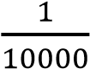
i.e. q² = 0.0001
= 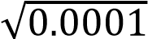
q = 0.01
Hence the frequency of the albino allele in the human population is 0.01.
(ii) Frequency of the heterozygous genotypes in the population.
Solution
p + q | = 1
P + 0.01 | = 1
p = 0.99
Frequency of the heterozygous genotypes in the population = 2pq
= 2 x 0.01 x 0.99
= 0.0198
- Explain why it is difficult to eliminate recessive allele from a population.
    - Hidden in heterozygotes: Heterozygous individuals have one dominant and one recessive allele. Because the dominant allele is expressed, the individual appears unaffected by the recessive trait, and the allele is not removed by selection.
    - Persistence through carriers: These heterozygous carriers can reproduce and pass the recessive allele to their offspring. This allows the allele to remain in the population indefinitely, even if it causes a genetic disorder when two copies are present (homozygous recessive).
    - Gene flow can introduce recessive alleles: If an allele is rare in one population but common in another, immigration can bring that allele into the first population, where it can persist.
    - Genetic drift: In smaller populations, random events can cause the frequency of any allele, including a recessive one, to change significantly, sometimes leading to its loss or fixation by chance, not necessarily due to selection against it.
    - Mutation: New mutations can continually introduce or reintroduce recessive alleles into the gene pool, even if selection is working to remove them.
    - Heterozygote advantage: In some cases, there might be a selective advantage to being a carrier (heterozygote). This occurs when the heterozygote has a higher fitness than either the homozygous dominant or homozygous recessive individual, such as in the case of sickle cell trait providing malaria resistance.

41. (a) Explain the meaning of the Hardy-Weinberg equilibrium principle
The Hardy-Weinberg equilibrium principle states that in a large, randomly mating population, the frequencies of alleles and genotypes will remain constant from generation to generation, provided no evolutionary forces are acting on the population.
(b) State four conditions that must be fulfilled in order for the principle to hold true
- absence of mutation,
- Absence of natural selection,
- Absence of gene flow (migration/emigration),
- Absence of genetic drift,
- Mating is random
- Large population
(c ) Brown eyes in a human population is caused by a dominant. If in a population, 84% of the people have brown eye, using Hardy-Weinberg formula, determine the percentage of the population who are.
- Heterozygous for eye colour. Show your working.
Let the allele for brown eyes be B
The allele for other eye colour be b
Frequency of allele B be p
Frequency of allele b be q
Given BB+ Bb constitute 84%
The hardy-Weinberg equation states
P² +2pq + q² | = | 1
given p² + 2pq | = | 0.84
q² | = | 1 – 0.84
q² | = | 0.16
=>q | = | 0.4
Also p + q | = | 1
p | = | 1-0.4
p | = | 0.6
The proportion of population that is heterozygous = 2pq =2 x 0.4 x 0.6 = 0.48
Percentage of heterozygous for eye color = 0.48 x 100 = 48%
- Homozygous dominant for eye colour. Show your working from above
p | = | 0.6
=> BB | = | p² | =(0.6)2
.; BB | = | 0.36
% 0f BB | = | 36%
Hence, the percentage of individual homozygous dominant for eye color is 36%
- In an oil seed plant species, the allele for tallness is dominant over that for dwarfness. Mean-while the allele for chlorophyll production and non-chlorophyll show incomplete dominance. The heterozygous plants are variegated.
  - Using suitable symbols, construct a diagram of a cross between a tall plant with green leaves and a dwarf plant with variegated leaves, to show the genotype and phenotypes of the offspring
Let
T be the allele for tall plant, t be the allele for dwarf plant
G be the allele for chlorophyll production
W be the allele for non- chlorophyll production
A tall plant with green leaves would have genotype TTGG or TtGG. While the dwarf plant with variegated would gave genotype ttGW. Two crosses are possible in this case.
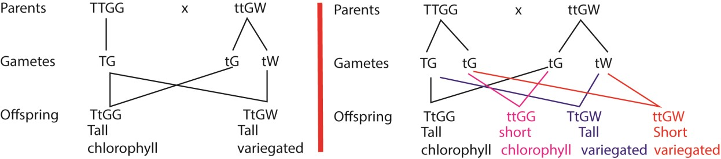
  - Explain why 25% of the offspring of the cross in (a) would fail to survive.
In the second cross, 25% of the offspring survival disadvantage in being dwarf with variegated leave. They cannot reach out for enough light do not have enough chlorophyll to absorb light for photosynthesis.
- In poultry feather color is controlled by two sets of alleles, W [white] dominant over w [colored] and B [black] dominant over b [brown] A foul heterozygous for both alleles [WwBb] is white.
  - Explain why the genetic constitution of WwBb is white?
When both genes are present in the genotype, gene W suppresses the expression of gene B in phenotype, a condition called epistasis.
  - Work out to show the phenotypic ratio of crossing a white cock (WwBb), with brown hen.
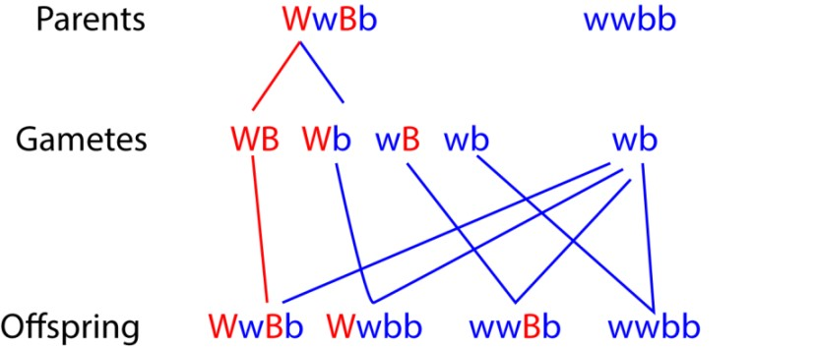
  - State the possible genotype of a black fowl

wwBB and wwBb

44. The figure below shows how sickle cell anemia has affected a family line. Sickle cell anemia is a recessive genetic defect which is not sex linked individuals are numbered 1 2 3………..12
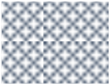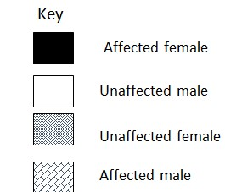

1

2

4

5

6

3

7

8

9

10

11

12

- State the number of all individuals in the family line that are certain to be heterozygous for this gene (2marks) 4, 9
Note that 3 and 4, 9 and 10 must heterozygous to produce affected person of their offspring. But 3 and 10 are just partners while 4 and 9 belong to the family line.

- What is the probability that individual 6 is heterozygous for this gene? (show your working)
Possible heterozygous include: 1, 2, 3, 4, 6, 8, 9, 10, 12
Number of possible heterozygotes = 9
Probability that 6 is heterozygous = 1/9

- The parasite which cause malaria digest hemoglobin in the red blood cells. Suggest two reasons an individual who is heterozygous for this gene may show resistance to malaria.
  - some of their red blood cells have reduced capacity of oxygen that they may not be able to support intracellular parasite
  - the sickle shaped have reduced life span to complete the life span of parasite
  - haemoglobin s may not be digestible

- State the difference between individuals who have sickle cell anemia and those that have sickle cell trait. (3marks)
Feature | Sickle Cell Anemia | Sickle Cell Trait
Gene Copies | Two copies of the sickle cell gene | One copy of the sickle cell gene
Symptoms | Serious symptoms, chronic anemia, and complications such as strokes and infections | Usually no symptoms
Health Outlook | Can be life-limiting and may lead to organ damage and early mortality | Generally healthy with a normal life expectancy
Risk Factors | Inherited the sickle cell gene from both parents (or one sickle gene and another abnormal gene) | Inherited one normal gene and one sickle cell gene
Complications | Chronic anemia, organ damage, and other serious health problems | Rare complications possible under extreme conditions, such as intense exercise in high temperatures (e.g., heat stroke, muscle breakdown)

45. (a) Distinguish between sex linked and sex limited genes
Sex-linked characteristics are those whose genes are carried on the sex (X-) chromosomes for example in humans are color blindness, and hemophilia while sex limited traits are characters that that show up exclusively in one sex only e.g. ovary in female
(b) Color blindness in man is caused by a recessive gene found on X-chromosome.
    - A boy with normal eye sight married a color blind girl. Using suitable symbols, work out the probability of producing a normal girl.
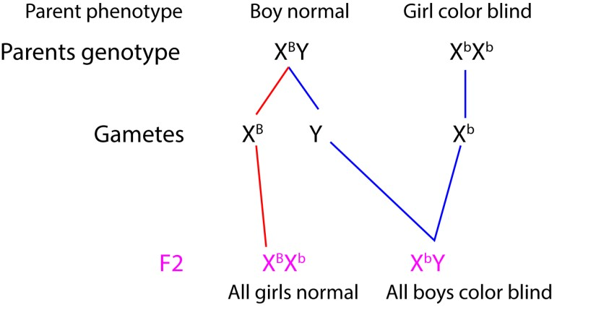
The probability of producing a normal girl is 1
    - If one the daughters from the marriage in (b)(i) above married a man with normal eyesight, what is the probability that they will produce a boy with normal eyesight?
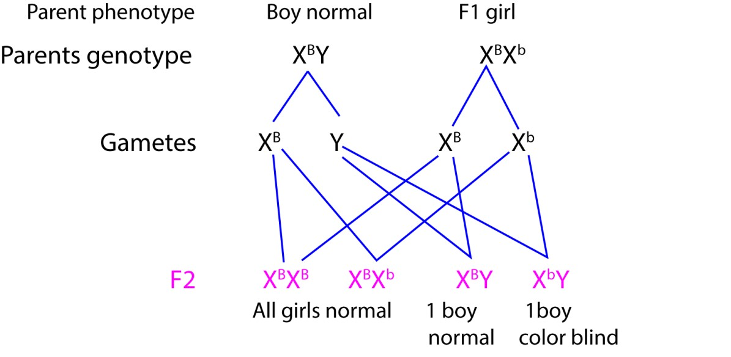
Probability of a normal boy = ½

- (a) State four situations where Mendel’s laws do not apply. (4marks)

    - Linkage
    - Incomplete dominance.
    - Co-dominance
    - Multiple alleles.

  - In animal species, individual that are homologous for gene A or its alleles die. Another independent gene B in homozygous blocks this lethal effect, otherwise B has no effect on the organism.
    - Work out the expected phenotypic ratio of the viable offspring in a cross of individual of AaBB and AaBB genotype. (5marks)

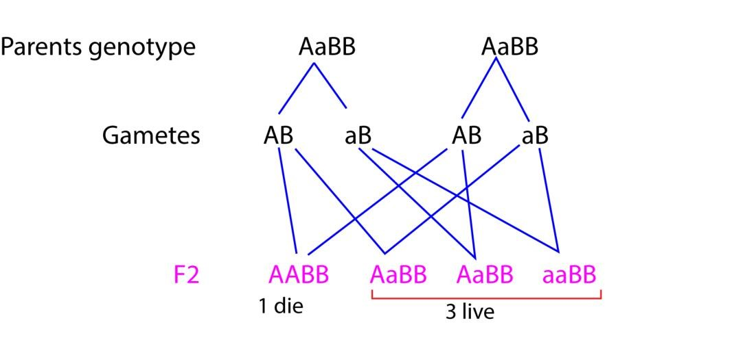
    - State the type of gene interaction in (b)(i) (1mark)
Epistasis
- In drosophila, the gene for Broad abdomen and long wings are dominant over the genes for narrow abdomen and vestigial wings. Pure breeding strains of the double dominant variety were crossed with a double recessive variety and a test cross was carried out on F1 generation.
  - Using suitable symbols, work out the expected phenotypic ratio of the test cross of the F1generation. If the genes for abdomen and length of the wing are liked. (7marks)

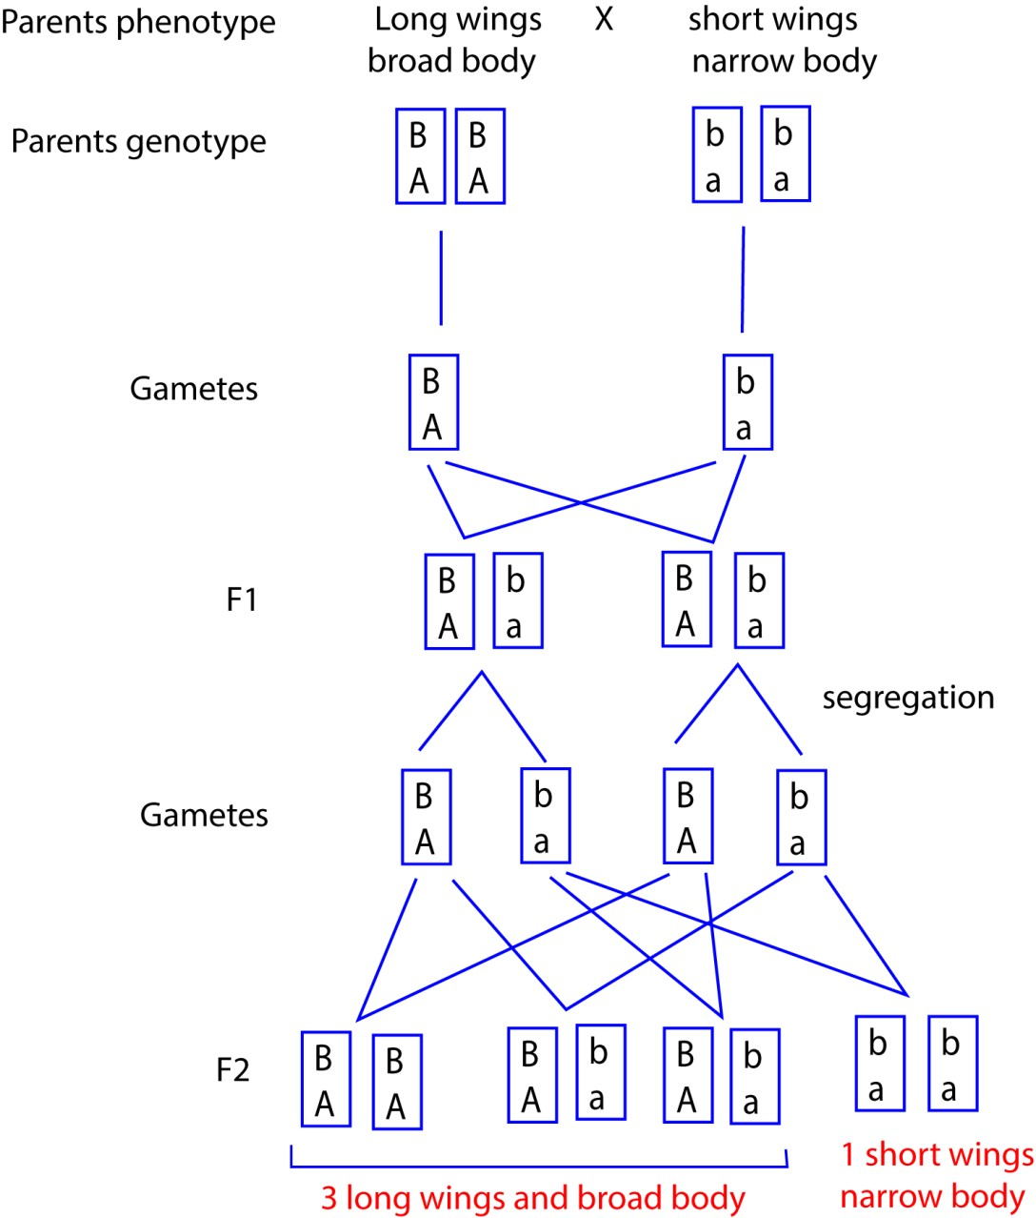
  - It was however observed that when the test cross of F1 generation was carried out, the following results were obtained (3marks) Broad abdomen, long wings 380
Narrow abdomen, vestigial wings 396
Broad abdomen, vestigial wing 14
Narrow abdomen, long wing 10
Calculate the distance in units between the genes for abdomen width and wing length
Crossing over value =

- (a) Define the following terms: backcross, sex linked and sex limited characters
Backcrossing is a breeding technique where a hybrid offspring is crossed with one of its parents to produce offspring that are genetically closer to the parent.
Sex linked character is trait whose genes are carried on the sex chromosomes.
Sex-limited characters are traits that are expressed in only one sex, despite both sexes carrying the genes for them. These genes are located on autosomal chromosomes, not sex chromosomes, and are often controlled by sex hormones like testosterone or estrogen. Examples include lactation in cattle (expressed in females only), breast development (in females), and beards in goats (expressed in males).
  - Which cells in in cereals are haploid, diploid and triploid?
Haploid = male gametes (in the pollen) and the female gametes (egg cell)
Diploid – those of embryo and all somatic (body) cells
Triploid – those of endosperm
  - Describe one method by which polyploidy can be artificially induced
By using a chemical like colchicine to prevent the separation of chromosomes during cell division, leading to a doubling of the chromosome number.
  - In sugarcane the gene for yellow midrib (y) and long internode (n) are recessive to green midrib (Y) and short internode (N), and are on the same chromosomes. A yellow sugar cane with long internodes was crossed with sugar cane heterozygous for yellow midrib and long internodes. The off spring were
256 YyNn, 38Yynn
272yynn, 34 yyNn
Calculate the cross over value
Crossing over value =
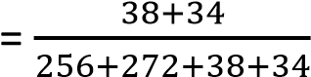
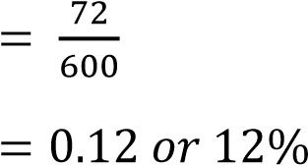
- (a) What is a sex-linked character?
It is characteristics (or traits) whose genes are carried on the sex chromosomes.
  - (i) Why are sex linked traits most common in males among humans?
Sex-linked traits are more common in males because they have only one X chromosome (XY), meaning there is no second chromosome to mask any recessive alleles.
(ii) Hemophilia is a condition caused by a recessive gene carried on X -chromosome.
Determine the phenotype of the children from a carrier mother and normal father.
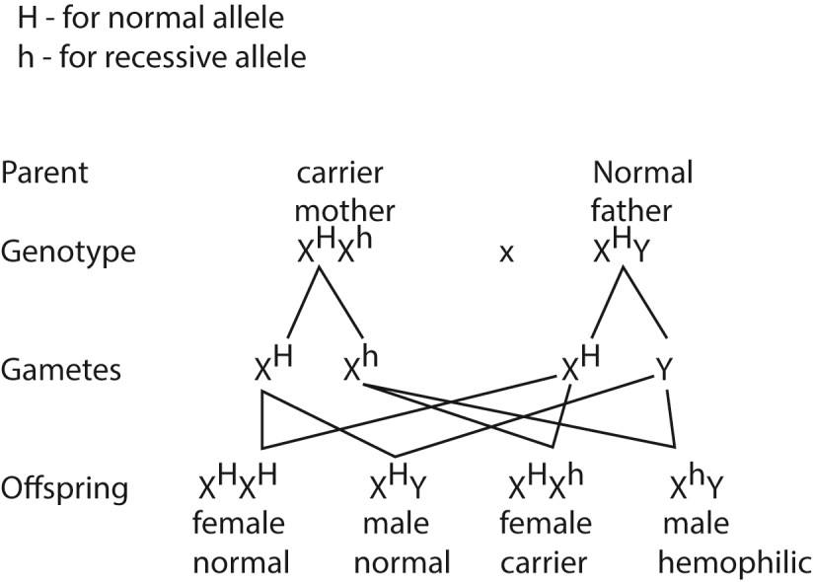
Phenotypes: all females are normal, half male – normal and half male - hemophilic
- (a) State Mendel’s first law of inheritance and explain what it means
Mendel's first law, also known as the law of segregation, states that during the formation of gametes (sperm and egg cells), the two alleles for each gene segregate from each other so that each gamete carries only one allele for each gene. This means

that a parent with two different alleles for a trait, such as a dominant and a recessive one, will pass on only one of these alleles to their offspring.
(b) (i) state the stages of meiosis that illustrate this law
Anaphase I
(ii) Explain what takes place in the stages you have named in (a)(ii) above
Anaphase I of meiosis illustrates Mendel's first law, the law of segregation, because it is the stage where homologous chromosomes, which carry the different alleles for a gene, separate and move to opposite poles of the cell. This physical separation ensures that each resulting gamete receives only one of the two alleles.
(d) In human beings, brown eyes are usually dominant over blue eyes. Suppose a blue-eyed man marries a brown-eyed woman whose father was blue-eyed. What proportion of their children would predict that will have blue eyes? Show your working. Let B = gene for brown color b = gene for blue color
Man’s genotype = bb
Woman genotype = Bb
Genetic cross
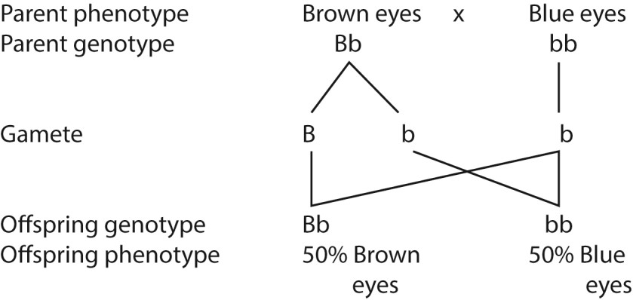
The proportion of children with blue eye is 50%
- Both hemophilia and color blindness are transmitted in the same way
  - What is the effect of each disease? (04marks)
Hemophilia's main effect is excessive or prolonged bleeding due to the body's inability to form blood clots properly.
Color blindness affects daily life by causing difficulty in distinguishing colors
  - Describe the transmission of the diseases (08marks)
Both hemophilia and color blindness are due to sex linked genes, the phenotypes of offspring depends on who of the parents is affected
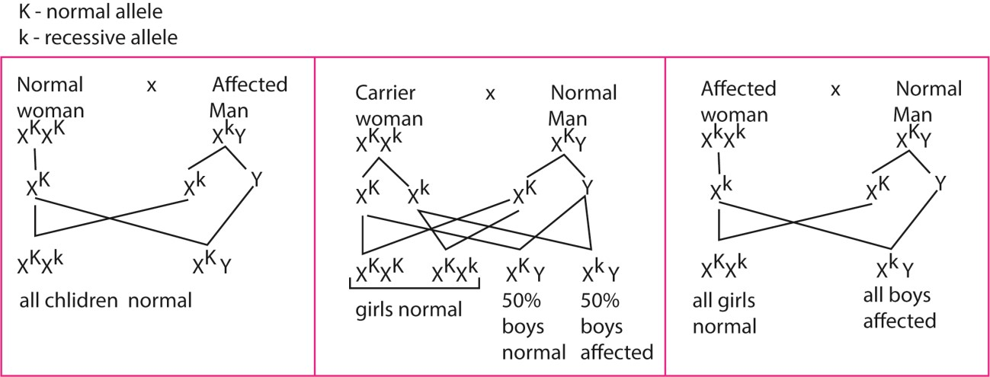
  - Explain why there are more color-blind individuals than hemophilic among the population in spite of similar way of transmission (8marks)
    - Mutations leading to color blindness are more frequent than those leading hemophilia
    - Hemophilic victims are less likely to survive compared to colorblind victims because excessive bleeding is fetal(historically) while colorblindness has minimal effect on life expectance.

Revision questions for evolution
Objective questions
- The gene for albinism is recessive to that form normal skin pigment in human. In a population where the allele frequency of albinism is 10%, the expected proportion of albinos in the population would be
  - 0.1
  - 0.01 C. 0.8
D. 0.9 B
- Insect and vertebrate living on land have jointed limbs for locomotion. This is an example of
  - Convergent evolution
  - Adaptive radiation
  - Divergent evolution
  - Natural selection A
- Which one of the following factors is least likely to contribute to the development of new species?
  - Gene mutation
  - Reproductive isolation
  - Geographical isolation
  - Stabilizing selection B
- Which one of the following may cause adaptive radiation to a variety of species?
  - Stabilizing selection
  - Directional selection
  - Cessation of selection
  - Disruptive selection D
- Which one of the following may occur to a community of organism as a result of natural selection?
  - Increase in the number of species
  - Adaptive to the environment by all organism

C. Extinction of species
D. Reduction in the level of mutation C
6. Which one of the following pairs of structures are not homologous?
- Arms of humans and wings of birds
- Legs of insects and those of mammals
- Ponds of bean and pericarp of maize grain
- Pectoral fins of fish and arms of humans B 7. From the following sources of variation, which one has the highest chance of producing new species
- Crossing over
- Independent assortment
- Mutation
- Random fusion of gametes C 8. Which one of the following is likely character in mammalian population illustrated in figure 1?


character

  - Height
  - Ear size
  - Blood group
  - Finger length C
- Which one of the following results when a gamete with non-disjunction is fertilized?
  - Duplication
  - Translocation
  - Monosomy
  - Polyploidy C
- Which one of the following is least likely to occur when organism of similar species competes for some limited resource?
  - Range restriction
  - Aggression towards each other
  - Extinction
  - Coexistence D
- Individuals lacking desired qualities are prevented from mating during artificial selection using the following methods except
  - Extermination
  - Segregation
  - Sterilization
  - Cross breeding D
- Structures of common origin modified in various ways to adapt animals to different modes of life is an illustration of
  - Homologous structure
  - Convergent evolution
  - Analogous structure
  - Cooperative anatomy A

- Which one of the following is likely to cause a faster rate of evolution?
  - Stabilizing selection
  - Directional selection
  - Disruptive selection
  - Slow changing environment B
- The more the variation in population, the greater is its potential to
  - Give rise to gene flow
  - Adapt to new changes in environment
  - Produce more offspring
  - Grow fact B
- Functional resemblance of wings of butterfly and a bird although from different origin, is an example of
  - Homology
  - Autology
  - Analogy
  - Phylogeny C
- The following are trisomic conditions except
  - Klinefelter’s syndrome
  - Turners syndrome
  - Down’s syndrome
  - XXX female B
- Which of the following is not likely to bring evolutionary change in a population?
  - Crossing over
  - Migration
  - Mutation
  - Genetic drift A
Crossing over is easily reversed
- Which one of the following structures is not homologous with the rest?
  - Bat wing
  - Human fore arm
  - Insect wing
  - Bird wing C

- Which of the following conditions result from gene mutation?
  - Klinefelter’s syndrome
  - Turners syndrome

C. Sickle cell anemia
D. Dawn’s syndrome C
The rest are examples of non-disjunction chromosome mutations
- Which of the following factors would contribute least to the development of new species?
  - Gene mutation
  - Chromosomal mutation
  - Geographical isolation
  - Environmental stability D
When environment is stable there is minimal selection
- Insects have different mouth parts modified to suit their different modes of feeding. This shows:
  - Speciation
  - Convergence evolution
  - Divergent evolution
  - Development of analogous structures C
- Which of the following maintains the highest level of genetic uniformity?
  - Interbreeding
  - Selective breading
  - Random breeding
  - Inbreeding D

Inbreeding is a cross between close relatives
- A possible explanation for occurrence of gill slits on a human embryo is that
  - gill slits are required for respiration at early stages
  - human may have evolved from fish
  - human and fish have a common ancestry
  - evolution still occurs C
- Among the following sets of organs; which contains homologous structures only?
  - bat wing, bird wing, human fore arm
  - fish pectoral fin, human for arm, insect wings
  - bird wing, bat wing, insect wings
  - fish pectoral fin, bat wing, human forearm A
- Which one of the following would not lead to evolution?
  - Better suited phenotype in a specific environment increasing in number
  - The environment remains stable for a long time.
  - Organism producing more offspring than the environment can support D. A large number of offspring dying before reproduction. B
- Which of the following is not a form of inbreeding?
  - Cross-breeding offspring of the same parent
  - Self-pollination
  - Back crossing
  - Test crossing A
- The camel family is found only in North Africa, Asia and South America. This is an example of
  - Adaptive radiation
  - Convergence radiation
  - Divergent evolution
  - Discontinuous distribution D

Discontinuous distribution
Discontinuous distribution in evolution refers to the geographic separation of closely related species into isolated areas, with large uninhabited regions in between. This pattern often indicates a history of continental drift and is explained by species once having a continuous range that broke apart as landmasses moved. Examples include lungfish in Africa, South America, and Australia; tapirs in South America and Southeast Asia; and alligators in South America and China.
Causes and explanations
- Continental Drift: The most significant factor, where the movement of continents separated populations, which then evolved independently in response to different environments.
- Extinction: The original continuous population may have gone extinct in the regions separating the current populations.
- Adaptive Radiation: Over time, isolated populations on different continents underwent adaptive radiation, evolving into distinct species that are now restricted to their specific regions.
- Paleoclimate Change: Changes in past climates, such as glaciation or desertification, could have eliminated populations in certain areas, leading to a discontinuous distribution in the surviving populations.

Examples
- Lungfish: Found in Africa, South America, and Australia, despite having a worldwide distribution in the Devonian period.
- Tapirs: Occur in South America and Southeast Asia.
- Rhinos: One genus is found in Africa and another in India.
- Alligators: Now found in North and South America, with an extinct relative in China that indicates a broader past distribution.
- Monotremes: Egg-laying mammals like the platypus and echidnas are limited to Australia, which is a discontinuous distribution for the group.

Significance
- Discontinuous distribution provides evidence for historical events like continental drift and the past distribution of organisms.
- It highlights how evolutionary processes, such as extinction, isolation, and adaptation, lead to the patterns of life we see today.
- The study of gross morphological and histological appearance of an organism in ecology is best described as
  - Comparative physiology
  - Comparative embryology
  - Comparative anatomy
  - Cell biology C
- The appearance of a gene of evolutionary advantage is a function of
  - Chance
  - Environmental demand
  - Needs of organism
  - Nature plan A
- Which one of the following would cause phenotypic variation among organisms of the same genotype?
  - Exposure to different environment
  - Continuous variation within the species
  - Different sex
  - Mutation A
- The phylogenetic approach to classification is used because it groups together all animals that show
  - analogous structures
  - homologous structures
  - convergent evolution
  - Adaptive radiation B
- Which of the following may be a result of inbreeding?
  - Improved fertility
  - Accumulation of lethal gene
  - Polyploidy
  - Increased mutation rate B
- Which of the following is not a likely result of polyploidy in plants?
  - Increased hardness
  - Resistance to diseases
  - Decreased hybrid vigour
  - Formation of seedless large fruits C
- Two population of a given species could only evolve into two distinct species if they are subjected to
  - Disruptive selection
  - Geographical isolation
  - Stabilizing selection
  - Genetic isolation D
- The pastoralist usually retains which his herd, a bull whose ancestor have got desirable characteristics. This is an example of
  - Inbreeding
  - Natural selection
  - Cross breeding
  - Artificial selection D
- The existence of different castes within termite is an instance of
  - Polymorphism
  - Genetic drift
  - Melanism
  - natural selection A
- Which one of the following effects of deforestation will least affect the gene pool of a population in a forest?
  - Accumulation of carbon dioxide in the atmosphere
  - Decrease in the number of individual at each trophic level
  - Loss of habitat for animal species
  - Decrease in the number of trophic levels in the forest ecosystem A
- The occurrence of a genetic defect among individuals of an isolated population in a percentage higher than expected is likely to be a result of
  - Natural selection
  - Speciation
  - Adaptation
  - Genetic drift D
- Which one of the following does not lead to change in allele frequency of a population?
  - Mutation
  - Selection
  - Sexual recombination
  - Genetic drift C
- The similarity of the skeletal structures of mole, monkeys and whales lead to the conclusion that they
  - Belong to the same class
  - Originate from the same environment
  - Descend from a common ancestor
  - Evolved converging C
- Which one of the following would lead to genetic death in animal population?
  - Hemophilia in a population
  - Sickle cell trait in a population
  - Infertile males in a population
  - Albinism in a population C
- The following can result in some variation of the offspring except
  - Haploid parthenogenesis
  - Fragmentation
  - Conjugation
  - Self-fertilization B
- Which of the following show divergent evolution?
  - Wings of a cockroach and a bat
  - Skeleton of a mouse and cray fish
  - Fore limbs of a pigeon and a monkey
  - Eyes of a locust and a kite C
- The possession of similar structures in an organism having different ancestral origin is a result of
  - Convergence evolution
  - Divergence evolution
  - Adaptive radiation
  - Parallel evolution A
- Which one of the following may occur to a community of organisms as a result of natural Section?
    - Increase in the number of species.
    - Adapting to the environment by all the organisms.
    - Extinction of species.
    - Reduction in the level of mutation, C
- Which one of the following would happen to individuals of the population in the shaded area in the figure below if selection pressure continued for generations acting on the phenotype?
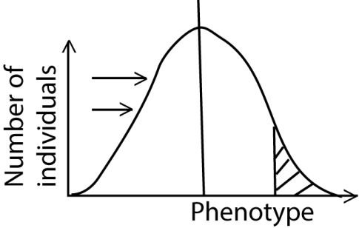
They would
    - Develop onto two distinct population
    - Die off and become extinct
    - Evolve into new species
    - Multiply in numberl. C
- Which one of the following genetic abnormalities does not result from non-disjunction?
    - Klinefelter’s syndrome
    - Turner’s syndrome
    - Hemophilia
    - Down’s syndrome C
Hemophilia is due to mutation
- Variation among organisms which reproduce by fission can be due to
    - Crossing over
    - Mutation
    - Random fertilization
    - Independent assortment B
- The figure below shows he frequency of a trait among a group of students

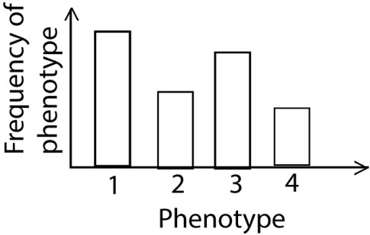
The difference in the phenotype s is due to
    - The altitude where individual live
    - Genetic make up
    - Frequency of disease among individual
    - Different diet among individuals B
- In breeding , the propagation of a variety with desirable characteristics is referred to as
    - Hybridization
    - Artificial selection
    - Cross breeding
    - Inbreeding B
Artifitial selection is the same as selective breeding
- Human eye and octopus’ eye are examples of
    - Homology
    - Divergent evolution
    - Analogy
    - Adaptive radiation C
- Which one of the following pairs of structures are not homologous?
    - arms of humans and wings of birds.
    - Legs of insects and those of mammals.
    - pods of beans and pericarps of maize grains.
    - pectoral fins of fish and arms of humans. B
- From the following sources of variation, which one has the highest chance of producing new species?
  - crossing over B. Independent assortment
C. mutation. D. Random fusion of gametes. C
Structured questions
- (a) Distinguish between hybrid and hybrid vigour
A hybrid is an organism created by cross-breeding two different varieties, species, or breeds. Hybrid vigor, also known as heterosis, is the biological phenomenon where the first-generation offspring (the hybrid) exhibits enhanced traits, such as increased size, growth rate, or yield, compared to its parent organisms. In short, the hybrid is the organism, while hybrid vigor is the superior performance of that organism.
(b). Explain how each of the following may alter the gene frequency
      - Closeness of population
Closeness within a population, such as inbreeding, can alter gene frequencies by increasing the likelihood of individuals with similar genetic backgrounds mating, which leads to more homozygosity (increased expression of both dominant and recessive traits) and a higher frequency of potentially harmful recessive alleles.
      - Small population size
A small population size can drastically alter gene frequency through the mechanism of genetic drift, which is the change in allele frequencies due to random chance. Loss of genes may lead to increased proportion of others while addition of new genes by mutation reduces the frequency of original genes.
- In human albinism is caused by an autosomal recessive allele. On average 1 in 10,000 is an albino.
(b) Give two characteristics of an albino (2marks)
      - Pale skin
      - Pink eyes
      - White/brown hair
(c) Using Hardy Weinberg formula p² +2pq + q² = 1, determine
    - the frequency of the albino allele in human population (2marks)
Frequency of albino q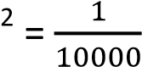
Frequency of albino allele, q = 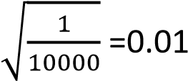
    - Frequency of heterozygous genotype in the population (2mars) Let proportion of dominant gene be p p + q = 1 p = 1 – 0.01 = 0.99
frequency of heterozygous = 2pq = 2 x 0.01 x 0.99 = 0.0198
(d) Explain why it is difficult to eliminate recessive alleles from a population (4mark)
- Recessive alleles are hidden in heterozygous condition where they cannot be eliminated by natural selection.
- In some cases heterozygous condition may have selective advantage supporting continued existence of the gene.
- Immigration may reintroduce the recessive allele
- Heterozygous carriers reproduce and pass the recessive allele to their offspring.
- New mutations can continually introduce or reintroduce recessive alleles into the gene pool, even if selection is working to remove them.
- When extensive lakes that existed in Bunyoro were reduced to isolated pools many years ago, four species of fish evolved as a result
  - Suggest how the drying up of the lake system to isolated pools resulted in evolution of the four new fish species. (4marks)
The drying up of the lake system created geographic isolation for the fish populations. With no gene flow, each isolated population began to experience random genetic mutations and different selection pressures. Over time, these genetic differences, combined with genetic drift, caused the isolated populations to diverge genetically, adapt to new environment hence, developing into new species.
  - Describe how environmental factors act as stabilizing forces to natural selection in an isolates pool after the evolution of a new species. (03marks)
In an established, stable population, environmental factors typically act as stabilizing forces to maintain the status quo rather than driving a major evolutionary shift through eliminating extreme genetic and phenotypic variations.

  - Suggest what would happen to the fish species if water levels rose and the isolated pools once again formed an extensive lake system. (03marks)
      - If the species have not been reproductively isolated for long, they may still be able to interbreed.
      - Competition between species may reduce the number of some species of fish. The better adapted will survive while others die and may become extinct.
      - May lead to coexistence if the four species develop adaptations that allow them to occupy different ecological niches within the newly formed lake.
- (a) Explain the meaning of the Hardy- Weinberg equilibrium principle (1mark)
Provided there are no disruptive influences such as mutations or selection, the frequency of alleles in a population remains constant, generation after generation. There is continued movement of gene (gene flow) within the population due to breeding but the overall gene frequencies remain constant. This stability is referred to as genetic equilibrium.
(b) State four conditions that must be fulfilled in order the principle to hold true (2marks)
      - No mutation occurs
      - Mating must be random - The population must be large.
      - No emigration or immigration from or into the population should occur
      - Generations should not overlap
      - All genotypes should be equally fertile, so that no selection occurs.
(c) Brown eyes in a human population is caused by a dominant allele. If in a population, 84% of the people have brown eyes, using Hardy-Weinberg formula, determine the percentage of the population who are
(i) Heterozygous for eye color. Show your working (4marks)
The proportion of population with double recessive gene, q² = 100 - 84= 16%
Proportion of recessive allele q = 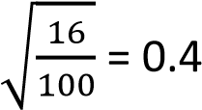
Let the proportion of dominant gene = p
p + q =1 – 0.4 = 0.6
Proportion of population that are that is heterozygous = 2pq= 2 x 0.6 x 0.4 = 0.48
Percentage of population that are that is heterozygous = 0.48 x 100 = 48%

(ii) Homozygous dominant for eye color. Show your working. (3marks)
Proportion of homozygous dominant = p² = 0.6 x 0.6 = 0.36
Percentage of homozygous dominant = 0.36 x100= 36%
- (a) Outline the causes of gene reshuffling.

    - Crossing over prophase 1 in meiosis
    - independent assortment at metaphase 1 of meiosis
    - Random fusion of gametes from two parents during fertilization.

  - In what way may variation resulting from gene reshuffling differ from that caused by mutation?
Mutations are the ultimate source of all novel genetic material, creating new alleles and variations, while gene reshuffling creates new combinations of existing alleles/variations.
  - What is the importance of variation in a population?
    - May lead to emergence of new species.
    - Increase chances of organisms to survive in different habitats.
    - Increase chance of resistance of organisms to diseases and toxic substances.
    - increases chance of population size control by natural selection - Reduces competition for natural resources.

  - Explain how constancy of species may be maintained through natural selection
Constancy of a species is maintained through natural selection primarily via stabilizing selection. When an environment is stable, natural selection does not favor a change in the average traits of a population. Instead, it works to eliminate extreme variations, resulting in a more uniform population over time.
- (a) State three ecological problem which arise from the accumulation of domestic waste in urban communities
    - soil and water contamination from leachate, - air pollution from decomposing and burning waste, - destruction of habitats.
    - creates breeding grounds for pests and vectors, contributing to the spread of disease.
  - Give two ways reducing domestic waste.
    - Reuse
    - Recycle
    - Reducing use of materials
    - Burying biodegradable rubbish.
    - Burning rubbish or treating it with chemicals to reduce bulk.
    - Use of organic waste to generate power (biogas)
    - Use of organic waste to produce fertilizers. use of biodegradable packaging
  - Figure below show lichen species growing along a 20km transect from urban Centre.

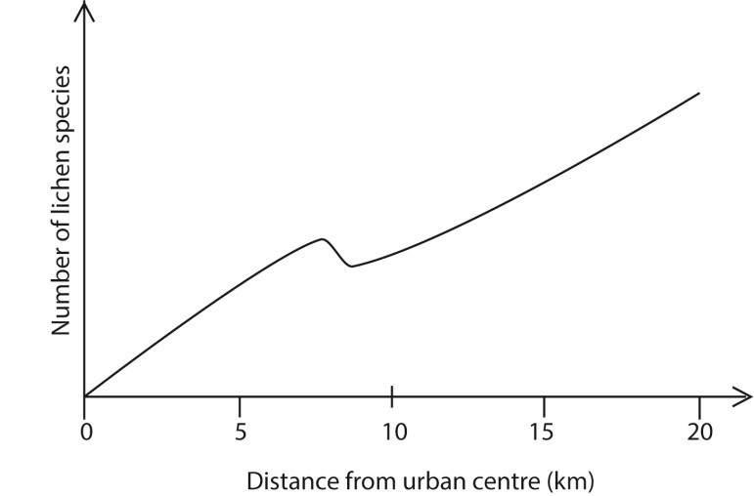

    - Explain the trend in the lichen species with distance
The level of pollution from industries in the urban centre reduces with increased distance from the urban centre. This leads to reduced levels of sulphur dioxide gas promoting lichen growth.
    - Suggest an explanation for the observed number of lichen species at a distance of 10km from the urban Centre.
There is a reduction in the number of lichen species at a distance of 10km from the urban centre. This is could be due to dumping of waste in the area, presence of an industry or small town and bush burning
- (a) How does resistance of malarial parasite to antimalarial drugs occur?
    - Failure of the parasite to absorb the drug
    - Formation of inaccessible forms during its development life cycle in man (tissue hypnozoites)
    - Parasite may use alternative biosynthetic pathway not affected by the drug.
    - The parasite tissue may become tolerant to drug molecules
    - Parasite may produce an enzyme that destroys the drugs (b) How may each of the following lead to speciation
    - genetic drift

Genetic drift is a mechanism of evolution in which allele frequencies of a population changeover generations due to chance (sampling error). Lose of gene from or introduction of gene by mutation or increase in allele frequency of gene in population may alter the selection pressure in a population leading development of new species.

    - Un random mating
Non-random mating can lead to speciation by reducing gene flow and creating distinct genetic clusters within a population, especially when coupled with other evolutionary forces like natural selection.
By favoring certain traits, non-random mating, such as assortative mating (mating with individuals of similar traits), can increase homozygosity and drive the divergence of populations over time. This divergence can eventually lead to reproductive isolation, where individuals from the two groups can no longer interbreed successfully resulting in the formation of new species.
.
- (a) Using examples. Give the meaning of adaptive radiation of species? (2marks) Adaptive radiation is an evolutionary process where a single ancestral species diversifies into multiple new species, each adapting to a different ecological niche.

Examples
- From a common marsupial ancestor, a large variety of marsupials evolved in the isolated continent of Australia e.g. kangaroo (herbivore), the Tasmanian wolf
(carnivore), and the koala (arboreal herbivore)
- On the Galápagos Islands, a single species of finch arrived and then evolved into 15 different Darwin's finches species with unique beak shapes and sizes specialized for different food sources such as insects, seeds, nectar etc.

- State the ecological importance of adaptive radiation (2marks)
It enables organisms with the structures to exploit different ecological niches hence reduce competition.
- How do adaptive radiation and homologous structures give evidence of evolution?
  - Adaptive radiation (3marks)
Presence of modified homologous structures in different organism for different environmental conditions and modes of life, is an indication of evolution from common ancestor.
  - Homologous structures (3marks)
Presence of structures with the same basic plan or fundamentally similar in different organism, though, modified to serve different functions in different environment is an indication of evolution from common ancestor.
62. (a) (i) What is meant by natural selection? (2marks)
Natural selection is the process whereby organisms better adapted to their environment tend to survive and produce more offspring.
(ii) How does it occur? (6marks)
Because resources are limited in nature, organisms with heritable traits that give them competitive advantage and favor their survival and reproduction will tend to leave more offspring than their peers, causing the traits to increase in frequency over generations.
(b) What is the importance of natural selection? (2marks) - May lead to emergence of new species.
- Increase chances of organisms to survive in different habitats.
- leads constant improvement of the population to better species
- Increase chance of resistance of organisms to diseases and toxic substances.
- population size in given environment is regulated to supportable limit.
- Eliminate undesirable genes from population - Reduces competition for natural resources.

63. (a) What do you understand by gene pool? (2marks)
A gene pool is the total set of genes and all their different alleles present in an entire population.
(b) What may cause a gene pool of a population to be static? (2mk)
- a large population size,
- no mutation,
- no migration,
- random mating,
- and no natural selection.
(c) (i) State three factors that may contribute to change in frequency of dominant and recessive alleles in a population. (3marks) - Natural Selection,
- Genetic Drift,
- Mutations the ultimate source of new alleles in a gene pool - Gene Flow.
- Nonrandom mating
(ii) Explain how each factor stated in c(i) above may cause change in the frequency of dominant and recessive alleles in a population. (3marks)
  - Natural selection increase alleles for favorable traits in a population and eliminates unfavorable alleles
  - Environmental change cause alteration in selection pressure
  - Mutation introduces new genes in a population
  - Genetic drift leads to change in allele frequencies due to chance
  - Nonrandom mating leads to selection of individuals with particular alleles to be passed on in the next generation.

- (a) State Darwin’s theory natural selection.
Darwin's theory of natural selection states that organisms with heritable traits that better suit their environment are more likely to survive and reproduce, passing those advantageous traits to their offspring.

  - State three observations and two deductions from which Darwin derived this theory.
Observation 1: Individuals within a population have a great reproduction potential, e.g., American oyster produces 10⁶ eggs per season.
Observation 2: The number of individual in a population remains approximately constant.
Deduction 1: Many individuals fail to survive or reproduce. There is a ‘struggle for existence’ with the population
Observation 3: Variations exists within all populations.
Deduction 2: In the ‘struggle for existence’ those individuals showing variation best adapted to their environment have a ‘reproductive advantage’ and produce more off spring than less adapted organism.
  - How does the modern view on evolution differ from Darwin’s View?
The modern view of evolution expands on Darwin's theory by incorporating genetics, adding mechanisms like mutation, gene flow, and genetic drift to natural selection, and utilizing modern molecular and statistical tools. While Darwin identified natural selection and "descent with modification" as the core drivers, his theory lacked a comprehensive understanding of inheritance and the genetic variation on which natural selection acts.
- (a)(i) What is mutation?
Mutations are essential to evolution because it introduces genetic variations in a population that form a basis of natural selection.
(ii) State the possible causes of mutation
The possible causes of mutation can be categorized as either spontaneous errors during normal cell processes or induced by exposure to environmental factors known as mutagens.
(b) What is the role of mutation in evolution of new species?
Mutations are essential to evolution because it introduces genetic variations in a population that form a basis of natural selection.

- Explain what is meant by each of the following concepts:
  - Continental drift
Continental drift is the theory that the continents have moved across the Earth's surface over geological time. Proposed by Alfred Wegener in the early 20th century, it suggests that the continents were once joined as a single supercontinent called Pangea, which broke apart and drifted to their current positions.
  - Divergent evolution
Divergent evolution is the process where two or more species that share a common ancestor become increasingly different over time.
  - Industrial melanism
Industrial melanism is the increased frequency of darker color variants in animal populations due to industrial pollution. (d) Vestigial organs
Vestigial organs are structures that have lost their original, primary function through evolution and are often smaller or underdeveloped compared to their ancestral counterparts
- The figure below illustrates selection pressure acting on a population of butter fly



Selection pressure

Phenotypic characteristic

Frequency

in population

  - State the type of selection being exhibited in the figure (1mark) Disruptive selection
  - Explain how this type of nature selection affects the phenotypic characteristics of the population.
Selection pressure acting from within the population as a result of increased competition may push the phenotypic characteristics away from population mean towards the extremes of the population
Thus the intermediate phenotypic characteristics are selected against in favour of the two extremes of the phenotypic characteristics.
  - (i) In the space below sketch the distribution curve that would result after many generations of this type of natural selection shown in (a)
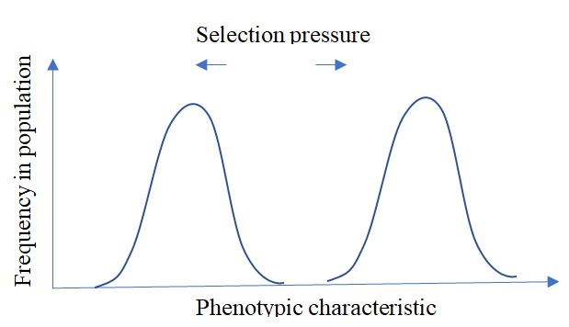
(ii) What ecological effect does the above type of selection have on the population?
(3marks)
    - It split the population into two subpopulations, each which may give rise to new species
    - It can also lead to appearance of different phenotypes within the population, i.e. polymorphism.

  - State the importance of genetic variation in natural selection? (2marks)
    - It can also lead to appearance of different phenotypes within the population, i.e.
polymorphism.
    - Genetic variation leads to phenotypic within a population, upon which natural selection acts.

Assay questions

68. (a) What is meant by genetic drift (04 marks)
Continental drift is the theory that the continents have moved across the Earth's surface over geological time. Proposed by Alfred Wegener in the early 20th century, it suggests that the continents were once joined as a single supercontinent called Pangea, which broke apart and drifted to their current positions.
(b) How can the genetic equilibrium of a population be upset? (9marks)
- Mutation: Any sudden, heritable change in the DNA sequence creates new alleles, directly altering the genetic makeup of a population and changing allele frequencies.
- Natural Selection: When certain genetic variations provide a survival or reproductive advantage, individuals with those traits pass them on more frequently, increasing the frequency of their alleles in the next generation.
- Gene Flow (Migration): The movement of individuals (and their genes) into or out of a population introduces or removes alleles, respectively, thereby changing the allele frequencies.
- Genetic Drift: Random fluctuations in allele frequencies, particularly significant in small populations, can lead to some alleles being lost and others becoming fixed by chance.
- Non-random Mating: When individuals choose mates based on specific traits (like assortative mating or inbreeding), it changes the distribution of genotypes, even if the overall allele frequencies remain the same.
- Large Population Size (Absence of Drift): While not a disruptive force itself, the lack of a sufficiently large population size allows genetic drift to have a greater impact.
(c) Explain how humans influence the evolution of species (7marks)
Humans influence evolution through

A. Habitat alteration
- Urbanization: New environments like cities can favor species that can adapt to them, such as rats and pigeons.
- Agriculture: The use of pesticides and herbicides creates intense selection pressure for resistance in weeds and insects.
- Deforestation: Removing forests causes habitat loss, which can drive some species to extinction and favor others that can survive in a more fragmented environment.

B. Direct selection
- Hunting and fishing: These activities select for individuals that are harder to catch, such as smaller fish that are more difficult to hook or animals that are less aggressive.
- Medical interventions: The widespread use of antibiotics has led to the evolution of antibiotic-resistant bacteria, a significant public health concern.
- Genetic engineering: Humans are directly changing the genetic makeup of species through selective breeding and genetic engineering, which is a form of artificial selection.
- Artificial selection: Human beings are able to select and allow breeding of animals or plants with characteristics at the expense of others. This may lead to emergence of bred animals or plants with the desired characteristics and extinction of the others.

C. Indirect selection
- Climate change: The warming climate is causing changes in ecosystems, such as earlier spring thaws, which can lead to a mismatch between the timing of breeding and food availability, placing pressure on populations.
- Invasive species: Humans have introduced many species to new environments, which compete with native species for resources and can alter the evolutionary trajectory of native populations.
- Pollution: Chemical and other pollutants can impose strong selective pressures on organisms, favoring those that can tolerate or metabolize the pollutants.

- (a) What is meant by the term natural selection? (3marks)
Natural selection is the process whereby organisms better adapted to their environment tend to survive and produce more offspring.
(b) Describe the role of each of the following in natural selection
  - Mutation (5marks)
Mutations are essential to evolution because it introduces genetic variations in a population that form a basis of natural selection.
  - Meiosis (8marks)
Meiosis is crucial for natural selection by generating genetic variation through processes like crossing over (prophase I) , independent assortment(metaphase I) and random segregation (metaphase II) providing diverse traits for selection to act upon, and producing haploid gametes for sexual reproduction, allowing for the combination and reshuffling of advantageous genes over generations. Genetic variations in a population form a basis of natural selection.

(c) Fertilization (fertilization) (4marks)
Fertilization's primary role in natural selection is to create genetic variation within a population, providing the raw material for selective pressures to act upon. By combining the unique genetic information from two parents, fertilization ensures that offspring are genetically different from one another and from their parents.
- (a) Explain what is meant by variation. (2marka)
Variation refers to any differences in traits among individuals of the same species, stemming from genetic (genotypic) or environmental factors. (b) How does meiosis contribute to variation? (07marks)
Meiosis generate variation through the following processes
  - Crossing Over: During Prophase I, homologous chromosomes exchange segments of DNA, creating new combinations of alleles (versions of genes) on each chromosome.
  - Independent Assortment: In Metaphase I, homologous chromosome pairs align randomly at the cell's center, leading to a unique mix of maternal and paternal chromosomes in each resulting gamete.
  - Random Segregation: The chromosomes further separate randomly into daughter cells (gametes), ensuring each gamete has a unique genetic blueprint.
  - Produces haploid gametes for sexual reproduction, enabling additional variations in offspring through random fusion alleles during fertilization
(c) Describe the role of variation in evolution. (11marks)
Variation is the raw material for evolution, providing the diverse traits within a population that natural selection acts upon, allowing species to adapt to changing environments, resist diseases and pollution, and ultimately survive, evolve and increase their chances to survive in different habitats/environment, Without variation, there would be no differences for advantageous traits to be selected for, and populations would struggle or fail to adapt to new challenges, increasing their risk of extinction.
- (a) Explain the following
    - Genetic isolation (2marks)
Genetic isolation occurs when mating can occur but fertilization is not possible and/or even when it occurs, the product is a sterile or inferior offspring. This is due to incompatible genetic constitution between organisms of a population.
    - Reproductive isolation (3marks)
Reproductive isolation is the inability of closely related species or populations to interbreed and produce viable, fertile offspring.
(b) Explain how the gene frequency of a population may be altered. (15marks)
  - Mutation: Any sudden, heritable change in the DNA sequence creates new alleles, directly altering the genetic makeup of a population and changing allele frequencies.
  - Natural Selection: When certain genetic variations provide a survival or reproductive advantage, individuals with those traits pass them on more frequently, increasing the frequency of their alleles in the next generation.
  - Gene Flow (Migration): The movement of individuals (and their genes) into or out of a population introduces or removes alleles, respectively, thereby changing the allele frequencies.
  - Genetic Drift: Random fluctuations in allele frequencies, particularly significant in small populations, can lead to some alleles being lost and others becoming fixed by chance.
  - Non-random Mating: When individuals choose mates based on specific traits (like assortative mating or inbreeding), it changes the distribution of genotypes, even if the overall allele frequencies remain the same.
  - Large Population Size (Absence of Drift): While not a disruptive force itself, the lack of a sufficiently large population size allows genetic drift to have a greater impact.
- (a) (i) Giving an example, explain what is meant by discontinuous variation? (3marks) Discontinuous variation is a clear – cut difference between the characteristics of individuals of the same population e.g. blood groups, tongue- rolling, sex (male or female) etc.

(ii) How does sexual reproduction cause variation? (8marks)
Variations are generated during sexual reproduction in the following ways
      - Crossing Over: During Prophase I, homologous chromosomes exchange segments of DNA, creating new combinations of alleles (versions of genes) on each chromosome.
      - Independent Assortment: In Metaphase I, homologous chromosome pairs align randomly at the cell's center, leading to a unique mix of maternal and paternal chromosomes in each resulting gamete.
      - Random Segregation: The chromosomes further separate randomly into daughter cells (gametes), ensuring each gamete has a unique genetic blueprint.
      - Random fertilization: Random fusion of gametes produces offspring of infinitely unique genetic combinations in each offspring.
(b) Explain how the environment influences the process of natural selection? (9marks) The environment is the primary driver of natural selection by creating selective pressures (like predation, resource scarcity, or climate) that favor
certain inheritable traits (adaptations) over others. These environmental factors determine which existing genetic variations within a population are beneficial, harmful, or neutral, ultimately influencing which organisms are more likely to survive and reproduce, thereby shaping the genetic makeup of future generations.
- (a) Give the different forms of isolation of species (3marks)
  - Stabilizing selection
  - Direction selection
  - Disruptive selection
(b) How may each of the forms of isolation given in (a) above lead to formation of species (17marks)
Directional selection can lead to species formation by causing populations to adapt to new or changing environments, leading to shifts in traits and genetic divergence. Over time, this consistent selection for one extreme of a trait can result in reproductive isolation between diverging populations, eventually forming distinct new species.

Stabilizing selection reduces phenotypic variation within a population by favoring intermediate traits and selecting against extreme phenotypes, leading to a more genetically uniform population centered around an optimal average. This process maintains the status quo, making populations less diverse and more suited to stable environments, but decreases their capacity to evolve rapidly if environmental conditions change. .

Disruptive selection, by favoring extreme traits over intermediate ones, increases genetic diversity, creates distinct subpopulations, and can ultimately drive the formation of new species (speciation) by leading to reproductive isolation between the favored extremes. This process results in a population with two or more distinct forms rather than a single average form.

- (a) What is meant by the following phenomena?
  - Natural selection
Natural selection is the process whereby organisms better adapted to their environment tend to survive and produce more offspring.
  - Reproductive isolation
Reproductive isolation is the inability of closely related species or populations to interbreed and produce viable, fertile offspring.

  - Polyploidy (4marks)
This occur when there is an increase in the entire haploid sets of chromosomes; i.e., 3n triploid], 4n [tetraploid]

  - Explain the role played by each of the phenomena in (a) above in evolution of new
species (11marks)

  - How may species become extinct? (5marks)
Species become extinct when they can no longer survive and reproduce in their environment, often due to habitat loss and degradation, climate change, invasive species, pollution, and overexploitation by humans, though natural disasters and slower evolutionary changes can also be causes. Extinction is the complete disappearance of a species, which can occur gradually or rapidly during mass extinction events.
- Describe how new species of organism may arise (20marks)
Development of new species is referred to as speciation. It occurs through genetic isolation, genetic divergence to reproductive Isolation when new species is formed
Key mechanisms include allopatric speciation (geographic separation) and sympatric speciation (isolation without physical separation), with factors like polyploidy and hybridization also playing crucial roles.
Speciation occurs through the following processes

1. Isolation of Gene Pools
For new species to form, the gene pools of two or more populations must become separated so that no gene flow occurs between them.
- Geographic Isolation (Allopatric Speciation): A physical barrier (e.g., a mountain range, river, or ocean) divides a population, leading to independent evolution in different environments.
- Habitat Isolation: Populations in the same area diverge in their preferred habitats or resources, leading to reduced interbreeding.
- Temporal Isolation: Populations begin to breed at different times of the day or year.
- Behavioral Isolation: Different mating rituals, songs, or recognition signals prevent successful reproduction.

2. Genetic Divergence
Once isolated, different evolutionary forces act on each population:
- Natural Selection: Different environments favor different traits, leading to adaptations unique to each population.
- Mutation: Random changes in DNA introduce new genetic variations.
- Genetic Drift: Random fluctuations in gene frequencies, especially significant in small populations (like the founder effect), can lead to rapid divergence.

3. Reproductive Isolation
Over time, genetic differences accumulate to the point where individuals from the two diverging groups can no longer produce viable, fertile offspring, thus becoming separate species.
- (a) State five evidences of evolution.
(b) To what extent do the evidences you have stated in (a), support the theory of evolution?
Ref. page 65
- (a) Distinguishes between continuous and discontinuous variation. (02marks)
Continuous variation in genetics refers to traits with a range of small differences, while discontinuous variation refers to traits with distinct categories.
  - Explain how each of the following causes variation in sexually reproductive organism.
    - crossing over during mitosis (03marks)
During Prophase I, homologous chromosomes exchange segments of DNA, creating new combinations of alleles (versions of genes) on each chromosome.
    - independent assortment of chromosomes during meiosis (05marks)
In Metaphase I, homologous chromosome pairs align randomly at the cell's center, leading to a unique mix of maternal and paternal chromosomes in each resulting gamete.
- (a) Giving examples, explain effect of
    - Increasing selection pressure on a population (07marks)
Increasing selection pressure accelerates the rate of evolution by more strongly favoring certain advantageous traits, leading to faster adaptation, reduced genetic diversity, and potentially rapid shifts in dominant phenotypes within the population. For example, a sudden rise in predators will quickly select for camouflage or speed, while intense antibiotic use drastically increases the pressure on bacteria to develop resistance.
    - Stabilizing selection pressure on a population (07marks)
Stabilizing selection is a type of natural selection that favors the average or intermediate phenotype in a population by selecting against the extreme variations of that trait. This pressure reduces phenotypic variation and maintains the status quo, which is common in stable environments where the "average" version of a trait is the most advantageous. The individuals with extreme traits become less common, while individuals with the intermediate trait become more prevalent.
Example, in human average birth weight of about 3.2 kg is favored. Underweight babies are more susceptible to disease and heat loss, while large babies are associated with complications during childbirth for both the baby and the mother.
  - Explain hoe comparative anatomy supports the process of evolution (06marks) Comparative anatomy supports evolution by revealing homologous
structures (indicating common ancestry), analogous structures (showing convergent evolution), and vestigial structures (demonstrating evolutionary reduction), all of which point to shared origins, divergent adaptations, and modification of body plans over time.

- (a) Table 1 shows the number of individual with a given length of fur in a population of terrestrial mammalian species for two different generation. The prevailing climatic temperature during the two generations changed from 15⁰C to 10⁰C.
Length of fur  (cm) | Number of individuals
Length of fur  (cm) | At 15⁰C | At 10⁰C
1.00 | 0 | 0
1.25 | 25 | 0
1.50 | 60 | 0
1.75 | 120 | 20
2.00 | 155 | 60
2.25 | 120 | 130
2.50 | 60 | 155
2.75 | 25 | 130
3.00 | 0 | 60
3.25 | 0 | 20
3.50 | 0 | 0
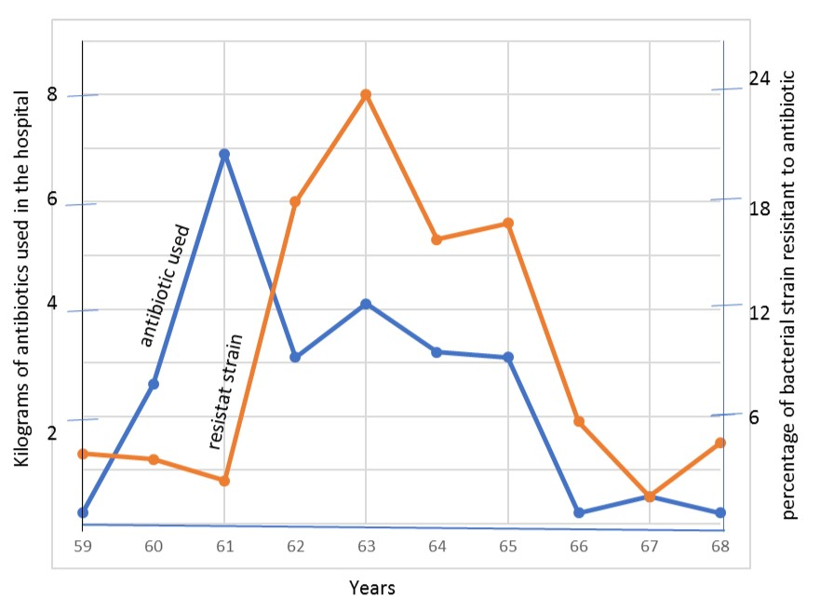
Figure 1

- Draw a graph of the relationship between fur and number of individuals at the two temperatures (08marks)
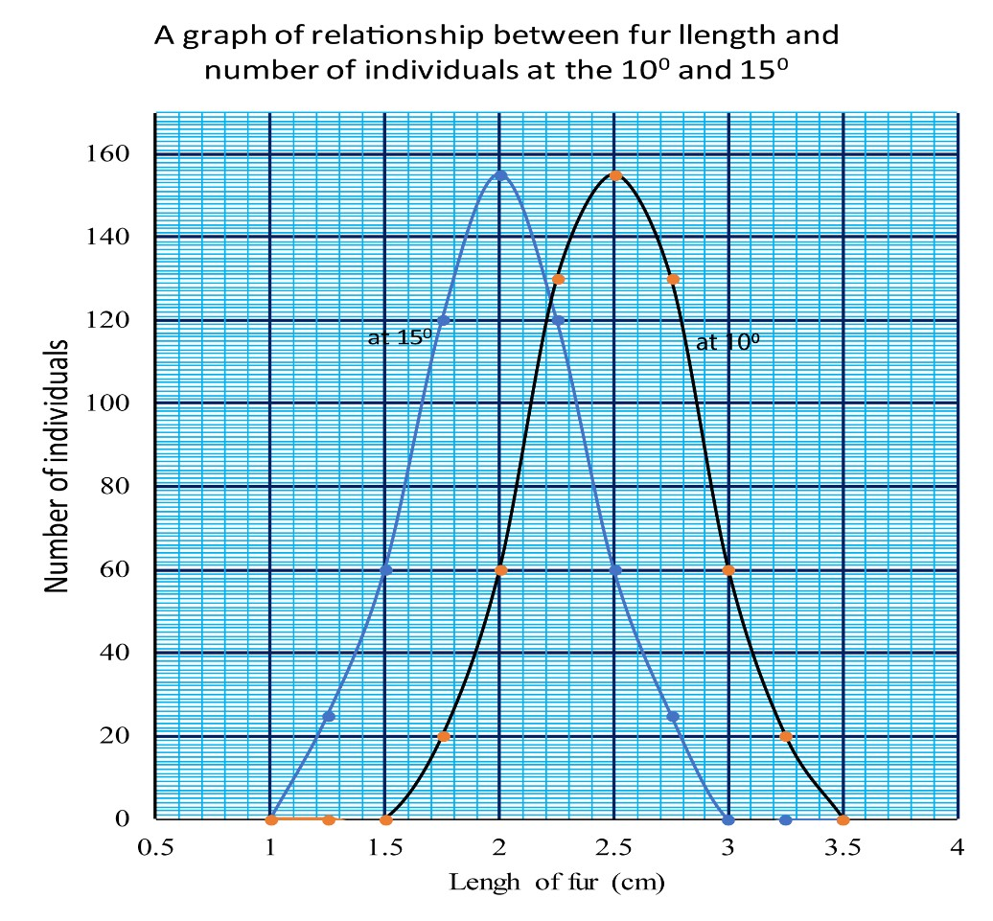

- What is the optimum length of fur at each temperature? (2marks)
At 10⁰C, optimum length is 2.5cm At 15⁰C, optimum length is 2.0cm

- (i) What is the effect of temperature on fur length among the individuals? (03marks) Temperature directly affects the length of fur among the individuals. High temperature induces growth of short fur while lower temperature induces growth of long fur among the individuals.
(ii) Suggest an explanation for the effect of temperature on fur length. (05marks)
Low temperature induces growth longer hair to provide insulation to the animal.
When an animal feels cold, cold the erector Pilli muscles in the skin contract and make the fur stand. This traps a layer of air which is an insulator between them and so prevents heat loss from the body by conduction.
The longer the fur the greater the amount of air trapped and the more efficient the insulation process.
This explains why animals in the cooler environments have developed longer fur as they have a greater tendency to lose heat than those in the warmer environment.
- (i) From figure 1, describe the trend of resistant strain with amount of antibiotics used (3marks)

The number of resistant strains reduces gradually as the amount of antibiotics increases rapidly in the 59 to 61 years period.
Thereafter, the number of resistant strains increases very rapidly to a peak as the amount of antibiotics is reduced in the 61 to 63 years period.
Finally, the number of resistant strains reduces as the amount of antibiotics used is reduced.
(ii) Suggest an explanation for the observed trend of resistant strains with the amount of antibiotic used (03marks)
The number of resistant strains reduces initially because of the susceptibility the bacteria to the antibiotics being used.
The number then increases rapidly, thereafter, because the present resistant strains reproduce rapidly to produce rapidly offspring that are not affected by the antibiotics used.
Reduction in number of resistant strains the amount of antibiotics is reduced is due to increased competition for food and space.

- A bacterium is a haploid organism that produce asexually by fission, twice every minute on average. Using this information, explain the rapid emergence of resistant strain (06marks)
Bacteria occur in such large numbers that there is a high chance of a resistant strain eventually appearing in the population due to random mutations.
As soon as this happens, use of antibiotics acts as the selection pressure, causing the vulnerable bacteria to die and leaving the resistant strains, with a survival advantage to continue growing.
Due to their high reproductive rate, the resistant strains rapidly multiply and exponentially increase in number.
- The data in table 1 and figure 1 illustrate the process of natural selection. State the selection pressure in each case (02marks)
In table 1, the selection pressure is temperature variation.
In figure 1, the selection pressure is the antibiotics used.
- Giving a reason in each case, predict what the effect of each of the following would be (i) If the use of antibiotics was stopped for a year. (05marks) the number of resistant strains of bacteria would decrease drastically.
Explanation
Resistant strains are mutants and therefore few in the general population of the bacteria.
They develop by chance and are given better survival advantage by the presence of antibiotics.
Stopping antibiotics for 1 year removes the selection pressure.
Non-resistant strains then survive better than the resistant strains.
The number of resistant strains then reduces as a result of competition for food and space
(ii) If the generation of the terrestrial mammal at a prevailing temperature of 10⁰C was supplied with an abundance of food (03marks) there would be reduction in length of fur.
Explanation
Abundant food supply provides enough raw materials for metabolism and therefore production of enough heat energy to counter the heat loss. The role, earlier performed by long fur, would be taken over by metabolism and so long fur would not be necessary.

TOPIC 2/2: Growth in Plants and Development in Insects
Competency: The learner justifies changes in the size and complexity of plants and insects, through data analysis of research findings, in order to develop strategies to improve agricultural productivity and environmental sustainability.
Table of Contents
Growth and development 2
Measuring growth 2
Meristems 4
Experiments to determine the region of growth in a root 5
Germination 6
Physiology of seed germination 7
Seed Dormancy 9
Importance of seed dormancy 9
Causes of seed dormancy 9
How to break seed dormancy 9
Seed banks 10
Growth in arthropods 11
The role of insect growth stages in ecosystems 12
The role of insect growth stages in Waste management 12
The role of insect growth stages in Food security 13
The role of insect growth stages in Water quality assessment 13

Growth and development
Growth is a permanent increase in size of an organism by addition of more body substance. The pattern of growth differs in different organisms. For plants however, have particular regions where they grow, called meristems.
Apical meristems are responsible for increase in length while secondary meristems are responsible for increase in girth or diameter of the stem. Three distinct process of contribute to growth; cell division, assimilation, and cell expansion.
Development; involve both an increase in size and differentiation of cell so that they become specialized.

Measuring growth
Growth can be quantified by measuring some features of the organism at suitable interval such as
- Length: this is easy to do and does not damage the organism but results may be misleading because it takes no account of growth in other direction.
- Area and volume are more accurate than measuring length but are impractical to measure.
- Fresh mass: this is easy to measure but may be inaccurate due to temporary fluctuation in water content
- Dry mass: this involves removing all water by drying before weighing. It is accurate but difficult to carry out and kills the organism

Growth curves
When any parameter is measured against set intervals of time, a growth curve is produced. Form many populations, organism or organs, the curve is S-shaped or sigmoid curve. It represents a slow growth at first, because there are so few cells initially that even when they are dividing rapidly the actual increase in size is small.

Please find free notes, tests and marking

The sigmoid growth curve

Growth parameter

Time

O

A

B

C

Explanation of the graph

OA: Slow growth due very dividing cells

AB: Exponential growth due to presence of big
number of dividing cell

BC Growth slows down and finally stops due

rate of
cell division equal to rate of cell death or cell
division limited by the genotype of the animal.

Limited and unlimited growth
Growth in plant and animal show two basic of growth i.e. limited [definite or determinate] growth and unlimited [indefinite or indeterminate] growth
Growth in annual plants
Growth in annual plant is limited and after a period of maximum growth, during which the plant matures and reproduce, there is a period of negative growth or senescence before the death of the plant. If the dry mass of the annual plant is plotted against time then sigmoid curve given below as obtained
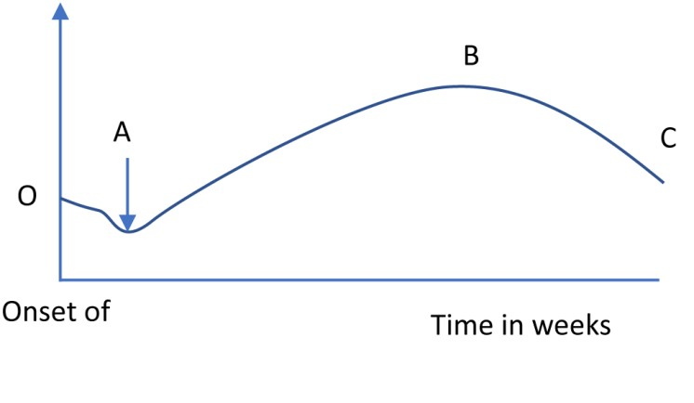
Explanation of the graph
-The negative growth in the first week is due to respiration of food reserves in the seed
-At A, the green leaves have now grown and opened above ground.
-Along AB dry mass increases because photosynthesis is greater than respiration
-Along BC, dry mass decreases due to dispersal of fruits and seed, loss of leaves / chlorophyll and high respiration as compared photosynthesis.

Several organs show limited growth but do not undergo a period of negative growth e.g., leaves and stem internodes. Animals that show limited growth include insects, birds and mammals.

Unlimited growth is seen in woody perennial plants and some invertebrates, fishes and some reptiles

In plants growth only occurs in group of immature cells called meristems.

Meristems
A meristem is a region of plant tissue, found chiefly at the growing tips of roots and shoots and in the cambium, consisting of actively dividing cells forming new tissue

The meristem has a number of defining features, including small cells, thin cell walls, large cell nuclei, absent or small vacuoles, and no intercellular spaces.
It is divided into three zones.
- The zone of cell division is closest to the tip and is made up of the actively-dividing cells of the root meristem, which contains the undifferentiated cells.
- The zone of elongation is where the newly-formed cells increase in length, thereby lengthening the root and shoot
- The zone of cell maturation where the elongated cells differentiate into specialized cell types

There are three types of meristems: -

- Apical meristems: these are found at the tips of roots and shoots and are responsible for primary growth of the plants i.e., increase in length.

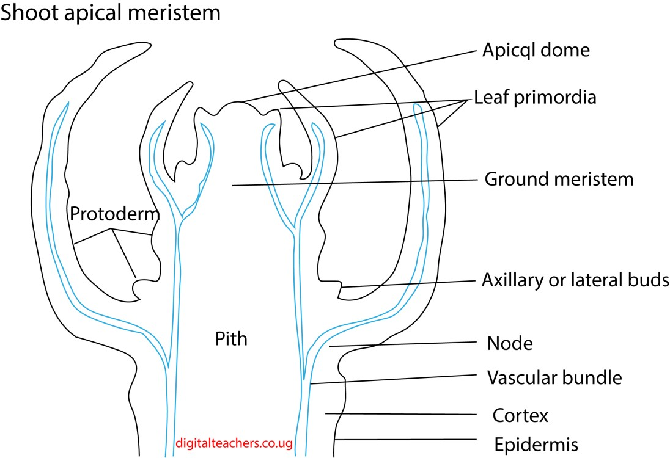

Role of apical meristem in growth
- Cell division and elongation causes increase in length
- Bud primodium give rise to bud which can develop gives rise to branches
- Pro-cambium gives rise to vascular tissue

Root cap meristem
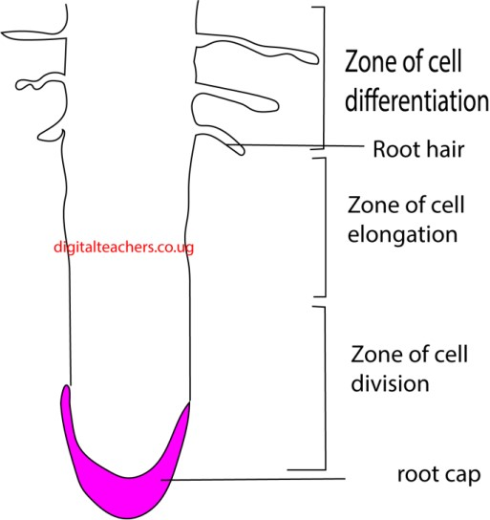
Role of root cap meristem
- Root cap protects the delicate root tip
- Cell division and expansion leads to increase in leangth
- Cell differentiation leads to formation of differents tissues

- Lateral meristems: these are found in a cylinder towards the outside of the stem and roots. They are responsible for secondary growth and cause increase in girth.
- Intercalary meristems: these are found at the nodes in monocotyledonous plants. They allow an increase in length in positions other than the tip.

Experiments to determine the region of growth in a root
- Take a freshly-germinated bean with a root about 2.5cm long. Mark the root every 2mm with line in permanent black ink.
- Pin the bean to the underside of a cork, with the root hanging downwards, and put the cork into the moist cotton wool
- After 2-3 days, the region of growth is indicated by the part where the black line are linger than 2mm.
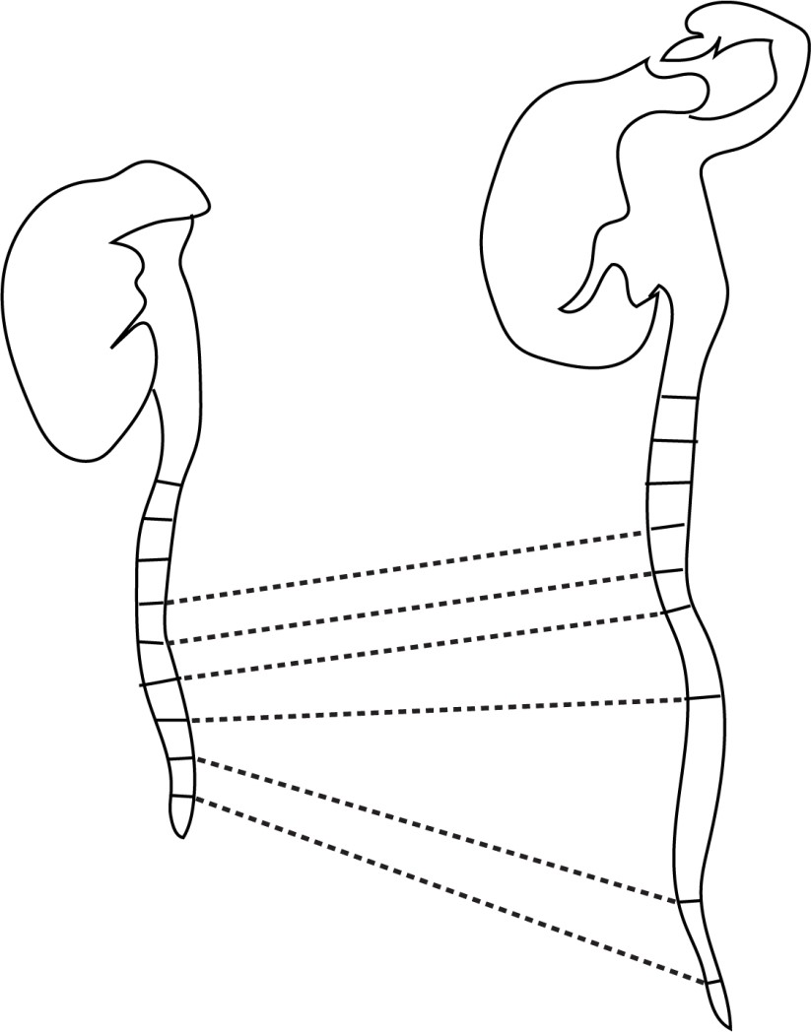

Germination
Seed germination may be defined as the fundamental process by which different plant species grow from a single seed into a plant
Conditions necessary for germination
1. Water
The role of water in seed germination may be
- Dissolve and leak away germination inhibitors
- Soften and rapture seed coat to allow in water and oxygen
- hydrate vital activities of protoplasm
- converts the insoluble food into soluble form for its translocation to the embryo
- Oxygen is necessary for aerobic respiration
- Temperature; moderate temperature (25 – 300C) activates enzymes.

Others
- Light: some seed require exposure to sunlight before they germinate
.
Experiment to demonstrate conditions necessary germination
Prepare 4 test tubes as follow
Test tube 1: place dry seeds on cotton and place in a test tube in a warm place such that seed are provided with air and warmth but no water
Test tube 2: seeds on a cotton wool are placed in a test tube full of freshly boiled and cooled water and then covered with oil to prevent entry of air.
Test tube 3: seeds in soaked cotton wool are placed in an open test tube and placed in a warm place. These seed have warmth, oxygen and water
Test tube4: seeds in soaked cotton wool are placed in an open test tube and test tube placed in a a beaker if ice
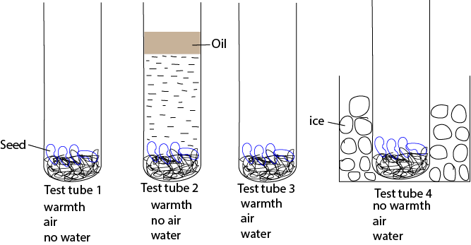
The setup is left for a few days
Observations
Seeds in test tube 3 germinated because they were provided with warmth, oxygen and water

Physiology of seed germination
- Germination starts with the rapid uptake of water by the seed through the micropyle by a process called ambition. Water then moves from cell by osmosis.
- The water causes swelling of the embryonic tissue thereby rapturing the seed coat and also activates gibberellins.
- Gibberellins diffuse to the aleurone layer (a special layer which one cell thick that surrounds the endosperm). Here gibberellins cause the synthesis and activation of hydrolytic enzymes such as amylase and proteases.
- Amylase catalyzes the breakdown of starch to glucose while proteases catalyze hydrolysis of proteins to amino acids.
- Glucose and amino acids are translocated from the storage centre (endosperm or cotyledon) of the seed to the growing regions of the embryo.
- Here glucose is used in respiration and in the formation of cellulose and other cell wall materials. Amino acids are used to make proteins, which are enzymes and structural components of protoplasm.
- Cell division, elongation and differentiation leads to immergence of a seedling from a seed.
Types of germination
- Epigeal germination
Here hypocotyl grows faster than epicotyl causing the cotyledon to grow above ground
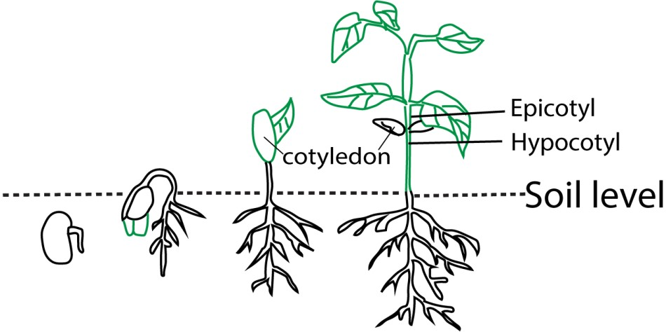
- Hypogeal germination
Here epicotyl grows faster than hypocotyl that the cotyledons remain under the soil.
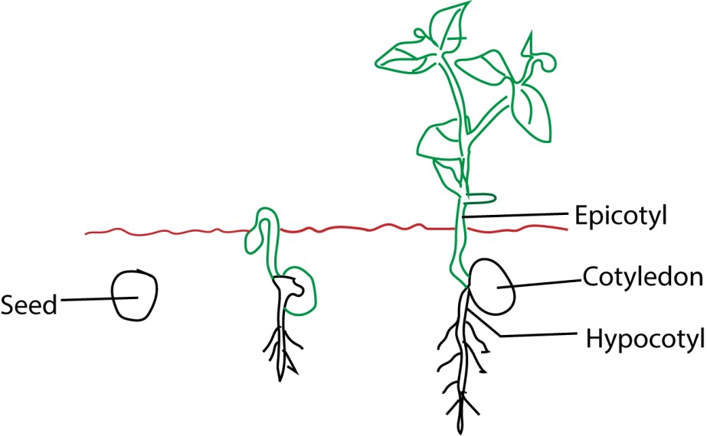

Seed Dormancy
Is the state in which a seed that is viable will not germinate even if the conditions that are necessary for germination are provided?
Dormant seed are usually dry, their metabolic activity is much reduced and they respire anaerobically.

Importance of seed dormancy
- Seed are able to withstand adverse external conditions such as very cold or very dry whether.
- It allows seed and fruits to disperse

Causes of seed dormancy
The main factors that causes the seed dormancy are:
- Seed coats impermeable to water and oxygen:
- hard seed coats that prevent the expansion of embryo.
- Immature embryo
- Presence of germination inhibitor
- Absence of light required for germination of seeds

How to break seed dormancy
- scarification (mechanically or chemically weakening the seed coat)
- stratification (chilling seeds
- leaching inhibitors (soaking seeds to remove chemicals).

- Exposure of seeds to light
- Use of growth regulator

Seed banks
Seed banks are facilities that store seeds to preserve genetic diversity for future use, often in cold, dry conditions to ensure viability. They are a critical tool for safeguarding crops against threats like disease, environmental disasters, and climate change. There are different types, including large-scale global reserves like the Svalbard Global Seed Vault and smaller community seed banks that serve local farmers, which can also improve local food security and empower communities.
Importance of seed banks
- Preserving Genetic Diversity: Seed banks store seeds with a wide range of genetic traits, which are essential for plant breeders to develop new crop varieties that are more resistant to disease, drought, and pests.
- Safeguarding Against Catastrophe: They act as a "backup" against global events like environmental disasters, wars, or climate change that could wipe out existing crops in the field.
- Supporting Food Security: By preserving a wide variety of seeds, seed banks help ensure that future food security is not dependent on a narrow range of crops.
- Improving Local Agriculture: Community seed banks can be particularly impactful, helping farmers access a wider range of seeds, learn new management techniques, and build stronger social cohesion.
How seed banking works
- Collection: Seeds are collected from various sources, including wild plants and diverse crop varieties.
- Preparation: Collected seeds are cleaned, dried under controlled conditions, and tested for viability.
- Storage: Seeds are stored in sealed containers in cold, dry vaults to maximize their lifespan.
- Testing: Seeds are periodically tested to ensure they remain viable for long-term storage.
- Withdrawal: Seeds can be withdrawn for planting or research purposes when needed.

Growth in arthropods
Due to inelastic nature of their exoskeletons, they appear to grow only in spurts interrupted by a series of moults. Significant growth is only possible when the new cuticle is still soft enough to allow the body to expand
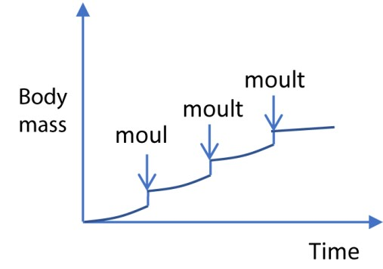
Arthrop
od growth curve

Moulting is controlled two main hormones: moulting hormones (ecdysone) and juvenile hormone. Moulting hormone is produced by gland in the first thoracic segment called prothoracic gland. Juvenile hormone is produced by a region behind the brain known as the corpus allatum. The production of both hormones is controlled by neurosecretory cells in the brain. All moults require moulting hormone. If juvenile hormone is present in high concentration larval moults occur, which means the insect remains as a larva.
Metamorphosis
Applies to those changes which occurs during the transition from larval to adult forms. It is very common in insect, frog and other amphibian’s metamorphosis enable the different stage organism develops to fill different ecological niches which reduces competition.

Complete metamorphosis
E.g. in butterfly


egg

Adult

Larva

Pupa

Incomplete metamorphosis
E.g. in cockroach

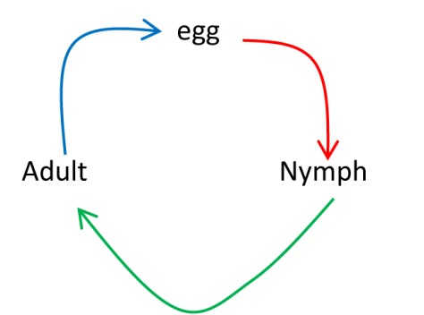

The role of insect growth stages in ecosystems
The developmental stages of insects play specialized roles in an ecosystem's functions, contributing significantly to waste management, food security, and water quality. Larvae, nymphs, and adults each interact differently with their environment to process waste, serve as food, and act as bioindicators.

The role of insect growth stages in Waste management
Different insect growth stages perform distinct roles in breaking down organic waste and recycling nutrients.
- Larval and nymphal stages: As detritivores, the immature stages of many insect species are the primary drivers of decomposition. They consume and fragment organic matter such as dead plants, carrion, and animal feces.
- Black soldier fly larvae (BSFL): These larvae have a voracious appetite and are highly effective at converting massive amounts of food waste, manure, and agricultural byproducts into high-protein biomass and nutrient-rich fertilizer (frass). The commercial farming of BSFL is a low-impact and efficient method for large-scale biowaste treatment.
- Dung beetles: Both adult and larval dung beetles feed on animal feces, recycling valuable nutrients and preventing nitrogen loss into the atmosphere. Their tunneling activity also aerates the soil, improving its structure and fertility.
- Blowflies and flesh flies: The larvae of these flies, known as maggots, are among the first responders to decomposing animal carcasses, accelerating their breakdown and the recycling of nutrients.
- Adult stage: While adult decomposers are less active in direct consumption, they are crucial for reproduction and waste localization. For instance, adult blowflies seek out and lay eggs on decaying matter, initiating the decomposition process.

The role of insect growth stages in Food security
Insects are a highly efficient and sustainable source of protein that can be harvested or farmed, providing food and feed at multiple stages of their life cycle.
- High conversion efficiency: Because insects are cold-blooded, they are extremely efficient at converting feed into body mass compared to traditional livestock.
- Larval and pupal stages: These stages are often the most nutrient-dense and harvested for consumption.
- Human food: Edible insects like caterpillars, beetles, grasshoppers, and crickets are a traditional and increasingly popular food source for humans in many parts of the world, providing high-quality protein, fatty acids, and micronutrients like iron and zinc.
- Animal feed: The larvae of species like the black soldier fly and mealworm are farmed commercially to produce protein-rich feed for poultry, fish, and other livestock. This provides a sustainable alternative to traditional feed ingredients like soy and fishmeal.
- Adult stage: Some species of adult insects, such as locusts and grasshoppers, are harvested and eaten. As pollinators, adult bees, wasps, and butterflies also indirectly contribute to food security by ensuring the reproduction of crops and wild plants.

The role of insect growth stages in Water quality assessment
Because they spend part or all of their lives in aquatic environments, many insects are sensitive bioindicators of water quality. Their presence, absence, or abundance can signal the level and type of pollution in a water body.
- Larval stage: The larval and nymphal stages of aquatic insects are especially useful for monitoring water quality because they are immobile and have varying levels of pollution tolerance.
- High-sensitivity bioindicators: The larvae of mayflies (Ephemeroptera), stoneflies (Plecoptera), and caddisflies (Trichoptera), known collectively as EPTs, require clean, well-oxygenated water to survive. Their presence indicates good water quality, while their absence is a sign of pollution.
- Low-sensitivity bioindicators: The larvae of midges (Chironomidae) and certain flies can tolerate low levels of dissolved oxygen and a range of pollutants. Their presence in high numbers, especially without EPTs, can indicate marginal to poor water quality.
- Specialized indicators: Some insect larvae, like those of certain aquatic midges, have been found to ingest and expel microplastics, making them potential tools for assessing microplastic pollution in freshwater.
- Adult stage: While less direct, the health of adult insect populations (e.g., dragonflies) that emerge from a water body can reflect the long-term health of that aquatic ecosystem.

Revision Exercise
- Which one of the following graphs in the figure below correctly represents the growth rate of multicellular organism?


C

Growth rate

time

Growth rate

time

Growth rate

time

Growth rate

time

A

B

C

D

- Worker bees and queen bee are polymorphic forms which differ in fertility as a result of
  - Feeding on different diet
  - Worker’s eggs not being fertilized
  - Workers being produced parthenogenetically
  - The queen having diploid cells while workers have haploid cells A
- Worker bees are
  - Sterile females developed from fertilized eggs
  - Fertile male developed from unfertilized eggs
  - Sterile females developed from unfertilized eggs
  - Fertile female developed from unfertilized eggs A

- Primary growth in plants is mainly the activity of A. lateral meristems.
  - apical meristems.
  - primary meristems.
  - intercalary meristems. B
- .When are gibberellins formed in the germinating starchy seed?
A. After water absorption. B. After production of amylase.
C. When the radicle emerges. D. During the production of amylase. A
- The figure below shows changes in mass of growing seedling with time
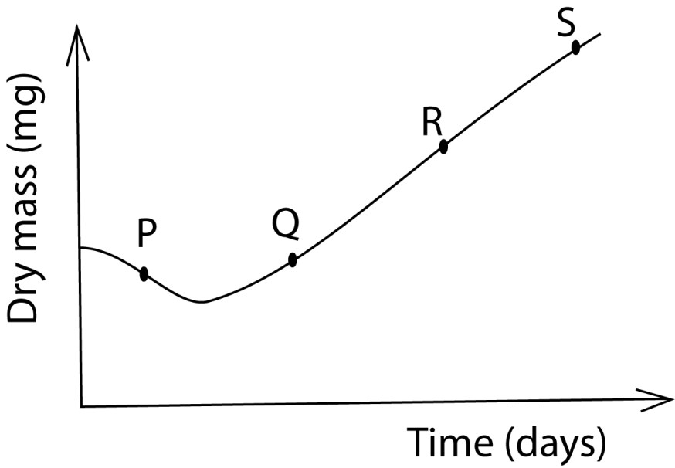
Which part of the curve indicates growth where respiration is higher than photosynthesis?
- R
- S
- P
- Q C
- The significance of Etiolation in germinating seed in the soil is that is A. Leads to rapid elongation of the hypocotyl in monocotyledonous plant
    - Allows maximum growth in length with minimum use of food reserves
    - Allows seedlings to grow in the dark
    - Ensure leaves remain small to break through the soil. B

- The primary meristematic tissues in plant which gives rise to the cortex is the
    - Ground meristem
    - Procambium
    - Protoderm
    - Protoxylem A
- In higher plants, the lateral roots originate from the
    - Endodermis
    - Epidermis
    - Pericycle
    - Cambium. C Structural questions
- (a) What is the role of apical meristem in root growth? (7marks)
Root apical meristem (RAM) performs the following roles in root growth
  - Primary Growth (Length Increase): The RAM is the site of cell division (mitosis), creating new cells that elongate and push the root through the soil, thus increasing its overall length.
  - Cell differentiation gives rise to different kinds of root tissues
  - Primary vascular tissue growth contributes to increase in the girth of the root.
  - Lignification of xylem cells contributes to support.
  - Formation of distinct primary meristems; Protoderm (Forms the outer protective layer, the epidermis (or rhizodermis in roots).), Procambium (Develops into the primary xylem and phloem, which are responsible for water and nutrient transport), Ground Meristem (Forms the cortex, which stores nutrients, and the endodermis, which regulates water movement into the vascular cylinder)
  - Root Cap Formation: The RAM produces the root cap, a protective layer of cells that shields the delicate meristem from abrasive soil particles as the root grows.
  - Pericycle Development: The procambium differentiates into the pericycle, which is crucial for the emergence of lateral roots.
  - Geotropism: The RAM is sensitive to gravity, growing downwards (positive geotropism) to anchor the plant and seek water.

(b) Describe the formation of secondary tissues in dicotyledonous plant. (13marks)
Secondary tissue formation in dicotyledonous plant occurs by lateral meristems and leads to secondary growth or thickening Lateral meristems include
- Vascular cambium
This divides into three layers of cells; the inner layer differentiates into secondary xylem; the outer layer into secondary phloem; while the inner layer remain meristematic. Phloem distributes manufactured food while the xylem transports water and provides mechanical support
- Cork cambium/phellogen
Divides into three layers of cells; the inner differentiates into secondary cortex, the outer cork while the inner remain meristematic.

12. Figure 5 shows change in dry mass of the embryo, endosperm and total mass of maize seeds germinating in light condition.
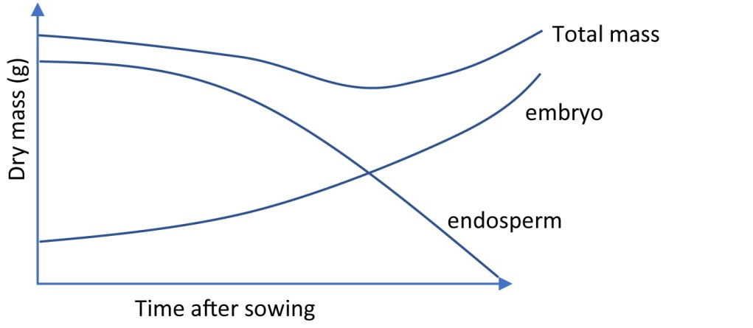

- Explain the changes in relative dry mass of the
(i) endosperm
The dry mass of the endosperm decreases during germination because its stored nutrients, such as starches, proteins, and lipids, are hydrolyzed into simpler compounds (like glucose and amino acids) and used for growth embryo and respiration (ii) embryo
The dry mass of an embryo increases during germination because it uses food reserves to cell division and growth. Later food from photosynthesis is also used.
- Explain why the total dry mass of the seedling initially decreases then later increases
The initial decrease in the total dry mass is due to the respiration of food reserves from endosperm. Later, the total dry mass increases as the first foliage leaf emerges and starts to photosynthesize. The carbohydrate formed more than compensate for the respiration losses so that there is a net increase in total dry mass.
- Suggest with reason, what would happen to the total dry mass of seedling if the seeds were germinated in the dark
The total dry mass of the seedling would continue to decrease gradually until the seedling dies with no subsequent increases. This is because the food store would be depleted by respiration and no photosynthesis would occur in the dark compensate for the loss.

- The graph below shows changes in lipids and sugar content of castor oil seeds during germination in the dark
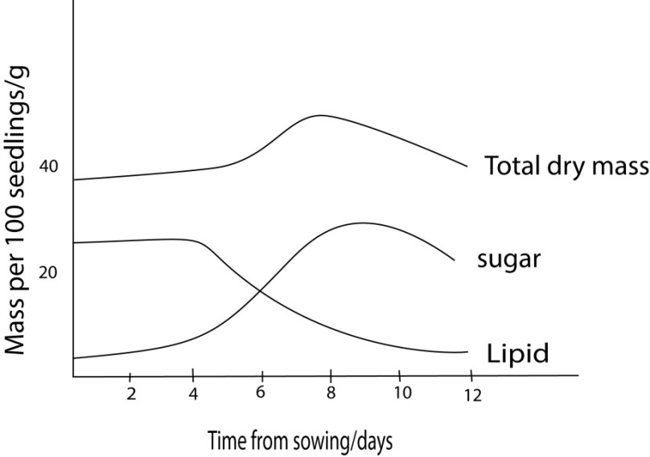
  - Explain the changes in lipid and sugar content and total dry mass during the experimental period.
    - The main storage food reserve is lipid
    - During germination, lipids decrease as they are broken down to fatty acids and glycerol
    - The fatty acids are either used directly for respiration or are converted to sugars. The sugar content therefore rises.
    - Sugar is translocated to the embryo
    - The dry mass at day 6, because of assimilation of sugars to structural materials and growth occurs.
    - Dry mass then fall because the lipids are exhausted and sugar decrease due to respiration
  - On the same graph indicate the shape of the curves if the seeds were to germinate in light (2marks)
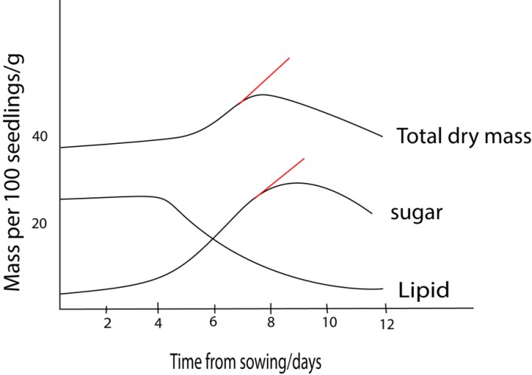
- (a) describe how the following tissues bring about growth in higher plants
(i) Apical meristem
      - Are found at the root and shoot apices - Meristematic cells initially divide by mitosis.
      - Some of the cells remain meristematic while others increase in size and differentiate to become permanent tissues.
      - Apical meristems increase lengths of root and shoot by increasing the number and size of cells at apices.
(ii) Vascular meristems
    - A lateral meristem consist of two types of cells fusiform and ray initials
    - Fusiform initials are elongated and divide by mitosis to form secondary phloem to the outside and secondary xylem on the inside. The amount of xylem produced normally exceeds the amount of phloem.
    - Ray initials are spherical and divide by mitosis to form parenchyma cells which accumulate to form rays between the neighboring xylem and phloem
Successive divisions results in increase in the girth of the plant (b) How does growth in mammals differ from that in flowering plants?
    - Growth control factors in plants are sensitive to environmental factors such as sunlight and gravitation pull while that of mammals does not.
    - Growth in plants is limited at the meristems while that of mammal occurs in all parts of the body

- The figure below shows the changes in dry weight of a germinating bean seed
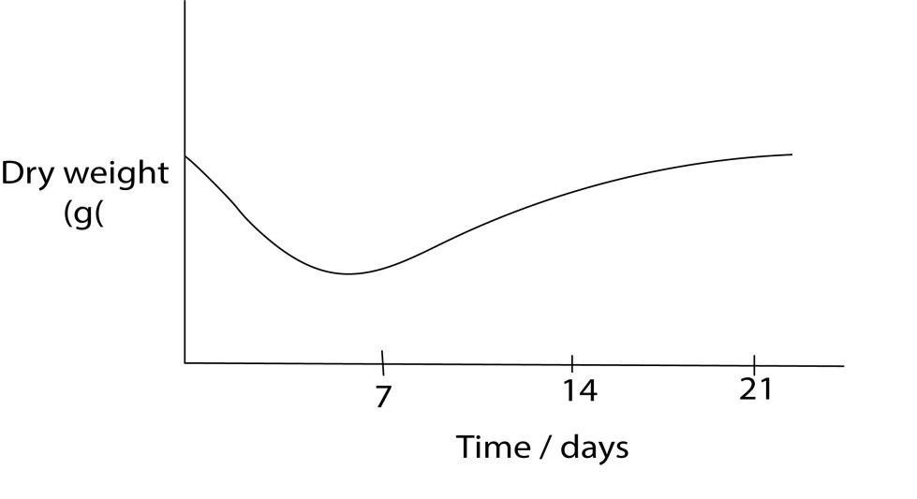
  - explain the changes
    - in the first seven (7) days
There is slow and then rapid decrease in dry weight due to respiration
    - between the seventh and 21 day

There is gradual increase in dry weight due to accumulation of sugars by photosynthesis.
  - Give the major factors that cause seed dormancy

    - hard impenetrable seed coat to water and oxygen
    - immaturity of embry
    - presence of germination inhibitors
    - unfavorable environment conditions
- (a) Describe the physiological changes that occur in a seed during germination (10 marks)
    - Germination starts with the rapid uptake of water by the seed through the micropyle by a process called ambition. Water then moves from cell by osmosis.
    - The water causes swelling of the embryonic tissue thereby rapturing the seed coat and also activates gibberellins.
    - Gibberellins diffuse to the aleurone layer whereby they cause the synthesis and activation of hydrolytic enzymes such as amylase and proteases.
    - Amylase catalyzes the breakdown of starch to glucose while proteases catalyze hydrolysis of proteins to amino acids.
    - Glucose and amino acids are translocated from the storage centre (endosperm or cotyledon) of the seed to the growing regions of the embryo.
    - Here glucose is used in respiration and in the formation of cellulose and other cell wall materials. Amino acids are used to make proteins, which are enzymes and structural components of protoplasm.
(b) Giving reasons, suggest suitable conditions under which seeds for planting should be stored (06 marks)
    - The suitable temperature for germination in most seeds is 25-30⁰C. Thus seeds should be kept at a temperature below this in order to prevent germination in these seeds.
    - Water is necessary for germination. Therefore, keeping seeds in a dry environment prevents germination and keeps the seed viable.
    - Light is important for germination in most seeds and therefore keeping them in darkness prevents germination and keeps the seed viable.
(c). Even when supplied with suitable conditions for germination, some seeds remain dormant, explain the importance of dormancy in seeds. (04 marks)
Dormancy allows for seed dispersal.
    - Seeds are able to survive unfavorable conditions like drought.
    - Dormancy prevents seeds from germination in the pods.
    - The low metabolic rate during dormancy enables seeds to stay viable for a long time.
- (a) Describe structural characteristic of cells of meristematic tissues. (03 marks)
Characteristics of meristematic tissues include small cells, thin cell walls, large cell nuclei, absent or small vacuoles, and no intercellular spaces.
    - Distinguish between apical and lateral meristems. (03 marks)
Apical meristem is the meristematic tissue at the tip of stem and roots, responsible for the primary growth or increase in length of the plant whereas lateral meristem is the meristematic tissue at the margins of roots and stems, which is responsible for the secondary growth or increase in girth of the plant.
    - Describe structural adaptation of vascular tissues for support. (14marks)
        - 1. Walls are lignified
        - 2. Vessels are circular for additional support.
- The figure below shows the accumulation of dry matter of bean plant measured at different stages of growth from plating up to harvesting time. Study the figure and answer the questions that follow.
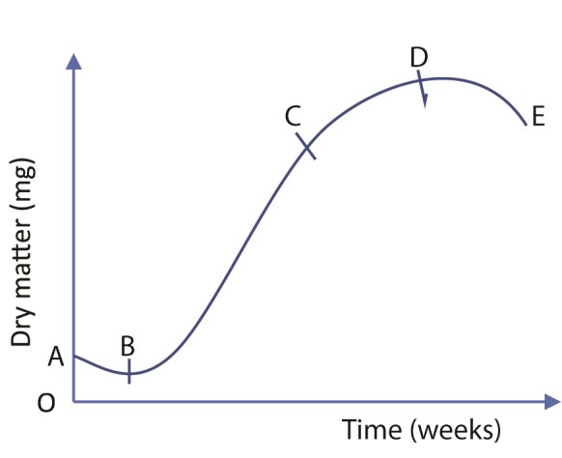
  - Name the different stages
    - A – B: lag phase/establishment stage
    - B – C: logarithmic stage/rapid growth stage
    - C – D: steady stage/maturation stage
    - D – E : decline stage/senescence
  - State four physiological events that occur between A and B (04marks)
  - Hydrolysis of storage food material
  - Synthesis of enzymes, nucleic acids, structural proteins
  - Respiration to provide energy for cellular activities
  - Glucose and amino acids are translocated from the storage centre (endosperm or cotyledon) of the seed to the growing regions of the embryo.
  - Cell division, elongation and differentiation leads to immergence of a seedling from a seed.

  - Account for rapid increase in dry matter yield between B and C (02marks)
    - Rapid cell multiplication due to presence of many cells - Absence of diseases and other environmental resistance.
    - Absence of pollutants
  - Suggest two causes of the decline in dry matter yield between A and E High rate cell death caused
    - Accumulation of waste/toxic materials in plant that inhibit growth
    - Diseases
    - Predators/parasite
    - Lack of water towards dry season
Figure A and B below show viability of fescue grass seed at different conditions.
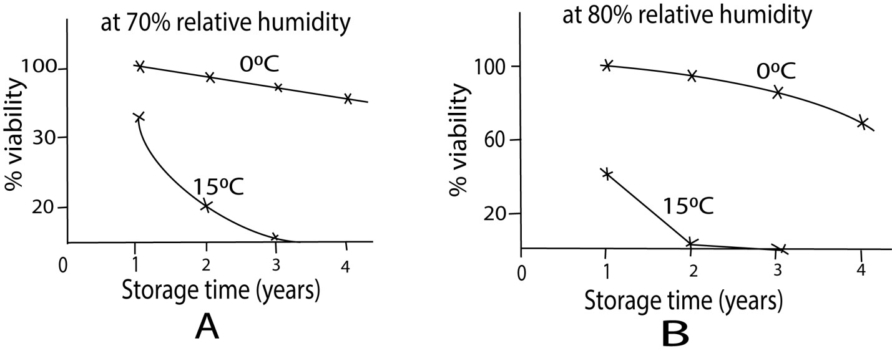

(a) From the figured state the factor that affect viability of fescue grass seed (1 ½ marks)
      - humidity
      - Temperature
      - Storage time
(b) Describe the effect of each factor in (a) on the viability of seeds (03marks)
      - The higher the humidity the faster the seeds lose viability
      - The higher the temperature the faster the seeds lose viability
      - The longer the seeds are stored, higher they lose viability

(c) Explain the effect of each factor in (a) on viability of seeds (5 ½ marks)
      - high humidity lead to loss of seed viability because it promotes growth of moulds, infections and pests.
      - High temperature lead to loss of viability it increases respiration and exhaustion food reserve. It also promotes moulds and pests.
      - The longer the seed are stored, the more they lose viability due to increase in damage by pest and moulds.
44. (a) Explain what is meant by dormancy in seeds. (02marks)
- Describe the causes of dormancy
- Explain why dormancy is more common in weeds than in tropical forest trees (08marks)

